Fish Resource and Aquatic Animals Dep.
Fish disease practical / 1st-2nd lecture

What is a fish disease?
A disease is a particular abnormal condition that negatively affects the structure or function of part or all of an organism, and that is not due to any external injury. Diseases are often construed as medical conditions that are associated with specific symptoms and signs. A disease may be caused by external factors such as pathogens or by internal dysfunctions.
Types of fish diseases
- What are the types of fish diseases?

1-Non-infectious diseases:
  - Can’t be spread from one fish another.
  - Not caused by germs or pathogens.

2- Infectious disease
  - Can be passed from one fish to another.
  - Caused by germs or pathogens.
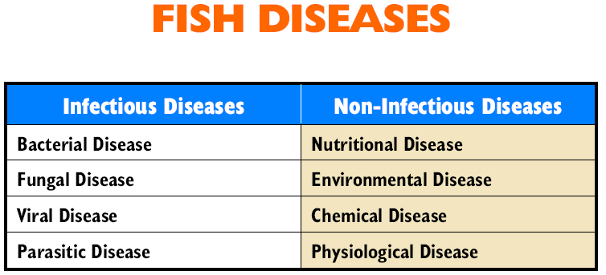

Causes of fish diseases
There are three major causes of fish diseases:
- Presence of environmental pathogens
- Low resistance of the fish stock
- Unsatisfactory water environment
Pathogens (e.g. bacteria, viruses, fungi and parasites) exist in all natural water bodies, yet healthy fish have adequate resistance against them. They can also adapt to reasonable environmental changes and in turn avoid diseases due to pathogenic infection.
Healthy fish
All factors in balance

Environment Pathogens
When the pathogen level of a water body rises sharply due to external factors, and the natural resistance of the fish stock cannot cope with the increased pathogens, the fish will become vulnerable to pathogenic infection and diseases.

Sick fish
Fish unable to cope with increased pathogens

Environment Increased Pathogens ***
In addition, external factors may also cause drastic changes in water quality, resulting in poor health and low resistance of fish stock. The risks of pathogenic infection and fish diseases or deaths are heightened.
Sick fish
Lowering of fish resistance

Environment Pathogens
deteriorating drastically
To prevent and control fish diseases, we should:
- Increasing the internal resistance of fish is important in the prevention of diseases.
- Selection of healthy fish seed.
- Proper density and rational culture.
- Careful management
- Qualitatively uniform ration and fresh food.
- Good water quality.
- Prevention of fish body from injury.

How to boost resistance of fish under culture?
1- Maintain a suitable stocking density. A crowded culture environment increases the risk of disease infection and makes the fish nervous. Fish knocking against each other often gets surface wounds and may develop diseases as a result.
2- Use a winnowing basket without knots to reduce the risk of infection caused by surface wounds. Avoid feeding the stock with trash fish that cannot provide balanced nutrition. This type of feed lessens the natural resistance of fish and makes them more vulnerable to pathogenic infection.
3- Use dry pellet feed which is hygienic, nutritious and low in bacteria. Dry pellet feed added with vitamins and minerals can further strengthen fish immunity.
How to reduce pathogens in the water body?
- Disinfect fish ponds and culture gear regularly.
- Store the dry pellet feed properly, Keep pellets in a cool, dry and covered place to prevent massive bacterial growth.
- Store trash fish properly. Pathogens may proliferate in improperly preserved trash fish. Such feed may introduce large quantities of pathogens to the water. Some pathogens can be eliminated by deep freezing.
- Never use trash fish that are not clean or fresh.
Fish diseases may cause severe losses on fish farms through:
- reduced fish growth and production;
- increased feeding cost caused by lack of appetite and waste of uneaten feed;
- increased vulnerability to predation;
- increased susceptibility to low water quality;
- death of fish.
How to inspect the health of your fish stock Fish farmers
should carry out a simple health inspection routine every day. To begin with, observe fish behavior (stage one). See if the fish are reducing feed intake or showing abnormal swimming patterns. If you are certain that the abnormal behavior is not connected with environmental factors, carry out a detailed health inspection (stage two). For example, check the body surface, fins and gills, and see if there are any surface parasites. Fish farmers should therefore keep daily feeding records to ensure they have sufficient information to compare general intake trends.
How can we prevent the water environment from deteriorating?
1- Do not over-feed - Avoid contamination caused by excessive organic matters depositing on the pond bottom/seabed.
2- Promptly remove fish carcasses in fish ponds/raft net cages. Avoid contamination caused by excessive organic matters depositing on the pond bottom/seabed.
3- Remove fouling organisms on the raft net cages regularly, clear obstructions so that organic matters and be removed from the fish culture zone by sea currents.
 | Sick fish | Healthy fish
Activity | Swimming slowly; sluggish response | Swimming actively; sharp and responsive
Body Color | Dull, dark or discolored | Bright and glossy
Body Surface | White layered patches | Intact
Body Shape | Thin | Normal size
Feed Intake | Poor appetite | Good appetite
Organs | Different fish diseases cause damage to different organs | Internal organs are healthy and normal

Disease manifestations in fish farming areas:

1 - There are a large number of water birds on the sides of the ponds.

2- There is a change in the waters of the ponds in the degree of transparency, color and smell.

3- Change the movement of fish where it becomes fast because of the presence of some pollutants and toxins and some parasites that affect the nervous system, as well as lack of vitamins:

A - Slow motion / tendency of fish to sleep and loss of senses.

B - Spiral movement / head and tail higher because of the injury of fish with some types of parasites.

C - circular motion \ because of the infection of some viruses.

4- unusual way of floating:

A- When the fish float on the surface of the water and try to breathe the air with the increased gecko cover, caused by infection with some parasites in the respiratory system or lack of oxygen.

B - When the fish float and the head and tail to the top or be in a slant or fall down is caused by the air bag injury some diseases.

C - When the fish try to rub its body plants, grass and rocks caused by the skin injury some diseases.
Fish Health Sample Collection Procedures
Biopsy Procedures
- For biopsy specimens, a fish does not need to be killed.
- Biopsy procedures on fish usually are cutaneous smears, fin biopsies and gill biopsies.
- A gill biopsy is performed by cutting a few tips of the primary lamella with the blades of the scissors.
- Both fin and gill biopsies should not cause undue harm to a fish.

Necropsy or autopsy Procedure
Ideally, the fish should be submitted alive for the postmortem examination. This gives the pathologist a chance to observe the fish prior to euthanasia and note any important clinical signs.
Unfortunately, some situations do not allow the pathologist to evaluate the fish while they are alive.
Fish should be dead less than 6 hours. Dead fish should be wrapped in paper or gauze and refrigerated. Do not freeze the fish.

