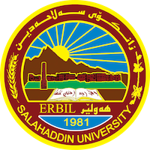
Academic Curriculum Vitae
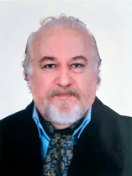

Personal Information:
Full Name: Mohammad Saleh Rostamzadeh (NAMO)
Academic Title: Collage of Fine Art
Email: mohammad.rostamzadeh@su.edu.krd
Mobile: 009647504313723

Education:
-Bachelor’s degree from Tehran University –Collage of Fine Art. 1988-1993
-Master’s degree from Islamic Azad University of Tehran – School of Fine Arts. 1999- 2002

Employment:
- Employment date:10/31/2006
- Starting date: 11/2/2006

Qualifications
- “Teaching ways” certificate (1/11/2009 to 10/5/2010)
- Microsoft PowerPoint2003 certificate (11/8/2009 to 17/8/2009)
- English Language Proficiency certificate (160 Hours) 2015

Teaching experience:
- State all teaching courses you delivered, stating undergraduate or post graduate
- Courses, trainings, lab supervision, etc.,

Research and publications
- ECCE HOMO (caricature book)
- Art and Technology (book)

Conferences and courses attended
- Give details of any conferences you have attended, and those at which you have presented delivered poster presentations.

Funding and academic awards
- List any bursaries, scholarships, travel grants or other sources of funding that you were awarded for research projects or to attend meetings or conferences.

Professional memberships
- Member of “The Kurdish Center of International PEN World Association of Writers” from 2020.
- Member of “Kurdistan Artists Organization” Since 2007.
- Member of “ Kurdistan Teachers Union” since 2007.

Professional Social Network Accounts:

- List your profile links of ReserchGate, LinkedIn, etc.

It is also recommended to create an academic cover letter for your CV, for further information about the cover letter, please visit below link:
https://career-advice.jobs.ac.uk/cv-and-cover-letter-advice/academic-cover-letter/

