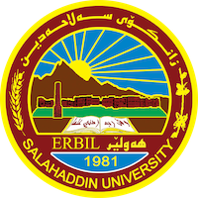
Academic Curriculum Vitae
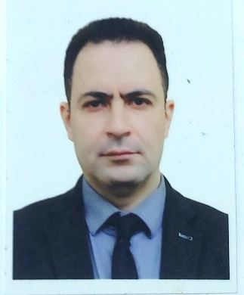
Personal Information:
Full Name: Mohammad Abdulrazzq Sultan
Academic Title: Assisstant Lecturer
Email: mohammad.sultan@su.edu.krd
Mobile: 07503127681

Education:
2007-2009: | M.Sc in Environmental Management (Environmental Economics) - Islamic Azad University-Iran  Thesis: evaluating and estimating of production function of lakes and swamp by cubb-duglas method.
1999-2004: | Bachelors in natural Resources engineering (Environmental Engineering) – Islamic Azad University-Iran

Employment:
Since 2013: | Present lecturer at Civil Department-College of Engineering- Salahaddin University-Erbil.

Qualifications

Teaching experience:
Salahaddin University, Civil Department
2013-2014 | Surveying I 2nd stage
2014-2015 | Surveying (2nd stage), irrigation engineering (3rd stage)
2015-2016 | Engineering Statistics (2nd stage), irrigation engineering (3rd stage)
2015-2016 | Engineering Statistics (2nd stage)
2016-2017 | Engineering Statistics (2nd stage)
2017-2022 Environmental Engineering (2nd stage)
2022-2023 | Environmental Engineering, irrigation engineering

Research and publications
Noor Khalid Yousif Yashooa, Dana Khider Mawlood, Muhammed Abdulrazzaq Sultan, (2022) " Analysing the Pollutants Dispersion in Erbil City-Kurdistan with Support of Statistical Analysis.” Zanco Journal of Pure and Applied Sciences,
ISSN (print):2218-0230, ISSN (online): 2412-3986, DOI: http://dx.doi.org/10.21271/zjpas

Conferences and courses attended

Funding and academic awards

Professional memberships
- Kurdistan Engineering Union Erbil

Professional Social Network Accounts:
ResearchGate: | https://www.researchgate.net/profile/Mohammad-Abdulrazaq

