Question Bank – Statistics – First Stage

Q1/ Define the following statistical terms briefly:
Quantitative Variable , Sample , Inferential statistics, Statistics and Population ?

Q2 / What’s the function of statistics?

Q3/ List general rules for constructing frequency table?
Q4 / What’s the differences between quantitative and qualitative variable ?
Q5 / What’s the differences between descriptive and inferential statistics ?
Q6 / What’s the differences between Sample and population ?
Q7 / List characteristics of normal distributions?

Q8/ From the following frequency table?
Classes | Frequency | Class Mean  (Mid Point) | Real Class | Relative Frequency | Frequency %
5 --- | 4 | . | ----- | . | ٠
8--- | 6 | . | ----- | . | ٠
--- | 2 | . | ----- | . | ٠
--- | 1 | . | ----- | . | ٠
--- | 2 | . | ----- | . | ٠
 | Σf= 15

Complete the following frequency table using the appropriate formulas?
Q9 / Draw Bars Diagram and polygon (Line Diagram) from the above tables ?

Q10 /the following data represents the weight gain (kg) of (5) Karadi lambs: (3, 5, 6, 8, 8)

- Calculate mean, median and mode?
- Calculate Range, Standard error (SE), Coefficient of variation (CV) then interpret the result?
Q11 / If the serum cholesterol of 6 broilers are (90, 86, 118, 132, 115 and 125 mg/ L) and the serum cholesterol of broiler is 100 mg/L. Does these samples represent the normal broiler cholesterol or not?

Q12/ : The blood pressure of six students were determined before and after examination

Student | X₁ (Before) | Χ₂(After) | d = (Χ1-Χ2) | (Χ1-Χ2)²
1 | 10 | 12 | -2 | 4
2 | 11 | 13 | -2 | 4
3 | 12 | 14 | -2 | 4
4 | 11 | 10 | 1 | 1
5 | 13 | 12 | 1 | 1
6 | 15 | 11 | 4 | 16
 |  |  | Σ d= 0 | 30

Q13: The protein content of 7 samples of wheat and 7 samples of corn were determined, does there are a significant differences between protein content of these two groups or not?
Wheat | Corn | (Χ₁ ₋ Χ)² | (Χ₂ ₋ Χ)²
10 | 8 | 1 | 1
8 | 6 | 1 | 1
9 | 8 | 0 | 1
7 | 7 | 4 | 0
9 | 7 | 0 | 0
11 | 8 | 4 | 1
9 | 5 | 0 | 4
63 | 49 | 10 | 8

Q14/ : Someone supposed that the real mean of ewes body weight in a flock is 50 kg. If we take a sample of 144 ewes from this flock and record their body weight, we obtain the mean and standard deviation and they were 45 and 24 kg respectively. Test the hypothesis μX = 50 kg using Z or t.

Q15 / Whats the Chi-Square test and discuss The purpose of this test ?
Q16 / When the Researchers use the Chi-Square test ?
\
Q17/ a scientist wants to know if education level and marital status are related for all people in some country. He collects data on a simple random sample of n = 300 people, part of which are shown below.
Table of Observed Values
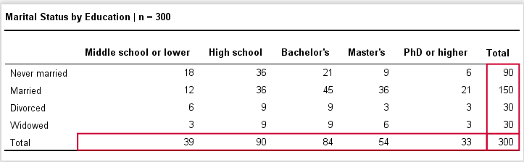

Q18: In an experiment on cotton plants possible to get in the second generation on 625 plants, their flowers are yellow color and 195 plants whose flowers are white, so do the results of experiment follow of isolation and Mendelian ratio, which is 3:1
Null hypothesis (Ho): isolation of flowers color are follow mendel ratio 3:1

Q19: a geneticist took a random sample of 300 men to study whether there is association between father and son regarding baldness. He obtained the following results.

 | Son
Father | Bald | Not
Bald | 85 | 59
Not | 65 | 91
Using α = 5% test whether there is association between father and son regarding boldness.

Q20: Suppose we have a sample of 120 plants, where 32 of them were diseased: (88 non-diseased and 32 diseased). Test the following hypothesis:

Ho: p = 70 %
Ha: p ≠ 70 %

Q21: In a population, the predicted proportions of white, brown, and pied are 0.36, 0.48, and 0.16, respectively. There were 140 white rabbits, 240 brown rabbits, and 20 pied rabbits in a group of 400 rabbits. Are the proportions in the rabbit sample different from what you'd expect?
Q22/

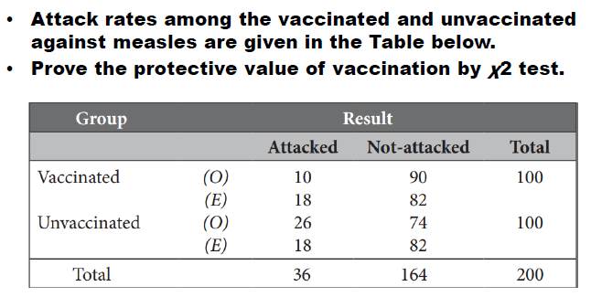

Q23/ List the methods of collecting data?
Q24/ . Consider you have the following data represented weaning weight of Karadi lambs (kg):
Calculate the Mean, Mode, Median, Standard Error and CV?
Q25/ Draw the normal distribution and standard normal distribution of yield with showing a confident limit of 68%, 95% and 99%?
Q26. Complete the following frequency table and then present the data in Graphics?
Q27. If the success percent of student in a secondary school in physics, chemistry and mathematics were 65%, 90% and 80% respectively. What will be the probability to have:
Q28. What are the three importance of covariation?
Q29/ . Average body weight of Karadi lambs in a sample taken from flock (A) consist of 51 lambs was 30 kg with variance 16 kg2. Also average body weight of lambs in a sample from flock (B) consist of 41 lambs was 26 kg with variance 9 kg2. Test the hypothesis μX= ……………….. ?
Q30/ . Suppose that the real percentage of lamb mortality in a flock is 20%. Test this hypothesis by using a random sample of 120 lambs and 23 lambs were dead?
Q31/ . In a flock of Awassi sheep, the supposed percent of twins was 30 %. Test this hypothesis using X2 if the real number of twins was 32 in a sample of 120 lambs (32 twins and 88 single lambs)? Tabulated X2 (P<0.05) with d.f. 1, 2, and 3 were 3.84, 5.99 and 7.81 respectively?
Q32. Data in the following table were dam weight at lambing and birth weight of their progeny?
1. Calculate phenotypic correlation between the two traits?
2. Calculate regression coefficient of birth weight on dam weight?

