Chapter One: Vectors & Scalars
http://www.jfinternational.com/ph/vectors-scalars.html
VECTORS AND SCALARS
In physics we must distinguish between vector quantities and scalar quantities.
A vector is an oriented quantity, it has magnitude and direction like velocity, force and displacement.
Scalars have no direction associated to them, only magnitude, like time, temperature, mass and energy.
Vectors are represented by arrows where the length of the arrow is drawn proportionally to the magnitude of the vector.
The letters denoting vectors are written in boldface.
1.- VECTORS ADDITION. GRAPHIC METHOD.
To add scalars like mass or time, ordinary arithmetic is used.
If two vectors are in the same line we can also use arithmetic, butnot if they are not in the same line. Assume for example you walk 4 km to the East and then 3 km to the North, the resultant or net displacement respect to the start point will have a magnitude of 5 km and an angle = 36.87º with the positive x direction. See figure.
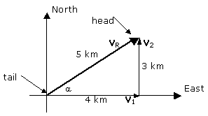
The resultant displacement V_{R} , is the sum of vectors V₁ and V₂, that is we write
V_{R} = V₁ + V₂ This is a vector equation.
The general rule to sum vectors in a graphic way (geometrically) which is in fact the definition how vectors are added, is the following:
(1) Use a same scale for the magnitudes.
(2) Draw one of the vectors, say V₁.
(3) Draw the other vector V₂, placing its tail on the head of the first one, making sure to keep its direction.
(4) The sum or resultant of the vectors is the arrow drawn from the tail of the first vector to the head of the second vector.
This method is called vector addition from tail to head.
Notice that V₁ + V₂ = V₂ + V₁, that is, the order does not matter.
This tail to head method can be extended to three or more vectors. Suppose we want to add the vectors V₁, V₂ and V₃ shown below:
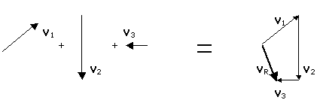
V_{R} = V₁ + V₃ +V₃ is the resultant vector outlined with a heavy line.
A second method to add two vectors is the parallelogram rule equivalent to the tail to head method. In using this parallelogram rule the two vectors are drawn from a common origin and a parallelogram is formed using the two vectors as adjacent sides. The resultant is the diagonal drawn from the common origin.
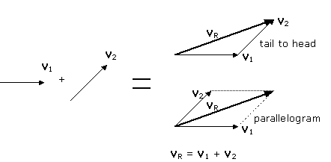
2.- SUBTRACTION OF VECTORS
Given a vector V it is defined the negative of this vector (-V) as a vector with the same magnitude as V but opposite direction:
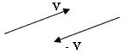
The difference of two vectors A and B is defined as per this equation:
A - B = A + (-B)
So we can use the addition rules to subtract vectors.
3.- MULTIPLICATION OF A VECTOR BY A
REAL NUMBER.
A vector V can be multiplied by a real number c. This product is defined in such a way that cV has the same direction as V and magnitude cV. If c is positive, the sense is not altered. If c is negative, the sense is exactly opposite to V.
ANALYTIC METHOD, VECTORS ADDITION.
1.- COMPONENTS
The graphical sum often has not enough exactitude and is not useful when the vectors are in three dimensions. As every vector can be represented as the sum of two other vectors, these vectors are called the components of the original vector. Usually the components are chosen along two mutually perpendicular directions. For example, assume the vector V below in the figure. It can be split in the component V_{x} parallel to the x axis and the component V_{y} parallel to the y axis.
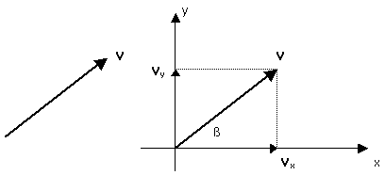
We use coordinate axis x-y with origin at the tail of vector V. Notice that V = V_{x} + V_{y} according to the parallelogram rule.
The magnitudes of V_{x} and V_{y} are denoted V_{x} and V_{y}, and are numbers, positive or negatives as they point at the positive or negative side of the x-y axis.
Notice also that V_{x} = Vcos and V_{y} = Vsen.
2.- UNIT VECTORS
Vector quantities can often be expressed in terms of unit vectors. A unit vector is a vector whose magnitude is equal to one and dimensionless. They are used to specify a determinated direction. The symbols i, j y k represent unit vectors pointing in the directions x, y and z positives, respectively.
Now V can be written V = V_{x}i + V_{y}j.
If we need to add the vector A = A_{x} i + A_{y} j with
the vector B = B_{x} i + B_{y} j we write
R = A + B = A_{x} i + A_{y} j + B_{x} i + B_{y} j = (A_{x} + B_{x})i + (A_{y} + B_{y})j.
The components of R are R_{x} = A_{x} + B_{x} and R_{y} = A_{y} + B_{y}
Exercise, Example: Use of components and unit vectors.
A boyscout walks 22 km in North direction, and then he walks in direction 60º Southeast during 47.0 km. Find the components of the resulting vector displacement from the starting point, its magnitude and angle with the x axis.
Solution: The two displacements are shown in the figure, where we choose the positive x axis pointing to East and the positive y axis pointing to North.
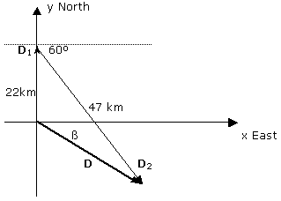
The resultant displacement D is the sum of D₁ and D₂.
Using unit vectors:
D₁ = 22 j
D₂ = 47cos60º i - 47sen60º j
Then D = D₁+D₂ = 22 j + 47cos60º i - 47sen60º j = 23.5 i - 18.7 j
and the resultant vector is completely specified with an x component D_{x} = 23.5 km and a y component D_{y} = -18.7 km. (Note D_{x} and D_{y} are scalars).
The same resultant vector can be specified giving its magnitude and angle:
D² = D_{x}² + D_{y}² = (23.5 km)² + (-18.7 km)² finding D = 30 km.
tan = D_{y}/D_{x} = -18.7/23.5 = -0.796 finding = -38.5º (under the x axis) or 38.5 Southeast.
Application Problems: Use of Addition Vector Tools to Solve Relative Velocity
Vector Problems, Example One.-
A motorboat velocity is 20 km/h in still water. If the boat must travel straight to the nearest shore in a river whose current is 12 km/h, ¿What up stream angle must the bow boat point at?
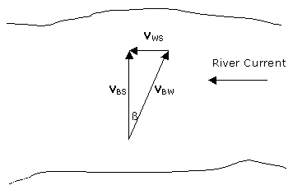
Before attempting to solve this problem, it is useful to do some considerations:
- Whenever a velocity is mentioned, it is necessary to specify what is its frame of reference to measure it. This is a case where we have relative velocities and the tool to find the resultant or the components is the vector sum.
- It is helpful to use an identification procedure that uses two sub indexes: the first sub index refers to the object and the second one to the frame of reference in which that velocity is measured. In this example V_{BW} is the velocity of the Boat relative to the Water, V_{BS} is the Boat velocity relative to the Shore and V_{WS} is the Water velocity relative to the Shore. Notice V_{BW} is produced by the boat motor, instead V_{BS} is V_{BW} plus the current effect. Hence, the boat velocity relative to the shore V_{BS}, is
(A) V_{BS} = V_{BW} + V_{WS}
The sentence "a motorboat velocity is 20 km/h in still water" means V_{BW} = 20 km/h, and the sentence "a river whose current is 12 km/h" means V_{WS} = 12 km/h. Notice V_{BS} points directly straight to the opposite shore as wanted. The angle can be obtained from the rectangular triangle in the figure:
sen = V_{WS}/V_{BW} = 12/20 = 0.6 then = 36.87º. The bow boat must point at an angle of 36.87º up stream in order to cross the river directly to the other shore.
Vector Problems, Example 2.-
A boat velocity is 2 m/s in still water. a) If the boat points the bow straight to the opposite shore to cross the river whose current is 1 m/s, what is the velocity, in magnitude and direction, of the boat relative to the shore? b) What is the boat position relative to its starting point, after 3 min?
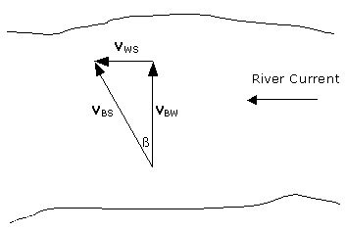
a) The boat velocity relative to the shore V_{BS}, is the sum of its velocity relative to the water V_{BW}, and the water velocity relative to the shore V_{WS} :
V_{BS} = V_{BW} + V_{WS}
As V_{BW} and V_{WS} are the sides of a rectangular triangle,
V_{BS}² = V_{BW}² + V_{WS}² or
V_{BS}² = (2m/s)² + (1m/s)² i.e. V_{BS} = 2.24 m/s.
Also, tan = V_{WS}/V_{BW} = 1/2 , then = 26.57º.
b) To calculate the position after 3 min we can use D = Vt, with D the vector displacement, V the vector velocity and t the time, an scalar. The direction of D is the same as V and its magnitude is V·t = 2.24 m/s·3·60 s = 403.2 m. The boat position is then at 403.2 m from the starting point and at a direction 26.57º down stream transverse to it

vectors addition of vectors components of vectors with examples
In physics and all science branches quantities are categorized in two ways. Scalarsand vectors are used for to define quantities. We can use scalars in just indication of the magnitude, they are only numerical value of that quantity. However, if we talk about the vectors we should consider more than numeric value of the quantities. Vectors are explained in detail below.
VECTORS
Vectors are used for some quantities having both magnitude and direction. We will first learn the properties of vectors and then pass to the vector quantities. You will be more familiar with concepts after learning vectors. Look at the given shape which is a vector having magnitude and direction.
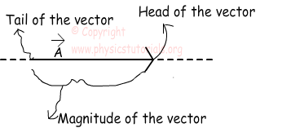
Head of the vector shows the direction and tail shows the starting point. We can change the position of the vector however, we should be careful not to change the direction and magnitude of it. In next subject we will learn how to add and subtract vectors. Moreover, we will learn how to find the X and Y components of a given vector using a little bit trigonometry.

ADDITION OF VECTORS
Look at the picture given below. It shows the classical addition of three vectors. We can add them just like they are scalars. However, you should be careful, they are not scalar quantities. They have both magnitude and direction. In this example their magnitudes and directions are the same thus; we just add them and write the resultant vector.
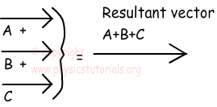

Let’s look at a different example.In this example as you can see the vector A has negative direction with respect to vectors B and C. So, while we add them we should consider their directions and we put a minus sign before the vector A. As a result our resultant vector becomes smaller in magnitude than the first example.

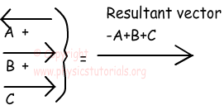

MULTIPLYING A VECTOR WITH A SCALAR
When we multiply a vector with a scalar quantity, if the scalar is positive than we just multiply the scalar with the magnitude of the vector. But, if the scalar is negative then we must change the direction of the vector. Example given below shows the details of multiplication of vectors with scalar.
Example Find 2A, -2A and 1/2A from the given vector A.
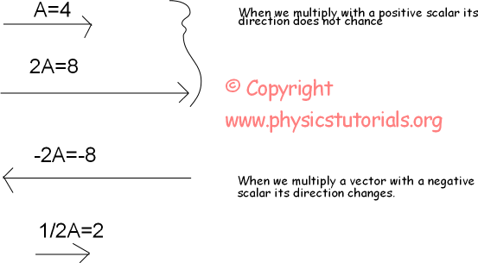

COMPONENTS OF VECTORS
Vectors are not given all the time in the four directions. For doing calculation more simple sometimes we need to show vectors as in the X, -X and Y, -Y components.
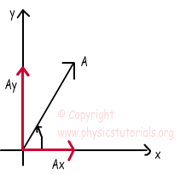

For example, look at the vector given below, it is in northeast direction. In the figure, we see the X and Y component of this vector. In other words, addition of Ax and Ay gives us A vector. We benefit from trigonometry at this point. I will give two simple equations which you can use and find the components of any given vector.
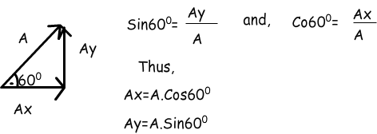

All vectors can be divided into their components. Now we solve an example and see how we use this technique.
Example Find the resultant vector of A and B given in the graph below. (sin30º=1/2, sin60º=√3/2, sin53º=4/5, cos53º=3/5)
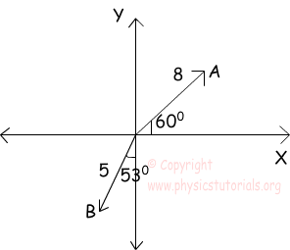
We use trigonometric equations first and find the components of the vectors then, make addition and subtraction between the vectors sharing same direction.
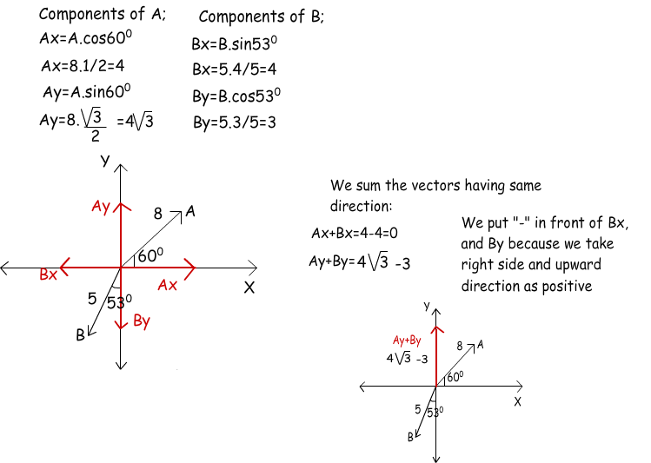

Example: Find resultant of the following forces acting on an object at point P in figure given below.
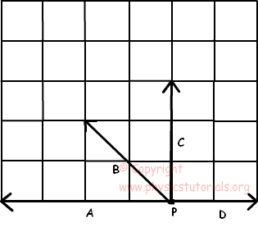
We add all vectros to find resultant force. Start with vector A and add vector C to it. After that, add vector D and C and draw resultant vector by the starting point to the end. Examine given solution below, resultant force is given in red color.
