Chapter Five:

Linear Momentum
1

Introduction to Momentum

We know that it is harder to get a more massive object moving from rest than a less massive object.
  - This is the concept of inertia previously introduced.
- Building on the concept of inertia, we ask the question, “How hard is it to stop an object?”
  - We call this new concept momentum , and it depends on both the mass of the object and how fast it is moving.

Introduction to Momentum
- For example, a kayak and a cargo-ship are moving through a harbor.
  - If they are both traveling at 5 kmh-1, you probably know intuitively that the cargo-ship is harder to stop.
  - But what if the kayak is moving at 50 kmh-1?
  - Which would you rather have to try to stop?

3

Linear Momentum
    - The linear momentum of an object is defined as the product of its mass and its velocity, it is measured in kg.m.s-1.

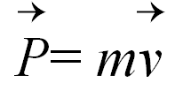
The relation for linear momentum is:

where P and v are vector quantities.

Linear Momentum
    - So an object may have a large momentum due to a large mass, a large velocity , or both.

    - Conceptual Question: Which has the greater momentum, an 18-wheeler moving on a straight road, or a Volkswagen rolling down a hill?

Changing an Object’s Momentum
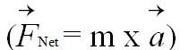
  - The momentum of an object changes if its velocity or mass changes, or both. We can obtain an expression for the amount of change by rewriting Newton’s second law

in a more general form.
  - This more general form of the second law says that the net force is equal to the rate of change of momentum:

Newton’s Second Law

In order to change the momentum of an object, a force must be applied
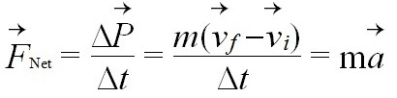
- The rate of change of momentum of an object is equal to the net force acting on it
■ Alternative form of the sercond Newton law
r Δp
=
F Δt
r dpr
=
F
dt

Changing an Object’s Momentum

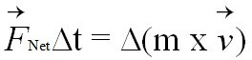
If we now multiply both sides of this equation by the time interval Δt, we get an equation that tells us how to produce a change in momentum:
- This relationship tells us that this change is produced by applying a net force to the object for a certain time interval.
  - The interaction that changes an object’s momentum—a force acting for a time interval—is called impulse .
  - Impulse is a vector quantity that has the same direction

01/22/14
as the net force.
IB physics (IC NL) 8

Fast Or Slow, It Doesn’t Matter To The System
Changing an Object’s Momentum
- Because impulse is a product of two things, there are many ways to produce a particular change in momentum.
- For example, two ways of changing an object’s momentum by 10 kilogram-meters per second are:
  - exert a net force of 5 N on the object for 2 s, or
  - exert 100 N for 0.1 s.
- They each produce an impulse of 10 N.s and therefore a momentum change of 10 kg.m.s-1.
- The units of impulse N.s are equivalent to those of momentum kg.m.s-1.

However, It Matters To Us
Changing an Object’s Momentum
- Although the momentum change may be the same, certain effects depend on the particular combination of force and time.
- Suppose you had to jump from a second- story window. Would you prefer to jump onto a wooden or a concrete surface?
  - Common sense tells us that jumping onto a wooden surface is better. But why is this so?

However, It Matters To Us
Changing an Object’s Momentum
- The reason being that the time of contact with the wood is going to be more than the concrete---
- Wood is soft compared to concrete– so we will not come to sudden stop when in contact with the wood
- More time of contact means less force acting on the body---- see Impulse formula

However, It Matters To Us
Changing an Object’s Momentum
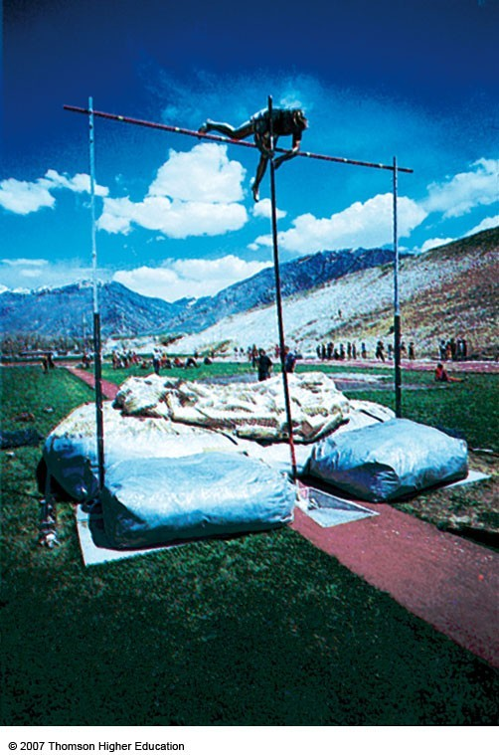
  - Because our bones break when forces are large, the particular combination of force and time interval is important.

■ Sometimes, as in a gymnasium, a wood floor may be enough of a cushion; in a car, the dashboards are made from foam rubber. Bumpers and air bags further increase the vehicle’s (and the passengers’) Δt.
A pole-vaulter0l1a/n2d2s/1o4n thick pads to increase the cIoBllpishioysnictsim(IeC NL) 12
and thus reduce the force. Otherwise, this could be a nasty fall.

Impulse – Momentum Theorem
If the ball is to be hit well –
Both the magnitude of force and the time of contact are IMPORTANT

IMPULSE = Average Force x Time of Contact

ur r
I = F .Δt

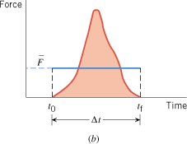
Impulse is a vector quantity and points in the direction of the Force.

Large Impulse – the ball leaves the bat with greater velocity
- but Velocity acquired also depends on the Mass of the ball

Thus Mass and Velocity play a role in how an object responds to an impulse
13

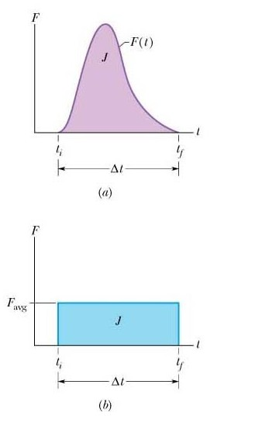Impulse-Momentum Theorem
14

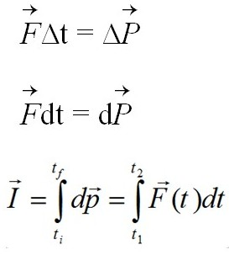
■ When a single, constant force acts on the object
■

I , the impulse acting on the object is equal to the change in momentum of the object (area under graph)
01/22/14 IB physics (IC NL)

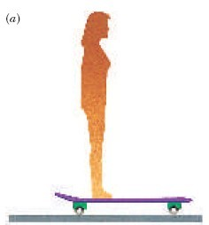
Conservation of Linear Momentum

Imagine standing on a giant skateboard, at rest.
  - The total momentum of you and the skateboard must be zero, because everything is at rest.

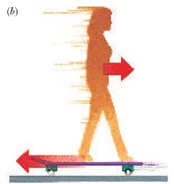
Now suppose that you walk on the skateboard. What happens to the skateboard?
      - When you walk in one direction, the skateboard moves in the other direction, as shown in the figure alongside.
      - An analogous thing happens when you fire a rifle: the bullet goes in one direction, and the rifle recoils

in the opposite direction 15

Conservation of Linear Momentum

■ The force you exert on the skateboard is, by Newton’s third law, equal and opposite to the force the skateboard exerts on you.
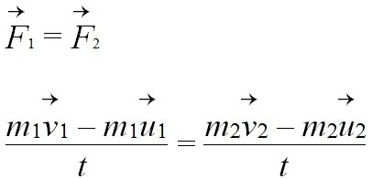
■ Because you and the skateboard each experience the same force for the same time interval, you must each experience the same-size impulse and, therefore, the same-size change in momentum.

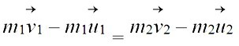
But the time is the same for both then
■

16

Conservation continued
- Because the impulses are in opposite directions (red arrows,
foot/skateboard & you), the changes in the momenta are also in opposite directions.
  - Thus, your momentum and that of the skateboard still add to zero.
  - 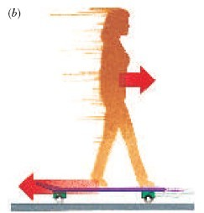Even though you and the skateboard are moving and, individually, have nonzero momenta,
17
the total momentum remains zero.

Conservation of Linear Momentum
- Because the changes in the momenta of the two objects are equal in size and opposite in direction, the value of the total momentum does not change. We say that the total momentum is conserved .
- We can generalize these findings. Whenever any object is acted on by a force, there must be at least one other object involved.
  - This other object might be in actual contact with the first,
  - or it might be interacting at a distance of 150 million km, but it is there. Consider the objects as a system. Whenever there is no net force acting on the system from the outside (that is, the system is isolated, or
closed), the forces that are involved act only between the objects within the system. As a consequence of Newton’s third law, the total momentum of the system remains constant.
- This generalization is known as the law of conservation of linear momentum .
18

Conservation of Linear Momentum
■ The Law of Conservation of Linear Momentum:
■ The total linear momentum of a system d
oes not change if
19

  - Or thethlinereearismnoomneetnetuxmteronfaal fnoriscoe.lated system is conserved.
  - In practice we apply the conservation of momentum to systems where the net external force is zero or the effects of such forces can be neglected.

Examples

Conservation of Linear Momentum

You experience conservation of momentum firsthand when you try to step from a small boat onto a dock.

■ As you step toward the dock, the boat moves away from the dock, and you may fall into the water.
- A large mass requires a small change in velocity to undergo the same change in momentum.

Conservation of Momentum and collisions

  - Momentum in an isolated system in which a collision occurs is conserved
■ An isolated system will have not external forces
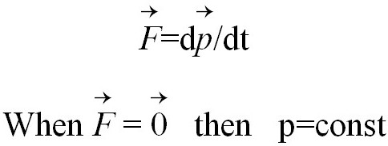
  - When no external forces act on a system consisting of objects that collide with each other, the total momentum of the system before the collision is equal to the total momentum of the system after the collision

Conservation of Momentum and collisions
    - When two object are moving with constant speeds and collide the linear momentum is always conserved.
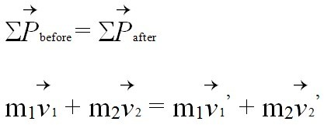
    - The sum of momentum before equals to the sum of momentum after.

    - Many cases appear here where both objects could be moving or one of them is at rest and the other moving.
    - Hint: always select a certain direction then resolve in order to solve.

Collisions
- Interacting objects don’t need to be initially at rest for conservation of momentum to be valid. Suppose a ball moving to the left with a certain momentum crashes head-on with an identical ball moving to the right with the same-size momentum.
  - Before the collision, the two momenta are equal in size but opposite in direction, and because they are vectors, they add to zero.
  - After the collision the balls move apart with equal momenta in opposite directions.
- Because the balls are identical and their masses are the same, the speeds after the collision are also the same.
These speeds depend on the ball’s physical properties.
- In all cases the two momenta are the same size and in opposite directions, and the total momentum remains

zero.
23

Collisions

Collision are of two types—
- Elastic collision
- Inelastic collision
- Momentum remain constant in both type of collisions.
- Elastic collisions: the bodies collide and move away from each other
- Inelastic collision: bodies move together after collision.

Elastic collision
- In any collision linear momentum is conserved but in elastic collision only the kinetic energy is also conserved.

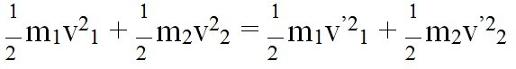

Collisions
■ We can use the conservation of momentum to measure the speed of fast-moving objects. For example, consider determining the speed of an arrow shot from a bow.
- We first choose a movable, massive target—a wooden block suspended by strings. Before the arrow hits the block (a), the total momentum of the system is equal to that of the arrow (the block is at rest).
- After the arrow is embedded in the block (b), the two move with a smaller, more measurable speed.
- The final momentum of the block and arrow just after the collision is equal to the initial momentum of the arrow. Knowing the masses, the arrow’s initial speed can be determined.

