***Experiment No. 3***

***Name***: Heat Pump Analysis

**Purpose**: to understand the heat pump and evaluate the value of COPHP (Coefficient of Performance of heat pump).

***Definition***: Heat Pump is a device used to transfer heat from a low temperature medium to a high temperature one

## *Heat pump Classification:*

A) Air–air heat pump

B) Air–water heat pump

C) Water–water heat pump

***Heat Pump Components:***

1. Compressor: Reciprocating (Hermetic), Rotary screw, Centrifugal … etc
2. Condenser: is a heat exchanger in which the working fluid condenses as it rejects heat to the surroundings. Condenser types are: Air cooled, Water cooled … etc.
3. Expansion (Throttling) Device (valve): Hand (manual) expansion valves, Capillary Tubes, Orifice … etc.
4. Evaporator: is a heat exchanger in which the working fluid evaporates as it receives heat from the surroundings. Evaporator types are: Air cooled, Water cooled … etc.



Heat exchanger: is a device used to exchange heat between two fluids

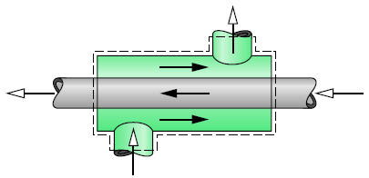

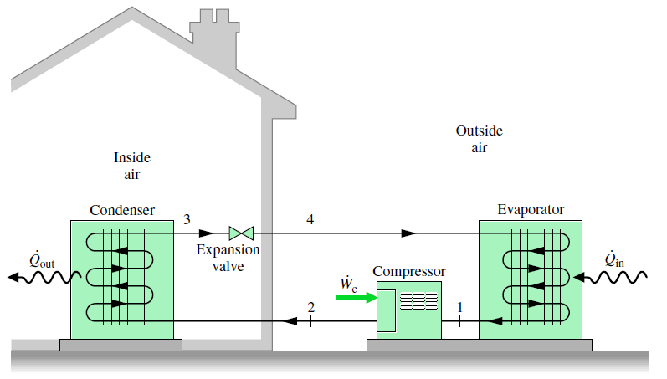

***Calculation:***

h1: calculated from Evaporator outlet temperature and evaporator (low) pressure

= enthalpy of refrigerant before entering the compressor.

h2: calculated from *condenser inlet temperature* and condenser (high) pressure

= enthalpy of refrigerant after leaving the compressor or before entering the condenser

h3: calculated from *condenser outlet temperature* and condenser (high) pressure

= enthalpy of refrigerant after leaving the condenser.

$${COP}_{HP}=\frac{Desired output}{Required Input}=\frac{{\dot{Q}}_{cond}}{{\dot{W}}_{comp}}$$

|  |  |  |  |  |  |  |  |  |  |  |  |  |
| --- | --- | --- | --- | --- | --- | --- | --- | --- | --- | --- | --- | --- |
|  |  |  |  |  |  |  |  |  |  |  |  |  |
|  | **Table** |  |  |  |  |  |  |  |  |  |  |  |
|  |  |  |  |  |  |  |  |  |  |  |  |  |
|  | **Time sec** | **Temp. evap. in °C** | **Temp. evap. out °C** | **Temp. cond. in °C** | **Temp. cond. out °C** | **Cond. Press. (bar)** | **Evap. Press. (bar)** | **h1** | **h2** | **h3** | **Mass (g/s)** | **COPHP** |
| 1 |  |  |  |  |  |  |  |  |  |  |  |  |
| 2 |  |  |  |  |  |  |  |  |  |  |  |  |
| 3 |  |  |  |  |  |  |  |  |  |  |  |  |
| 4 |  |  |  |  |  |  |  |  |  |  |  |  |
| 5 |  |  |  |  |  |  |  |  |  |  |  |  |
| 6 |  |  |  |  |  |  |  |  |  |  |  |  |

***Graph:***

1. Relation between Time with COPHP for.x

***Relation between Time with COPHP .***

***Discussion***

1. Describe the graphe.
2. What is the effect of the heat capacity of the absorbent on the amount of heat absorbed by the evaporator.
3. In your openion, which is better for indor heating: using a heat pump or an electric heater.
4. How we can to delay water freezing to a value less than 0°C.

*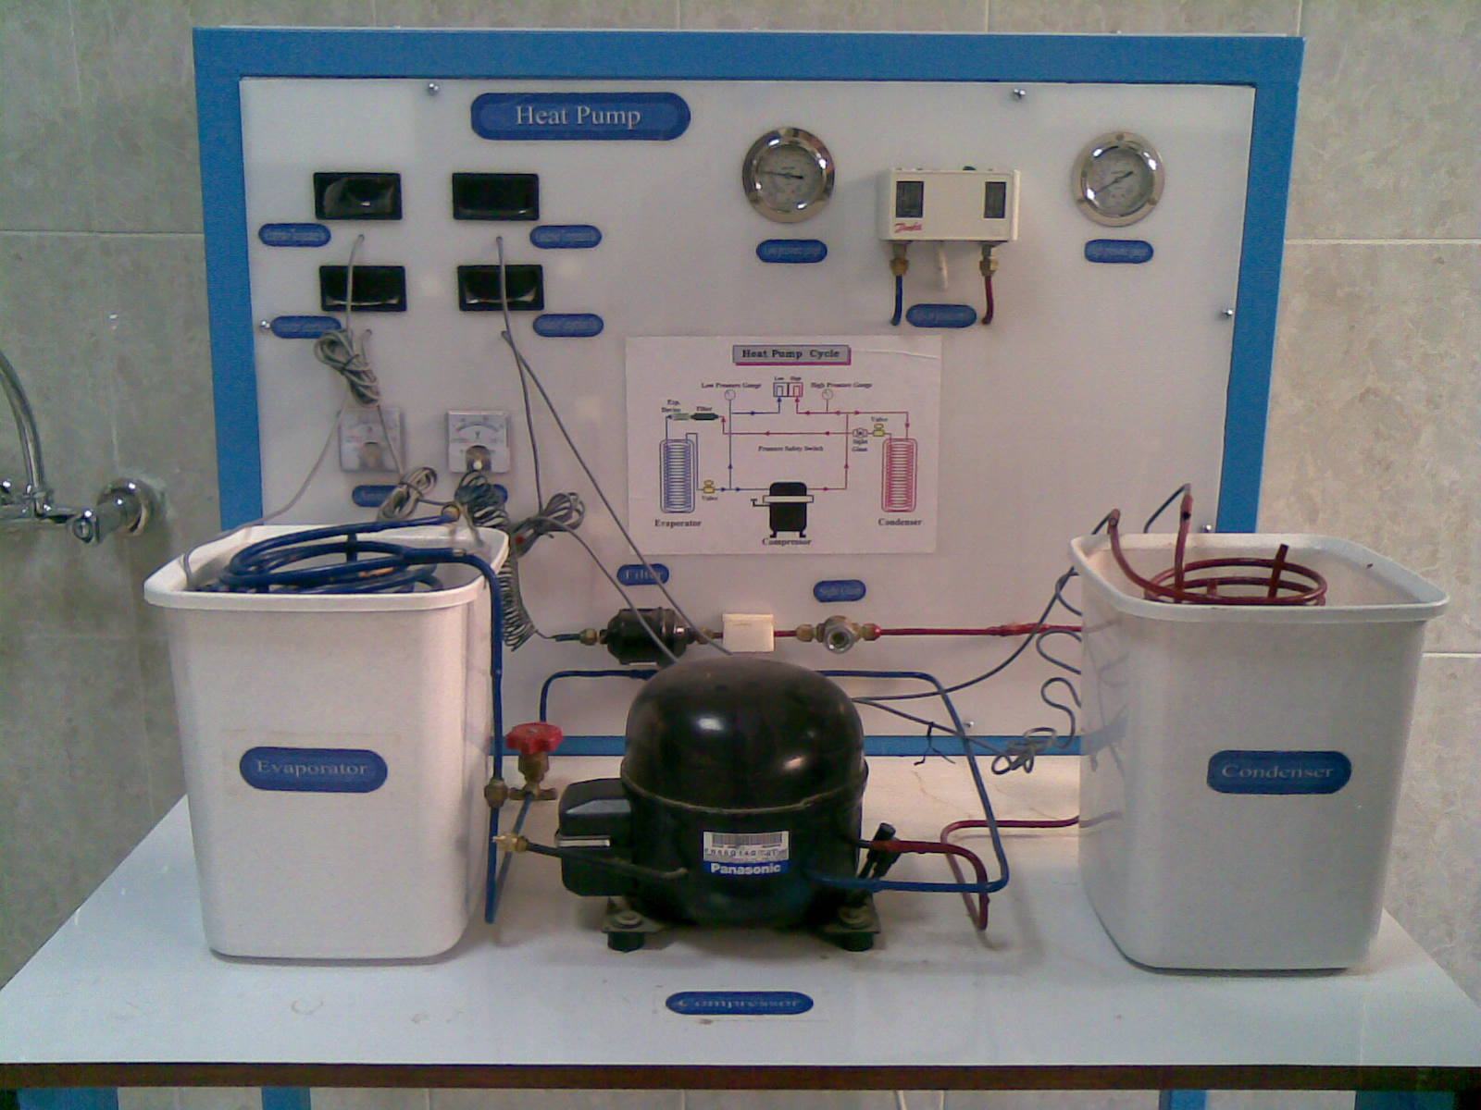DISCRIPTION OF HEAT PUMP:*

**12**

**8**

**7**

**10**

**6**

**14**

**13**

**11**

**9**

**4**

**2**

**5**

***L2=18cm***

***L1=19cm***

***H=28cm***

**3**

**1**

**THE DEVIC IS COMPOSED OF THE FOLLOWING *MAIN* COMPONENTS:**

1. COMPRESSOR: It’s a hermetic compressor (FN66Q14G) model, works with refrigerant R134a.
2. CONDENSER: It’s of evaporative kind immersed in a tank of water, the tank has the shape of trapezoidal parallel piped, it has a square base but larger at the top as shown on the picture above with the dimensions. $\left(\frac{L_{1}+L_{2}}{2} = \frac{19+18}{2} \right)$ =**18.5 cm** (average length), A=LAV*H=18.5*28=**518 cm2**(area of one face), for volume we multiply the area of one face by the width, since the base and the top are square so width= LAV, then volume= 518*18.5=**9583cm3=9.583 litre , but we put 8 litres of water** .
3. EXPANSION VALVE (capillary tube):  *Reduce pressure from condenser pressure to evaporator pressure, and regulate the refrigerant flow from the high-pressure liquid line into the evaporator at a rate equal to the evaporation rate in the evaporator.*
4. EVAPORATOR: It’s of bare tube kind immersed in a tank of water of the same shape and volume of the condenser.

**THERE ARE OTHER COMPONENTS IN THE CYCLE OF THE DEVICE;**

1. ***Sight glass*** after the condenser, to control the gas if it’s decreased or not.
2. ***Filter:*** to prevent any particle to enter the evaporator.
3. ***Low pressure gauge:*** Reads the pressure of the refrigerant at the compressor input.
4. ***High pressure gauge:*** Reads the pressure of the refrigerant at the compressor output.
5. ***Condenser temperature in:*** It’s a LED screen reads the temperature of the refrigerant at the inlet of the condenser.
6. ***Condenser temperature out:*** It’s a LED screen reads the temperature of the refrigerant at the outlet of the condenser.
7. ***Evaporator temperature in:*** It’s a LED screen reads the temperature of the refrigerant at the inlet of the evaporator.
8. ***Evaporator temperature out:*** It’s a LED screen reads the temperature of the refrigerant at the outlet of the evaporator.
9. ***Ammeter:*** Reads the current amount given to the cycle.
10. ***Voltmeter:*** the voltage amount given to the cycle.

***The overall dimensions of the device are as follows:***

(Length= 101 cm, width= 71 cm, height= 138 cm)

***And this is the cycle diagram of the device:***

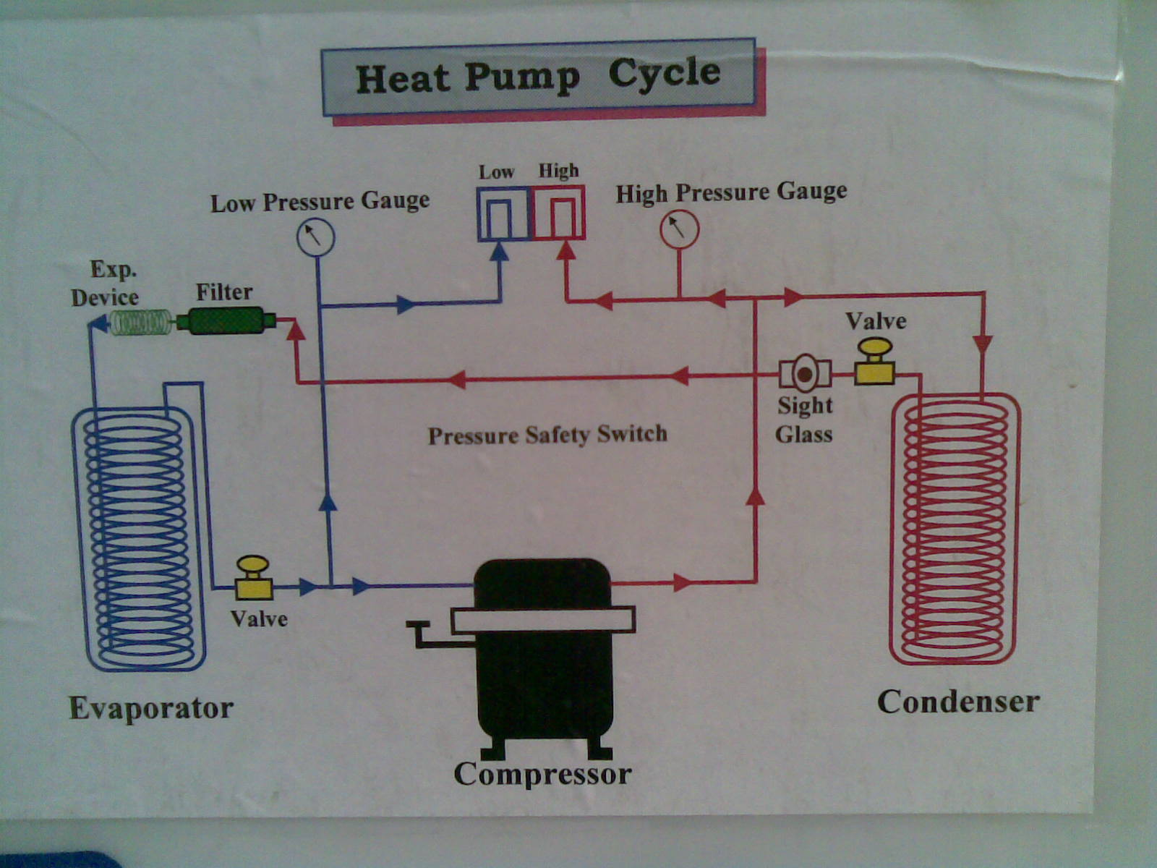



|  |  |  |  |  |  |  |  |  |  |  |  |  |
| --- | --- | --- | --- | --- | --- | --- | --- | --- | --- | --- | --- | --- |
|  |  |  |  |  |  |  |  |  |  |  |  |  |
|  | **Table** |  |  |  |  |  |  |  |  |  |  |  |
|  |  |  |  |  |  |  |  |  |  |  |  |  |
|  | **Time sec** | **Temp. evap. in °C** | **Temp. evap. out °C** | **Temp. cond. in °C** | **Temp. cond. out °C** | **Cond. Press. (bar)** | **Evap. Press. (bar)** | **h1** | **h2** | **h3** | **Mass (g/s)** | **COPHP** |
| 1 |  |  |  |  |  |  |  |  |  |  |  |  |
| 2 |  |  |  |  |  |  |  |  |  |  |  |  |
| 3 |  |  |  |  |  |  |  |  |  |  |  |  |
| 4 |  |  |  |  |  |  |  |  |  |  |  |  |
| 5 |  |  |  |  |  |  |  |  |  |  |  |  |
| 6 |  |  |  |  |  |  |  |  |  |  |  |  |
| 7 |  |  |  |  |  |  |  |  |  |  |  |  |
| 8 |  |  |  |  |  |  |  |  |  |  |  |  |
| 9 |  |  |  |  |  |  |  |  |  |  |  |  |
| 10 |  |  |  |  |  |  |  |  |  |  |  |  |