- Personal information
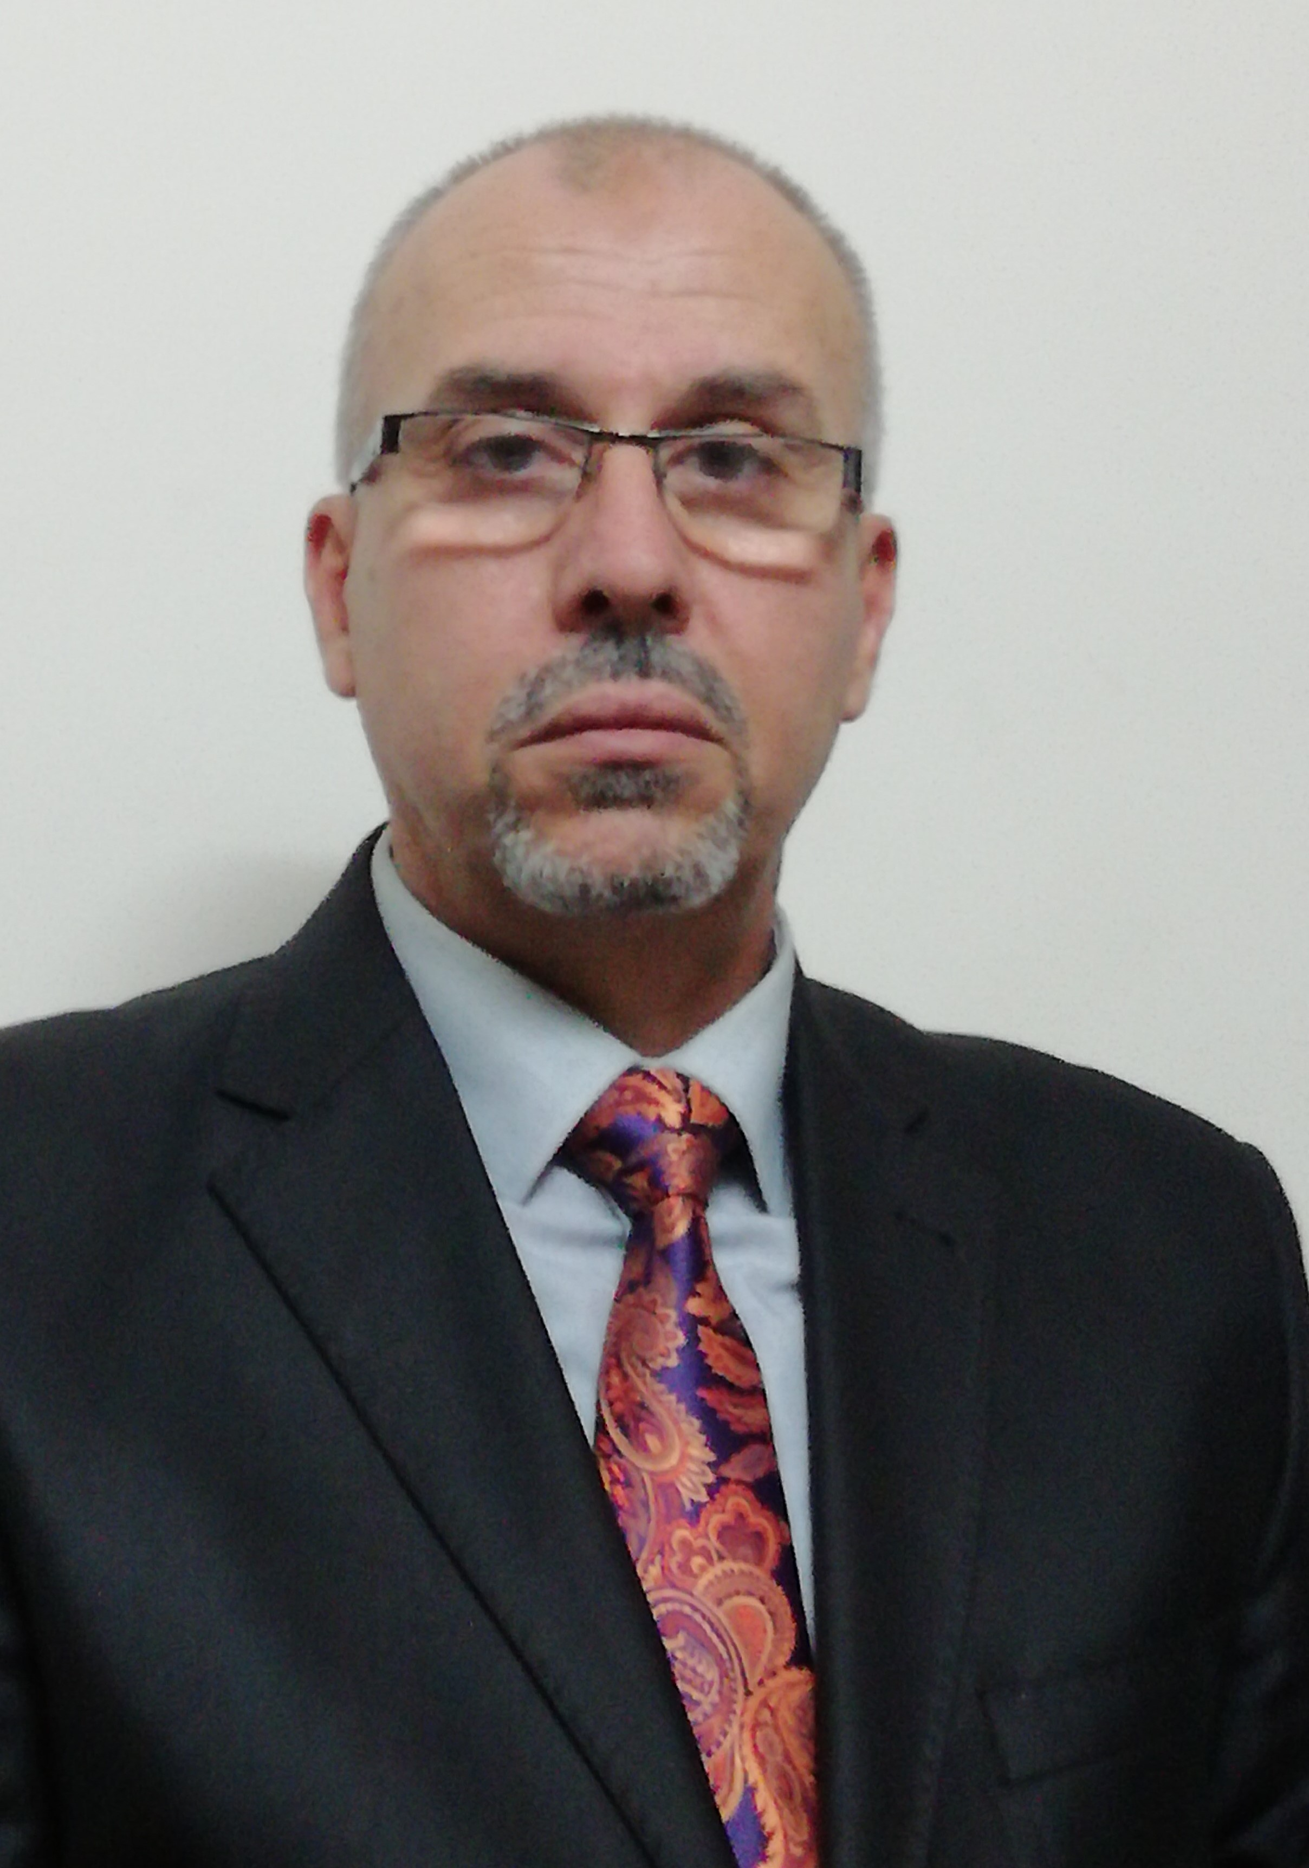
Name: Dr. Mohammed Anwer Jassim.
Scientific Title: Assistant Professor.
Address: Erbil, Framanbaran district.
City: Erbil, Kurdistan - Region, Iraq.
Gender: Mail.
Marital Status: Married.
Email: mohammed.jassim@su.edu.krd

- Education
- Institution: State University of land use planning.
Location: Moscow – Russian Federation.
Completion Date: February 1995.
Degree: Doctor Philosophy in applied sciences of surveying and Geomatics.
Dissertation titled: "The accuracy analysis of surveying works for establishment the city cadastre ".

- Institution: Polytechnic Institute named Albairouny.
Location: Tashkent – USSR.
Completion Date: July 1991.
Degree: MSc in science of surveying Engineering and Cadaster. Thesis titled: "Accuracy analysis of the city cadastre applications in Iraq".

- Institution: Baghdad University – College of Engineering.
Location: Baghdad, Iraq.
Completion Date: July 1985.
Degree: BSc in science of Surveying Engineering.

- Teaching Experiences:
Date: February 2011- Current time.
Position: Lecturer / Assistant Professor.
Location: Salahaddin University–College of Engineering – Geomatics Engineering Department.
Work description:
- Supervisor of the MSc & PhD in Geomatics and surveying engineering studies.
- Member of department’s syllabuses and study programs committee.
- Member of the department’s scientific committee.
- Lecturer of PhD, MSc, and High Diploma studies for subjects of:
- Advanced geodesy.
- Advanced surveying engineering.
- Least Squares adjustment.
- Lecturer of BSc subjects: hydrographic surveying, adjustment theory, global geodesy,
and theory of errors.

Date: February 1996 – January 2004.
Position: Lecturer in surveying engineering department.
College: Technical College of Baghdad – Organization of Technical Institutes.
Location: Iraq – Baghdad.
The work description:
- Teaching the subjects of: plane surveying, geodesy, adjustment theory, cartography and digital mapping, engineering surveying and cadastre.
- Teaching the theoretical base of the systems of GNSS and GIS.
Date: February – 2000.
Position: Lecturer of postgraduate courses.
College: Baghdad University - Engineering College – Surveying engineering department.
Description work:
- Lecturer of the digital mapping and advanced cartography course for postgraduate students. Courses of MSc in surveying engineering sciences.

Date: July – 2002.
Position: Member of consultant committee
College: Technical college of Baghdad.
The work description:
- Writing and reviewing the study programs for the postgraduate courses in order to open the MSc study for the surveying engineering department.

Date: September 2002.
Position: Lecturer.
College: Technical college of Baghdad – surveying engineering department.
The work description:
- Lecturer of the MSc courses: micro surveying networks, city cadastre, and digital mapping, for the postgraduate students.

Date: July 1998.
Position: Lecturer.
College: College of engineering – AL Nahrain University.
The work description:
- Lecturer of the subject of plane surveying - civil department
- Supervisor on the undergraduate projects for the bachelor's degree – civil department.

Date: July 1996.
Position: Member of consultant committee.
College: Authority of technical education – technical college of Baghdad.
The work description:
- Writing and reviewing the study programs for the four stages to open a new department of a surveying engineering in Baghdad technical college – authority of technical education – ministry of higher education and scientific research.

- Theses Supervision and Examination:
- Supervisor on MSc thesis titled "Identification of the optimal positions of the points in micro surveying networks using the successive Approximation method". Technical college of Baghdad. Baghdad. 2006.

- Member of examination committee to obtain the degree of master’s in surveying sciences in Baghdad University – College of Engineering for 7 years.

- Member of the research evaluation committee in the Foundation of technical education – technical college of Baghdad.
- Supervisor on undergraduate projects, in surveying engineering department, Salahaddin University-Erbil.

- Supervisor of post-graduate student for MSc thesis titled “Extraction the geoidal model based on Karbala 1979 datum for Erbil-Duhok territory”. Salahaddin University- College of Engineering - Geomatics Eng. Department.

- Supervisor of PhD dissertation titled “Geomatics Applications for Efficient Cadastral systems in Urban Planning”, in geomatics engineering department.

- Co-Supervisor of PhD dissertation titled “GIS-GA coupled model for optimum multi- sites water harvesting system”, in dams and water resources department.

- Supervisor of post-graduate student for MSc thesis titled “Validation of the direct UTM coordinates transformation method based on the 7 - parameters transformation”. Salahaddin University- Erbil, College of Eng., Geomatics Eng. Department.

- Publications
- Paper titled "Automation of the surveying works for the city cadastre in Iraq" student conference of Poly Technical institute of Tashkent. 1991.
- Paper titled "Error propagation in the positions of the boundaries pointes in case of urban areas" – Journal Geodesy and Cartography - No. 9. September 1993.
- Research: "Accuracy analysis of the digital information obtained by methods of digitizing for map production". The first scientific conference of the state commission for surveying -ministry of irrigation. 1996.
- Lectures about "Using the modern instruments and methods in the applications of the field surveying". Arabic united for technical education. Booklet of the workshop. 2004.
- Lectures about "The systems of coordinates and data capturing for GIS applications ". UN- HABITAT. Booklet of the workshop – 2005.

- Research titled “TIN Model extraction for Dukan Lake floor using HYPACK system”. Zanco Journal of pure and applied sciences. Vol.27, No.6, 2015.
URL: http://zancojournals.su.edu.krd/index.php/JPAS/article/view/347

- Research titled “Accuracy analysis of boundary point establishment based genetic algorithm optimization”. General sciences Journal-Erbil polytechnic University. Vol.6, No.1, 2016.
URL: http://www.epu.edu.krd/journal/index.php?page=research&id=19

- Research titled “Novel (RDQ) method for precise Qibla determination using GNSS built in a computer software”. Zanco Journal of pure and applied sciences. Vol.28, No.2, 2016.
URL: http://zancojournals.su.edu.krd/index.php/JPAS/article/view/840

- Research titled “The Ellipse of Position Error”. Zanco Journal of pure and applied sciences. Vol.31, No. S3, Supplementary issue. 2019.
URL: http://zancojournals.su.edu.krd/index.php/JPAS/article/view/3257

- Research titled “The Error in Calculated Distance due to the propagation of
Positions Error”. IOP Publishing - IOP Conf. Series: Materials Science and Engineering 737 (2020) 012227. 2020
URL: https://iopscience.iop.org/issue/1757-899X/737/1

- Research titled “GNSS Observations to Find the Relationship between The Global Datum World Geodetic System WGS84 and the Local Datum Karbala 1979. A Case Study of Erbil-Duhok Territory”. The journal of Duhok University-Pure and Engineering Sciences, Vol. 22 No.2 (2019).
URL: http://journal.uod.ac/index.php/uodjournal/article/view/587

- Research titled “Local Geoid Model Generation Using the Geometrical Approach”. Journal of Civil Engineering and Architecture, USA. Vol. 15. 2021.
URL: http://www.davidpublisher.com/index.php/Home/Article/index?id=46266.html

- Research titled “Novel Approach of Adjustment Theory Based on ANN Backpropagation”. Journal of Civil Engineering and Architecture, USA. Vol. 15. No. 5. 2021. URL: http://www.davidpublisher.org/index.php/Home/Journal/detail?journalid=30&jx=JCEA&cont=1

- Research titled “Evaluation of the direct UTM coordinates transformation based on the standard 7- parameters method”. Journal of Civil Engineering and Architecture, USA. Vol. 16. No. 8, 2022.
URL: https://www.davidpublisher.com/index.php/Home/Article/index?id=48071.html

- Research titled “Effect of Latitude as a Significant Element on The Results of Direct UTM Coordinates Transformation Method”. Photogrammetric Engineering & Remote Sensing. Vol. 89, No. 9, September 2023, pp. 533–536.
Doi: 10.14358/PERS.22-00125R2.

- Research titled “Development of land value algorithm for establishing an effective cadastral system in Erbil city”. Heritage and Sustainable Development. Vol. 5, No. 2. August 2023. PP. 199-212.
https://doi.org/10.37868/hsd.v5i2.183
URL: https://hsd.ardascience.com/index.php/journal/article/view/183

- Research titled “Optimization of the Urban Green Area in Erbil Territory for Sustainable Development”. Periodicals of engineering and natural sciences. Vol. 11, No. 3. May 2023. PP. 203-216.
URL: http://pen.ius.edu.ba/index.php/pen/article/view/3555

- Research titled “Enhancing Transportation Efficiency with the Aid of GNSS-RTN Technology”. Conference ICEIT2024. 6 of Feb. 2025.
DOI: https://doi.org/10.31972/iceit2024.045.

6. Workshops and conferences:
- Workshop for development and training the teachers of surveying departments - Technical institutes. Authority of technical education.
Location: Technical college of Baghdad.
Company: The Arabic United for Technical Education.
Work description: Lecturer of the subject of "using most modern methods and instruments in plane surveying applications".
- Participated in the training course in Arc GIS (I & II) and its applications.
Date: December 2004.
Location: Amman - Jordan.
Company: UN – HABITAT.
- Workshop for development the abilities of trainers on Arc GIS by coordinating with the UN – HABITAT in Iraq.
Date: February 2005
Location: Baghdad – Iraq.
Company: UN – HABITAT in Iraq and technical college of Baghdad .
- Participated in the workshop of remote sensing technology and its applications in Iraq -Mousil University – 1988.
- Participated in the workshop about the remote sensing applications and space images interpretation. The Iraqi association of remote sensing Baghdad –1997.
- Participated in the workshop "The aspects of development of the surveying department in engineering college in Baghdad University". Sept- 2000.
- Participated in the workshop "Establishing of the GIS center in the ministry of the planning". Baghdad Oct - 2004.
- Lecture with title "Geo-database building with ArcGIS system" in the scientific conference of UN – relief and works agency for Palestine refugees in the near east – Wady-Alsair college in Jordan – Amman.2006.
- The second international workshop “City and quality of life toward sustainable urban transportation case of Erbil”. Salahaddin University-Erbil. March 2012.
- First International conference on engineering and innovative technology (SU-ICEIT2016). Erbil, Kurdistan, Iraq. April 2016.
- Workshop for updating the study programs in engineering colleges in Iraq-Kurdistan region. Erbil- Sep. 2018.
- Second International conference on engineering and innovative technology (SU-ICEIT2019). Erbil, Kurdistan, Iraq. April 2019.
- 4th International Conference on Buildings, Construction and Environmental Engineering 7-9 October 2019, Istanbul, Turkey

7. Training Courses:
● Training course on ArcGIS I/II and its applications in Info-Graph training center in
Amman, Jordan. 2004.
● Training course in “methods of teaching”, Salahaddin University-Erbil, Kurdistan
Region, Iraq. 2012.
● Training course in “senior leadership preparation course”, ministry of planning, Baghdad,
Iraq. 2002.

Computer Skills: Skill Level
AutoCAD (2D) Expert
Microsoft Office package Excellent
MATLAB Excellent
Visual Basic Good

Language Skill Level
Arabic Native Language
English Fluently
Russian Fluently
Kurdish Fluently

