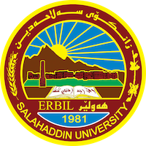
Academic Curriculum Vitae
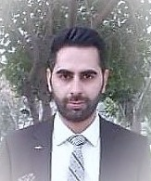
Personal Information:
Full Name: Mohammed Hussein Rassul
Academic Title: Asst. Lecturer
Email: (mohammed.rassul@su.edu.krd)
Mobile: 0750 654 5210

Education:
- Bachelor Degree in English Language-College of Education-2012
- Master’s Degree in English Language and Applied Linguistics-2017

Employment:
- As a teacher- Ministry of Education-2012
- University Teacher-Salahaddin University-2017-Present

Qualifications
- Bachelor Degree in English Language
- Master’s Degree in English Language & Applied Linguistics
- Language Qualification-Kurdistan University
- Diploma in Teaching-2017
- British TESOL Certificate-Imperial College

Teaching experience:
- I have taught many different subjects at Salahaddin University-College of Arts including; General English, Reading Comprehension, Phonetics & Phonology, Teaching Grammar & Vocabulary, Grammar, Translation Theories, Translation Principles, Kurdish to English Translation.
- Delivered lectures at Salahaddin university language center for over (6) years., and etc.,

Research and publications
- Third Stage Students’ Difficulties in Translating Idiomatic Expressions: An Analytical Study
- Handling Students’ Disruptive Behaviour in Language Study Classroom: A Descriptive Analytical Study
- Teaching English Language to Young Students through Animated Videos as an Online Learning Media
- Agricultural Land Loss and Urban Expansion in the Sulaimanyiah Zone: A Remote Sensing and Geographic Information System Based Study
- Third Stage Student’s Lexical Collocation Errors in Academic Writing: An Analytical Study

Conferences and courses attended
- College of Arts Conference
- International Conference between Fredrick Alexander & Salahaddin University

Funding and academic awards
- No

Professional memberships
- Member in Kurdistan “Translators Without Borders” Association
- Member in MESPO Organization
- Member in Postcards for Peace Organization

Professional Social Network Accounts:

- LinkedIn
- Facebook
- Twitter
- Research Gate
- Google Scholar

It is also recommended to create an academic cover letter for your CV, for further information about the cover letter, please visit below link:
https://career-advice.jobs.ac.uk/cv-and-cover-letter-advice/academic-cover-letter/

