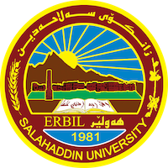
Academic Curriculum Vitae
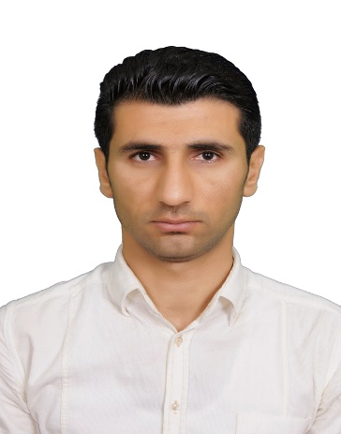
Personal Information:
Full Name: Mohammed Najat Sofi
Academic Title: Asst. Lecturer
Email: mohammed.sofi@su.edu.krd
Mobile: 00964750 4778122

Education:
- 2014-2017: (M.Sc. in Fish Production). Effect of Optifeed® as a Natural Feed Additive on Growth, Feed Utilization and Blood Parameters of Common Carp (Cyprinus carpio). Fish Resources and Aquatic Animals Department, College of Agricultural Engineering Sciences, University of Salahaddin.
- 2008-2012: (B.Sc. in Animal Resources). Department of Animal Resources, College of Agricultural Engineering Sciences, University of Salahaddin.

Employment:
- 2021-2023 . Assist. Lecture of Fish Production/ Department of Fish Resources and Aquatic Animals/ college of Agricultural Engineering Sciences / University of Salahaddin, Erbil, IRAQ.

Qualifications
- Teaching qualifications
- IT qualifications (ICDL) certificate
- Language qualifications such Language center and IELTS or any equivalent
Teaching experience:
- Fish Production
- Fish Nutrition
- Aquatic Feed and Feeding
Research and publications
Conferences and courses attended

Professional memberships
Membership of Kurdistan Agronomist Syndicate. Teachers of Kurdistan Syndicate.

ORCID ID: 0009-0003-1441-7579
Academic Profile: https://academics.su.edu.krd/profile-admin/index.php?p=dashboard

Scholar Account: https://myaccount.google.com/u/1/?hl=en

