Answer the fowling questions
- The point at which p-type and n-type semiconductors are joined is called … (a) p-n junction (b) semiconductor diode, (c) depletion layer
- …….. is the voltage or electric field build near the p-n junction, which prevents the electric current through the semiconductor. (a) Reverse voltage, (b) Barrier voltage, (c) high resistance.
- …… is the region present near the p-n junction where no mobile charge carriers are present. (a) forward bias, (b) reverse bias, (c) Depletion region
- The process of applying voltage across the p-n junction diode is called (a) biasing of diode. (b) Zener effect, (c) I-V characteristic of diode.
- A p-n junction diode allows electric current only in (a) forward bias, (b) reveres bias , (c) forward and reverse bias.
- Zener diode is a p-n junction diode specially designed for operation in the breakdown region in …… bias condition. (a) regulator, (b) dynamic resistance, (c) reverse.
- The voltage at which the Zener diode breaks down is called the …. voltage. (a) breakdown, (b) Zener, (c) reverse
- When the voltage across the Zener diode exceeds its Zener voltage rating VZ . In ‘on’ state, the voltage across Zener diode remains constant until the voltage across it drops less than VZ . This property of Zener diode makes its use as a (a) voltage regulator, (b) reference voltage, (c) both (a) and (b)
- The breakdown mechanism in a lightly doped p-n junction under reverse biased condition is (a) Avalanche breakdown (b) Zener breakdown (c) non of these
- The breakdown mechanism in a highly doped p-n junction under reverse biased condition is (a) Avalanche breakdown , (b) Zener breakdown, (c) non of these
- The resistance offered by a p-n junction diode to the changing forward current is defined as the (a) forward resistance, Ohmic resistance, (c) dynamic resistance.
- the ratio of the diode voltage and current at the point of interest and is not sensitive to the shape of the V-I characteristic curve is the (a) static or dc resistance, (b) dynamic resistance, (c) none of these
- the peak value of the output waveform in the following circuit is (a) 15 V , (b) 25 V , (c) –25 V,
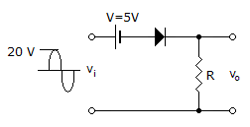
- The peak for both half cycles of the output waveform of the following circuit is (a) 16 V, –4 V , (b)16 V, 4 V ,(c) –16 V, 4 V,
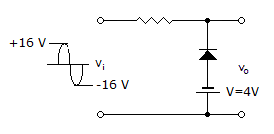
- the peak inverse voltage (PIV rating) for the 1N4007 rectifier diode is (a) 0.7V, (b) 1000V, (c) 2000V
- The type of diode circuit is used to add or restore a dc level to an electrical signal is called (a) clipper or limiter,(b) clamper , (c) R-C filter network.
- the current level of the following circuit is (a) 0A, (b) 4.76mA, (c )5mA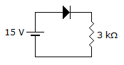
- If the ac supply is 50 Hz, Then the be the ripple frequency out of the full-wave rectifier is (a) 50 Hz , (b) 100Hz, (c) 0Hz
- The following circuit is (a) Half-wave rectifier, (b) Clipper, (c) Clamper
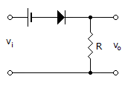
- For the following circuit the value of the load resistor R_{L}is (a) 5 k , (b) 5.5 k , (c) None of these
