Kurdistan Region-Iraq
Ministry of higher Education scientific Research
University of salahaddin
College of Education
Department of physics

Determination the Temperature of Black Body from Its Spectrum.

Prepared by :
Frmesk Faisal Rasul
Supervised by :
Dr. Muhamad Abdullah Hamad

This research project is submitted to University of Salahaddin as a
Partial fulfillment for bachelor degree of science in physics

April 2024

Supervisor Certificate

This research project has been written under my supervision and has been submitted for the award of the degree of BSc. in (Physics).

Signature
Name: Assistant Professor Dr.Muhamad A.Hamad
/4 /2024

I confirm that all requirements have been completed.

Signature:
Name:
Head of the Department of . . . . . .
Date /

Acknowledgements …..

First and foremost, I would want to thank Allah, the Ever-Magnificent, the Ever-Grateful, for His favor and assistance. I also want to thank the physics department at the college of education, Salahaddin University, and all of the resources that helped make this research possible. I also want to express my gratitude to Dr. Muhammad Abdullah Hamad, my supervisor, for all of his help and advice during this project. Lastly, I would want to thank all of the people who have helped me in my work and helped me develop as a research scientist. I would like to take this time to thank all of my close friends from the bottom of my heart. In addition, I would like to sincerely thank my family for their steadfast support during the course.

Contents:

Title ……………..…………………………………………………...
Acknowledgment……………………………………………………..III
Table of content……………………………………………………… IV
ABSTRACT…………………………………………………………..1
Introduction……………………………………………………………2
Theory…………………………………………………………………6
Results and Discussion………………………………………………...12
Conclusion……………………………………………………………..20
Reference……………………………………………………………....21

Abstract
A body that absorbs all radiation that is incident upon it is called a blackbody. This body will produce radiation at the same rate that it receives radiation from the surrounding medium when it is in equilibrium. A blackbody may also be referred to as a "complete absorber" at times.
Temperature and wavelength affect the energy that is radiated. The total quantity of energy (area under the curve) that the blackbody emits grows with temperature. Additionally, the distribution's peak changes to shorter wavelengths as temperature rises. The following connection, known as Wien's displacement law, is followed by this shift. T = 0.2898X102m.k λmax
Finding the wavelength that corresponds to the maximum in the intensity versus wavelength curve is the first step towards determining a star's surface temperature. Currently, the relationship between the temperature of hot objects and their spectrum studied.

Chapter One: Introduction
1.1- INTRODUCTION
The thermal electromagnetic radiation emanating from a black body, which is an opaque and non-reflective body, or from a body in thermodynamic equilibrium with its surroundings is known as radiation from the black-body. Its particular spectrum and intensity are only dependent on the body's temperature, which is taken to be uniform and constant for theoretical and computational purposes.(Shu-Kun, 1999) Black-body radiation is an approximation of the thermal radiation that many common things spontaneously generate. Black-body radiation is contained in a completely insulated container in thermal equilibrium, and it will escape through a hole drilled in its wall if the hole is small enough to not significantly affect the equilibrium.
Since the majority of the radiation emitted by a black body at ambient temperature is infra-red, which the human eye is unable to detect, the body appears black. A black body appears subjectively grey when viewed in the dark at the lowest temperature at which light is only slightly visible. This is because the human eye is only sensitive to black and white at very low intensities; in reality, the visible light's frequency would still be red, even though its intensity would be too low to be perceived as red, even though the black body's objective physical spectrum peaks in the infrared range. (Partington, 1949) When it becomes a little hotter, it appears dull red. As its temperature increases further it eventually becomes blue-white.
Although planets and stars are neither in thermal equilibrium with their surroundings nor perfect black bodies, black-body radiation is used as a first approximation for the energy they emit. Black holes are near-perfect black bodies, in the sense that they absorb all the radiation that falls on them. It has been proposed that they emit black-body radiation (called Hawking radiation), with a temperature that depends on the mass of the black hole. (Zele et al., 2003)
Black-body radiation has a characteristic, continuous frequency spectrum that depends only on the body's temperature, (Kogure and Leung, 2007). called the Planck spectrum or Planck's law. The spectrum is peaked at a characteristic frequency that shifts to higher frequencies with increasing temperature, and at room temperature most of the emission is in the infrared region of the electromagnetic spectrum.(Wien, 1893) As the temperature increases past about 500 degrees Celsius, black bodies start to emit significant amounts of visible light. Viewed in the dark by the human eye, the first faint glow appears as a "ghostly" grey (the visible light is actually red, but low intensity light activates only the eye's grey-level sensors). With rising temperature, the glow becomes visible even when there is some background surrounding light: first as a dull red, then yellow, and eventually a "dazzling bluish-white" as the temperature rises(Partington, 1949). When the body appears white, it is emitting a substantial fraction of its energy as ultraviolet radiation. The Sun, with an effective temperature of approximately 5800 K. is an approximate black body with an emission spectrum peaked in the central, yellow-green part of the visible spectrum, but with significant power in the ultraviolet as well.
Black-body radiation provides insight into the thermodynamic equilibrium state of cavity radiation. If each Fourier mode of the equilibrium radiation in an otherwise empty cavity with perfectly reflective walls is considered as a degree of freedom capable of exchanging energy, then, according to the equipartition theorem of classical physics, there would be an equal amount of energy in each mode. Since there are an infinite number of modes this implies infinite heat capacity (infinite energy at any non-zero temperature), as well as an unphysical spectrum of emitted radiation that grows without bound with increasing frequency, a problem known as the ultraviolet catastrophe. Instead, in quantum theory the occupation numbers of the modes are quantized, cutting off the spectrum at high frequency in agreement with experimental observation and resolving the catastrophe. The study of the laws of black bodies and the failure of classical physics to describe them helped establish the foundations of quantum mechanics.
All normal matter emits electromagnetic radiation when it has a temperature above absolute zero. The radiation represents a conversion of a body's thermal energy into electromagnetic energy, and is therefore called thermal radiation. It is a spontaneous process of radiative distribution of entropy.
Conversely all normal matter absorbs electromagnetic radiation to some degree. An object that absorbs all radiation falling on it, at all wavelengths, is called a black body. When a black body is at a uniform temperature, its emission has a characteristic frequency distribution that depends on the temperature. Its emission is called black-body radiation.
The concept of the black body is an idealization, as perfect black bodies do not exist in nature(Tiwari et al., 2018).
Graphite and lamp black, with emissivity’s greater than 0.95, however, are good approximations to a black material. Experimentally, black-body radiation may be established best as the ultimately stable steady state equilibrium radiation in a cavity in a rigid body, at a uniform temperature, that is entirely opaque and is only partly reflective. A closed box of graphite walls at a constant temperature with a small hole on one side produces a good approximation to ideal black-body radiation emanating from the opening. In equilibrium, for each frequency the total intensity of radiation that is emitted and reflected from a body is determined solely by the equilibrium temperature, and does not depend upon the shape, material or structure of the body (Tiwari et al., 2018).
For a black body (a perfect absorber) there is no reflected radiation, and so the spectral radiance is due entirely to emission. In addition, a black body is a diffuse emitter (its emission is independent of direction). Consequently, black-body radiation may be viewed as the radiation from a black body at thermal equilibrium. When the body is black, the absorption is obvious: the amount of light absorbed is all the light that hits the surface. For a black body much bigger than the wavelength, the light energy absorbed at any wavelength λ per unit time is strictly proportional to the black-body curve. This means that the black-body curve is the amount of light energy emitted by a black body, which justifies the name. This is the condition for the applicability of Kirchhoff's law of thermal radiation: the black-body curve is characteristic of thermal light, which depends only on the temperature of the walls of the cavity, provided that the walls of the cavity are completely opaque and are not very reflective, and that the cavity is in thermodynamic equilibrium. When the black body is small, so that its size is comparable to the wavelength of light, the absorption is modified, because a small object is not an efficient absorber of light of long wavelength, but the principle of strict equality of emission and absorption is always upheld in a condition of thermodynamic equilibrium.(Yang and Wei, 2016)
Calculating the black-body curve was a major challenge in theoretical physics during the late nineteenth century. The problem was solved in 1901 by Max Planck in the formalism now known as Planck's law of black-body radiation. By making changes to Wien's radiation law (not to be confused with Wien's displacement law) consistent with thermodynamics and electromagnetism, he found a mathematical expression fitting the experimental data satisfactorily. Planck had to assume that the energy of the oscillators in the cavity was quantized, i.e., it existed in integer multiples of some quantity. Einstein built on this idea and proposed the quantization of electromagnetic radiation itself in 1905 to explain the photoelectric effect. These theoretical advances eventually resulted in the principal of classical electromagnetism by quantum electrodynamics. These quanta were called photons and the black-body cavity was thought of as containing a gas of photons. In addition, it led to the development of quantum probability distributions, called Fermi–Dirac statistics and Bose–Einstein statistics, each applicable to a different class of particles, fermions and bosons.
The wavelength at which the radiation is strongest is given by Wien's displacement law, and the overall power emitted per unit area is given by the Stefan–Boltzmann law. So, as temperature increases, the glow color changes from red to yellow to white to blue. Even as the peak wavelength moves into the ultra-violet, enough radiation continues to be emitted in the blue wavelengths that the body will continue to appear blue. It will never become invisible—indeed, the radiation of visible light increases monotonically with temperature (Yang and Wei, 2016)

Chapter Two: THEORY
All bodies emit and absorb radiation. (Recall that radiation is heat transfer by electromagnetic waves.) The Stefan-Boltzmann law showed that the amount of energy radiated is proportional to the fourth power of the temperature, but did not say how the heat radiated was a function of the wavelength of the radiation.
Because the radiation consists of electromagnetic waves, we would expect that the energy should be distributed evenly among all possible wavelengths. However, the energy distribution is not even but varies according to wavelength and frequency. All attempts to account for the energy distribution by classical means failed.
Let us consider for a moment how a body can radiate energy. We know that an oscillating electric charge generates an electromagnetic wave. A body can be considered to be composed of a large number of atoms in a lattice structure as shown in figure 1(a). For a metallic material the positively ionized atom is located at the lattice site and the outermost electron of the atom moves throughout the lattice as part of the electron gas.
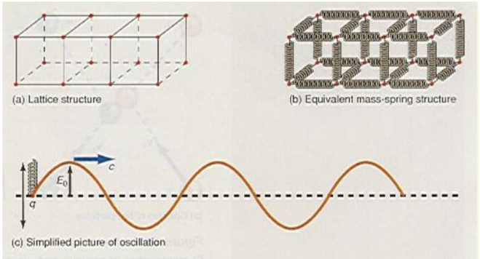

Figure (1) A solid body emits electromagnetic radiation.
Each atom of the lattice is in a state of equilibrium under the action of all the forces from all its neighboring atoms. The atom is free to vibrate about this equilibrium position. A mechanical analogue to the lattice structure is shown in figure 1(b) as a series of masses connected by springs. Each mass can oscillate about its equilibrium position. To simplify the picture further, let us consider a single ionized atom with a charge q and let it oscillate in simple harmonic motion, as shown in figure1(c). The oscillating charge generates an electromagnetic wave that is emitted by the body. Each ionized atom is an oscillator and each has its own fixed frequency and emits radiation of this frequency. Because the body is made up of millions of these oscillating charges, the body always emits radiation of all these different frequencies, and hence the emission spectrum should be continuous.(Evans et al., 2023)
The intensity of the radiation depends on the amplitude of the oscillation. As you recall from general physics, a typical radiated wave is given by
E = Eo sin (kx -ωt) ………… 1
Where k=2π/λ and ω= 2πυ
Thus, the frequency of the oscillating charge is the frequency of the electromagnetic
wave. The amplitude of the wave $E_{O}$ depends on the amplitude of the simple harmonic motion of the oscillating charge. When the body is heated, the heat energy causes the ionized atoms to vibrate with greater amplitude about their equilibrium position. The energy density of the emitted waves is given by:
𝑢=$ε_{O}E^{2}$ ……………………….. 2
Or $u=ϵ_{o}E_{o}^{2} \sin^{2}\left(kx-wt\right)$ ……….……..3
Thus, when the amplitude of the oscillation Eo increases, more energy is emitted.
When the hot body is left to itself it loses energy to the environment by this radiation process and the amplitude of the oscillation decreases.
The amplitude of the oscillation determines the energy of the electromagnetic wave.
Because of the extremely large number of ionized atoms in the lattice structure that can participate
in the oscillations, all modes of vibration of the lattice structure are possible and hence all possible frequencies are present.
Thus, the classical picture of blackbody radiation permits all frequencies and energies for the electromagnetic waves. However, this classical picture does not agree with experiment.(Yang and Wei, 2016)
The radiated energy varies with wavelength and temperature. As the temperature of
the blackbody increases, the total amount of energy (area under the curve) it emits increases. Also, with increasing temperature, the peak of the distribution shifts to
shorter wavelengths. This shift obeys the following relationship, called Wien’s displacement law
𝜆_{𝑚𝑎𝑥}𝑇 = 0.2898𝑥10⁻² 𝑚.𝑘 ………….. .……….. 4
Where is the wavelength at which the curve peaks and T is the absolute temperature of the object emitting the radiation.
A hotter star has a radiation curve more like the upper curve in Active Figure2. In this case the star emits significant radiation throughout the visible range, and the combination of all colors causes the star to look white. Such is the case with our own Sun, with a surface temperature of 5 800 K. For much hotter stars, the peak can be shifted so far below the visible range that significantly more blue radiation is emitted than red, so the star appears bluish in color. Stars cooler
than the Sun tend to have orange or red colors. The surface temperature of a star can be obtained by first finding the wavelength corresponding to the maximum in the intensity versus wavelength curve, then substituting that wavelength into Wien’s law.
For example, if the wavelength were 2.30 x10⁻⁷m, the surface temperature would be given by
T= 0.2898𝑥10−2𝑚.𝑘/𝜆𝑚𝑎𝑥
=0.2898𝑥 ${10}^{-2}$𝑚.𝑘/2.3𝑥${10}^{-7}$𝑚
= 1.26𝑥${10}^{4}$𝑘
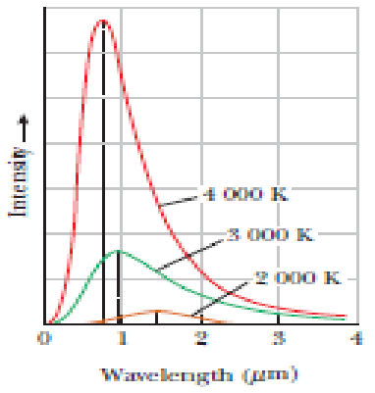
Figure(2): Intensity of blackbody radiation versus wavelength at three different
temperatures.
Note that the total radiation emitted (the area under a curve) increases with increasing temperature.
Attempts to use classical ideas to explain the shapes of the curves shown in Figure(2) failed.
Figure(3) shows an experimental plot of the blackbody radiation spectrum (red curve), together with the theoretical picture of what this curve should look like based on classical theories (blue curve).
According to Rayleigh- Jeans law the emitted energy from the black body can be calculated as:
𝑈𝜗=2$c$𝐾𝑇/${}^{4}$ ( 5)
According to the above equation the black body emit the energy continuously and at long wavelengths, classical theory is in good agreement with the experimental data. At short wavelengths, however, major disagreement exists between classical theory and experiment.
As lambda approaches zero, classical theory erroneously predicts that the intensity should go to infinity, when the experimental data show it should approach zero and called ultraviolet catastrophe

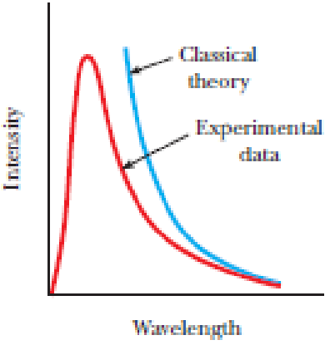
Figure 3: Comparison of experimental data with the classical theory of blackbody
radiation.
Planck’s theory matches the experimental data perfect. The total power density from a blackbody is determined by integrating the spectral irradiance over all wavelengths which gives:
U=εσT4 ……………………. 6
where σ is the Stefan-Boltzmann constant experimentally measured to be 5.6705 ×10⁻⁸W / ($m^{2}.k^{4}$) and T is the temperature of the blackbody in kelvin.
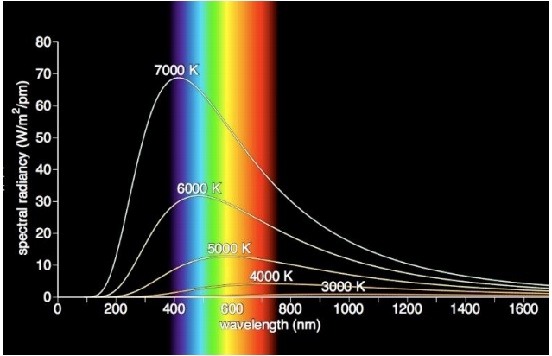
Figure (4):Emitted spectrum of the black body in different temperature.
The emissivity (ε = 1 for an idealized blackbody) is simply the ratio of the emissive power of an object to that of an ideal blackbody and is always less than 1.
Max Planck (1858-1947), a German physicist, tried to “fit” the experimental results to the theory, and the emitted energy is equal to:
𝑈𝜗=2ℎ𝜗3/𝐶2 1/(𝑒^{ℎ𝜗/𝐾𝑇}−1) ……… 7
At small frequency 1/𝑒^{ℎ𝜗/𝐾𝑇}−1=𝐾𝑇/ℎ𝜗
Then Planck relation reduce to the classical theory, but at high frequency emitted energy go to zero. However, he found that he had to break with tradition and propose a new and revolutionary concept. Planck assumed that the atomic oscillators cannot take on all possible energies, but could only oscillate with certain discrete amounts of energy given by
E = nhυ ………………….. 8
where h is a constant, now called Planck’s constant, and has the value h = 6.625 x 10-34 J s
In equation 8 υ is the frequency of the oscillator and n is an integer, a number, now called a quantum number. The energies of the vibrating atom are now said to be quantized, or limited to only those values given by equation 8 Hence, the atom can have energies hυ, 2hυ, 3hυ, and so on, but never an energy such as 2.5 hυ. This concept of quantization is at complete variance with classical electromagnetic theory.(Ariwahjoedi et al., 2023)
In the classical theory, as the oscillating charge radiates energy it loses
energy and the amplitude of the oscillation decreases continuously. If the energy of the oscillator is quantized, the amplitude cannot decrease continuously and hence the oscillating charge cannot radiate while it is in this quantum state.
If the oscillator now drops down in energy one quantum state, the difference in energy between the two states is now available to be radiated away. Hence, the assumption of discrete energy states entails that the radiation process can only occur when the oscillator jumps from one quantized energy state to another quantized energy state.
As an example, if the oscillating charge is in the quantum state 4 it has an energy, E₄=4hυ
When the oscillator drops to the quantum state 3 it has the energy, E₃=3hυ
When the oscillator drops from the 4 state to the 3 state it can emit the energy
ΔE = E₄ - E₃ = 4hυ - 3hυ = hυ
Thus, the amount of energy radiated is always in small bundles of energy of amount
hυ. This little bundle of radiated electromagnetic energy was called a quantum of energy. Much later, this bundle of electromagnetic energy came to be called a photon.
Although Planck started what would be eventually called quantum mechanics, and
won the Nobel Prize for his work, he spent many years trying to disprove his own theory.

Chapter Three: RESULTS AND DISCUTION

3.1- Star’s color
The color of stars according to their class codes are as follows:
Class (G) having a yellow as a conventional color it mean that their (λ_{max}) in their spectrum is at yellow region or at (570-590nm) therefore according to Wiens formula (λ_{max}T=0.2898X10⁻²m.k) its surface temperature is (5200-6000k) and For (K) having orange as a conventional color it mean that their (λ_{max}) in their spectrum is at orange region or at (590-620nm) therefore according to Wiens formula (λ _{max}T=0.2898 X10²m.k) its surface temperature is (3700-5200k) and For (M) having a red as a conventional color it mean that their (λ_{max}) in their spectrum is at red region or at (620-750nm) therefore according to Wiens formula (λ_{max}T=0.2898X10²m.k) its surface temperature is (2000-3700k)
T=4000K
3.2- Determine the surface temperatures of stars.
The star looks a little bit redder than the Sun so its surface temperature must be less than 5800K".
Disperse the light from a star ("take a spectrum"), find the wavelength at which you have the most radiation, then apply Wien's Law. Wien's Law lets us quantify the color-temperature relationship but Wien's Law gives temperatures for objects with Planck-like spectra. Stars don't quite have Planck spectra because of the absorption lines, flux redistribution and other complications like that.
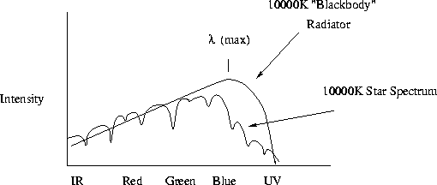

Fig.(5)
The spectrum of a star is not quite a Planck spectrum. One of the two ways it is really done - measure colors: The basic idea - for Planck spectra (from solid objects), the ratio of the light in two different color filters unambiguously gives the temperature of the objects. The relationship between color and surface temperature is just a little more complicated however and needs to be calibrated using computer models.

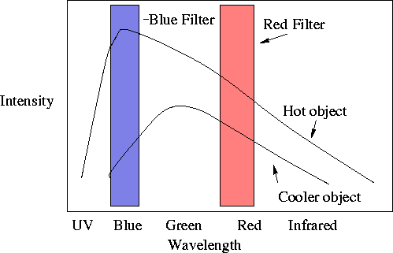
Fig.(6)
Cooler objects will have redder colors. So, at the simplest level we can simply sort them out by color with the red stars being the coolest and the blue stars being the hottest. To the extent that Stellar spectra look like blackbodies, the temperature of a star can also be measured amazingly accurately by recording the brightness in two different filters.(Evans et al., 2023)
3.3- stellar temperature:
Measure the brightness of a star through two filters and compare the ratio of red to blue light.
Compare to the spectra of computer models of stellar spectra of different temperature and develop an accurate color-temperature relation.
Besides the fact that the spectra of stars are not quite Plank spectra, there is another problem which is that there is stuff between the stars. This stuff is dust and it has properties similar to the upper atmosphere of the Earth - Blue light is more effectively scattered than Red light. This is called "interstellar reddening". So...
Most stars appear redder than they really are. This means that if we use colors to estimate temperatures, then we will always measure stars to be cooler than their real temperatures.
Stars of a given Luminosity appear weaker than you would calculate given the distance and inverse square law, these things lead to all sorts of confusion.

3.4- Spectral Types
A long time ago, astronomers recognized that different stars had dramatically different absorption lines in their spectra. Some had strong absorption lines due to Hydrogen and little else, some had no Hydrogen lines and many lines due to Iron, Calcium and other elements. The different spectral types were assigned letters with type "A" having the strongest Hydrogen absorption lines, type "B" the next strongest, and so on down the alphabet (skipping lots of letters for various reasons).
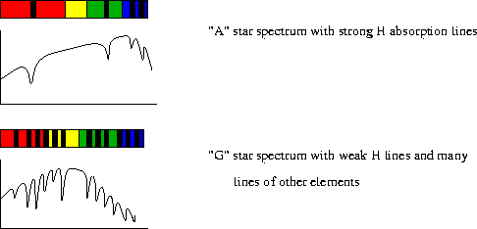

Fig(7)
One could conclude that these stars had different chemical compositions, but the strong correlations between the presence of various lines and a star's color suggested by Atomic physics.
3.4.1- Here's how it works:
Think about the absorption lines caused when a gas of Hydrogen atoms absorbs photons with an energy that corresponds to an electron jumping from the 1st excited state to the 2nd excited state in the H atom. This photon has a wavelength of 636.5 nm.
For this to happen, there must be some H atoms in the gas with their electrons in the 1st excited state.
3.4.2- Suppose we are talking about the atmosphere of a star.
For stars with low surface temperatures, the atoms and molecules in the atmosphere are on average not flying around as fast as in a hotter gas. This means:
There will be fewer energetic collision between atoms that could knock electrons into excited states and essentially all the H atoms have their electrons in the ground state so even if there are many H atoms, there will be no tell-tale absorptions at 636.5nm.
For stars with high surface temperature, the atoms in the atmosphere are flying around very quickly.
Now there are many energetic collisions but a large fraction of the H atoms are ionized with no chance of producing absorption lines. Or, for stars with just the right surface temperature such that collisions continuously populate the 1st excited state with electrons, there will be LOTS of photons caught that bump the electrons to the 2nd excited level and there will be strong H-absorption lines.
- So a lack of hydrogen absorption lines in a star does not necessarily mean the star's atmosphere is devoid of Hydrogen, it could also mean that the star has a low or very high surface temperature.
- These temperature effects are far and away the most important things when determining spectral types. This can be turned around and we can use spectral types to assign surface temperatures for stars.
- One very nice thing about the spectral type of a star is that the spectral type doesn't change as you add more and more dust between the Earth and a star.
Suppose you measure two stars with identical Spectral Type but Star X is much redder than Star Z. What do you conclude? The colors of Star X have been strongly affected by interstellar reddening.
Once it was recognized that differences in spectral type were due mostly to differences in temperatures of the stars the spectral sequence was reordered by temperature. This has led to lots of dumb reminder devices to remember the following sequence:
3.4.3- Spectral type and distance
Now we can see how to extend the distance ranking to beyond the ~100 parsecs that we get from Trigonometric parallax. This is a technique called Spectroscopic Parallax.
Take a spectrum of a star.
Find the closest match in spectral type among the nearby stars.
Assume that the nearby and distant object are the same sort of star, specifically the same Luminosity.
Now compare the apparent brightness and luminosity, apply the inverse square law and you have the distance.
Hold it! What about dust? If the distant star has a redder color than its nearby spectral-type match, the color difference tells you how much dust there is along the line-of-sight and we can calculate how much of the lowering is due to dust and how much is due to distance.
The Radiance of different temperatures for hot objects calculated theoretically , for this purpose a matlab code written and used for this calculation and the output results shown in table (1)

Table (1): Radiance spectrum against wavelength for different temperatures

 | T=3000k | T=4000K | T=5000K | T=6000K
Wavelength | _{Radiance}  _{(wm^2/pm)} | _{Radiance}  _{(wm^2/pm)} | _{Radiance}  _{(wm^2/pm)} | _{Radiance}  _{(wm^2/pm)}
350 | 0.000178 | 3.53E-05 | 0.002692 | 0.022891
400 | 0.00104 | 0.000239 | 0.012313 | 0.086443
450 | 0.001112 | 0.00289 | 0.032615 | 0.158776
500 | 0.003103 | 0.0064 | 0.061098 | 0.255864
550 | 0.004297 | 0.013084 | 0.081859 | 0.307573
600 | 0.005612 | 0.018724 | 0.106525 | 0.331142
650 | 0.006739 | 0.028725 | 0.122848 | 0.31273
700 | 0.00611 | 0.029714 | 0.130868 | 0.311958
750 | 0.008577 | 0.04039 | 0.131976 | 0.282002
800 | 0.00912 | 0.041272 | 0.111504 | 0.273077
850 | 0.009306 | 0.042227 | 0.121953 | 0.244305
900 | 0.008450 | 0.041255 | 0.107672 | 0.205998
950 | 0.009341 | 0.039925 | 0.101822 | 0.183759
1000 | 0.009963 | 0.042343 | 0.094687 | 0.164813
1050 | 0.010105 | 0.038915 | 0.085441 | 0.151979
1100 | 0.01009 | 0.034314 | 0.07818 | 0.139279
1150 | 0.008711 | 0.034745 | 0.073397 | 0.117549
1200 | 0.008718 | 0.030577 | 0.061539 | 0.107748
1250 | 0.00963 | 0.028933 | 0.059259 | 0.095356
1300 | 0.006094 | 0.026229 | 0.053882 | 0.080966
1350 | 0.010192 | 0.024218 | 0.048328 | 0.075264
1400 | 0.007595 | 0.021643 | 0.045597 | 0.065613
1450 | 0.007832 | 0.025758 | 0.040407 | 0.06398
1500 | 0.00524 | 0.021662 | 0.034091 | 0.054382
1550 | 0.005707 | 0.018764 | 0.029436 | 0.052495
1600 | 0.005739 | 0.015094 | 0.032877 | 0.04327
1650 | 0.005926 | 0.015207 | 0.026234 | 0.040566
1700 | 0.004246 | 0.014461 | 0.024958 | 0.035684
1750 | 0.005323 | 0.014588 | 0.023587 | 0.028968

Relation of the radiance of the object against the emitted wavelength plotted as shown in fig.(8-11).
Figure(8): relation of radiated energy with the emitted wavelength for (T=3000K)

When the temperature is (3000k), the maximum wavelength is (1350nm) and radiation is (0.010192wm²/pm) and the maximum wavelength gets smaller compared to (2000k), which makes the color shift towards blue. Also the area under the curve becomes wider. At such temperature still most of the radiation is at infrared range, and a portion of the radiation is emitted as visible light, while only a narrow amount is emitted as UV light.

Figure(9): relation of radiated energy with the emitted wavelength for (T=4000K)

When the temperature is (4000 k), the maximum wavelength is (850 nm) and radiation intensity is (0.042343wm²/pm) at such temperature the maximum wavelength becomes shorter compared to the maximum wavelength at temperature at (3000 k), the area under the curve shifts towards shorter wavelength. At such temperature most of the radiation emitted is at infrared and visible light, and a small portion is at UV range.

Figure(10): relation of radiated energy with the emitted wavelength for (T=5000K)

When the temperature is (5000 k), the maximum wavelength is (600 nm) and radiation intensity is (0.131976wm²/pm) at such temperature the maximum wavelength becomes shorter compared to the maximum wavelength at temperature at (4000 k), the area under the curve shifts towards shorter wavelength. At such temperature most of the radiation emitted is at visible light, while less at infrared and UV range.

Figure(11): relation of radiated energy with the emitted wavelength for (T=6000K)
When the temperature is (6000 k), the maximum wavelength is (450 nm) and radiation intensity is (0.331142wm²/pm) at such temperature the maximum wavelength becomes shorter compared to the maximum wavelength at temperature at (5000 k), the area under the curve shifts towards shorter wavelength. At such temperature most of the radiation emitted is as UV light, and the visible color is shifted toward blue and white while a narrow range is emitted as infrared.
T=6000K
Figure(12) relation of radiated energy with the emitted wavelength for (T=6000K, 5000K, 4000K, 3000K)
This graph clearly shows the relation between wavelength and radiation intensity of a blackbody at different temperatures.

4. CONCLUTION

From results of the present work one can conclude that at higher temperatures the area under the curve became greater and then the radiation intensity rises. Also increase temperature cause to shifting the wavelength belong to the maximum intensity towards shorter wavelength, and the maximum wavelengths become shorter and shorter, also the color shifts toward blue then white and finally toward UV light. This shifting towards blue noted in color of stars.
From results of the present work seems that one can compute the surface temperature of any star from its spectrum

5. References

ARIWAHJOEDI, S., SALIM ADAM, A., LUTHFAN PRIHADI, H. & ZEN, F. 2023. Black-Body Radiation in a Uniformly Accelerated Frame.
EVANS, N. R., FERRARI, M. G., KURASZKIEWICZ, J., SILVERBERG, S., NICHOLS, J., TORRES, G. & FISCHBACH, M. 2023. The Mass–Temperature Relation for B and Early A Stars Based on International Ultraviolet Explorer Spectra of Detached Eclipsing Binaries. The Astronomical Journal, 166, 109.
KOGURE, T. & LEUNG, K.-C. 2007. The Astrophysics of Emission-Line Stars.
PARTINGTON, J. R. 1949. An advanced treatise on physical chemistry. Vol. 1, Fundamental principles. The Properties of gases, London, Longmans, Green & Co. London.
SHU-KUN, L. 1999. Modern Thermodynamics: From Heat Engines to Dissipative Structures. Entropy: International and Interdisciplinary Journal of Entropy and Information Studies, 1.
TIWARI, B. N., HADZIEVA, E. & POGARCIC, I. 2018. Optimized Passive Defense Measures via IR Imaging. Applied System Innovation, 1, 50.
WIEN, W. 1893. Eine neue Beziehung der Strahlung schwarzer Körper zum zweiten Hauptsatz der Wärmetheorie.
YANG, X. & WEI, B. 2016. Exact research on the theory of the blackbody thermal radiation. Scientific Reports, 6, 37214.
ZELE, E. L. S., VANDAELE, P., BOTTELDOOREN, D. & LENAERTS, J. 2003. Implementation and Evaluation of a Course Concept Based on Reusable Learning Objects. Journal of Educational Computing Research - J EDUC COMPUT RES, 28, 355-372.

Appendix I

% Planck2 computes the spectral radiance of an ideal blackbody radiator
% in units of W/m^2/sr/Hz as a function of the frequency in Hz and
% temperature in Kelvin.
%
% The temperature T must be specified as a scalar (single value). The
% frequency nu may be specified as either a scalar or a vector. If nu
% is a vector, the function returns a vector of spectral radiances (one
% for each wavelength). If you want to evaluate the spectral radiance
% at a large number of frequencies, it is far more efficient to create
% a vector of wavelengths and call this function only once rather than
% making a separate call for each wavelength.
%
% Reference: Wikipedia article entitled "Black Body",
% URL= http://en.wikipedia.org/wiki/Black_body_radiation
%
% REVISION HISTORY
%
% Version 2.0, 4-3-2007: Modified code to use the first three terms of
% a Taylor expansion for exp(x)-1 when x is less than 4.9e-6. For
% x < 4.9e-6, the three-term Taylor expansion is more accurate.
%
% Version 1.0, 3-22-2007: Initial version.
%
function specrad= Planck2(nu,T);
c = 299792458; % speed of light in vacuum [m/s]
h = 6.6260693e-34; % Planck's Constant [Joule-seconds= kg*m^2*s^-1]
k = 1.3806505e-23; % Boltzmann Constant [JK^-1= kg*m^2*s^-1*K^-1]
a= 2*h*nu.^3/c^2; b=h*nu/(k*T);
if (b < 4.9e-6)
specrad= a ./ b ./ (1 + 0.5*b);
else
specrad= a ./ (exp(b)-1);
end

