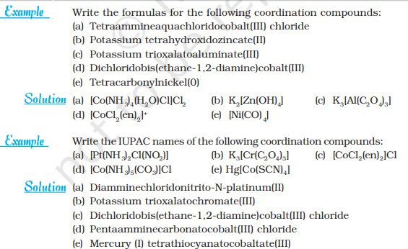

Problems:
(a) What is the systematic name of Na₃[AlF₆]?
(b) What is the systematic name of [CoCl₂(en)₂]NO₃?
(c) What is the formula of tetraammine bromo chloroplatinum(IV) chloride?
(d) What is the formula of hexaamminecobalt(III) hexachloroferrate(III)?
(e) What is the systematic name of Li[AlH₄]?
(f) What is the systematic name of Na₃[Co(NO₂)₆]
1-Give the chemical formula for Hexaaquanickel(ll) aquapentabromochromate(lll).
2-Give the name for [Co(NH₃)₆][CoCl₆].
3-Practice naming some complex compounds:
a-[PtCl₂(NH₃)₂] b-K₂[PtCl₄] c-[Pt(NH₃)₄]²⁺
d-[Pt(NH₃)₃Cl]Cl e-[Ni(CN)₄]²⁻ f- [CoCl₄(NH₃)₂]⁻.
Practice writing the complex compound formulas:
1-Hexaaquochromium(III) chloride.
2-Ammonium diaquatetrachloroaurate(III).
3-Potassium hexacyanoferrate(II).
4-Potassium hexacyanoferrate(III).
5-Lithium tetrahydrido aluminate(III).
6-Sodium hexanitrito Cobaltate(III).
. 7-Potassium tetracyanoaurate(II) ion
Clicker Qstn:
the correct name for the complex Na₂[Ni(CN)₄]
- Disodium tetranickelcyanide.
- Sodium tetracyanidenickel(l).
- Disodium tetracyanonickelo(lV).
- Natrium tetranickel(Vl)cyanide.
- Sodium tetracyanonickelate(ll).
- [Ag(NH₃)₂]Cl or [Ag(NH₃)₂]NO₃.

- In these compounds,
- silver is ____________.
- NH₃ is ______________.
- and Cl⁻ or NO₃⁻ is ____________________.
- C.N. is ____________.
- Ligands are attached by ___________bonds.
- Counterions are attached by _______ bonds.
- 1-[Co₂(CO)₈] 2-[Fe₂(CO)₉] 3-[Cr(C₆H₆)₂]
- 4-[Fe(CO)₂(NO)₂] 5-[PdCl₂(NH₃)₂] 6-[Fe(CN)₆]⁴⁻
- 7-[Cd(CN)₄]²⁻ 8-[Cu(CN)₄]³⁻ 9-K₄[Fe(CN)₆]
- 10-K₃[Fe(CN)₆] 11-[Co(NH₃)₆]³⁺ 12-Na[Fe(CN)₆]
- 13-[CoCl(NH₃)₄(H₂O)]Cl₂ 14-Li[AlH₄] 15-Na₃[Co(NO₂)₆]
- 16-[Ag(NH₃)₂]NO₃ 17-K[Au(CN)₄]⁻ 18-[Ni(CN)₄]²⁻

Q/ write Limitations of Sedgwick theory
Structure of complex compounds based on VBT
- Structure of nickel tetracarbonyl [Ni(CO)₄] .
- Formation of [NiCl₄] ²⁻
- Structure of [Ni(CN)₄]^{2- .}
- Structure of [CoF₆]^{3- .}
- Structure of [Co(NH₃)₆]^{3+ .}
Q/ Draw the electron box diagram, geometrical structure, hybridization and calculate magnetic moment for the following coordination compounds according VBT:
1- [FeF₆]³⁻ 2-[CuCl₅]³⁻ 3-[Co(NH₃)₄(H₂O)Cl]Cl₂
4-Li[AlH₄] 5-Na₃[Co(NO₂)₆] 6-[Ag(NH3)₂]NO
7-K[Au(CN)₄]⁻ 8-[Fe(CN)₆] ⁴⁻ 9-[Cd(CN)₄]²⁻
10-[Cu(CN)₄]³⁻ 11-K₄[Fe(CN)₆] 12-K₃[Fe(CN)₆]

