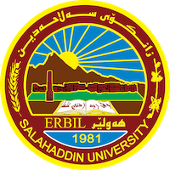

**Academic Curriculum Vitae**

**Personal Information:** 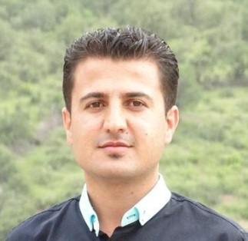

Full Name: Muhammad Hamakharib Muhammad

Academic Title: Lecturer

Email: (university email): Muhammad.muhammad@su.edu.krd

Mobile: 07501110643

**Education:**

* Masters: Islamic Archaeology
* Undergraduate: Archaeology

**Employment:**

* University of Salahadin/ College of Arts/ Archaeology Department

**Qualifications**

* Masters: Archaeology
* Undergraduate: Archaeology

**Teaching experience:**

* General English for university student / Undergraduate
* English Texts/ Undergraduate

**Research and publications**





**Conferences and courses attended**



**Funding and academic awards**

**Professional memberships**

**Professional Social Network Accounts:**

* Research Gate: <https://www.researchgate.net/signup.SignUpPublications.html>
* Google Schooler: https://scholar.google.com/citations?user=eShLUbUAAAAJ&hl=en
* Facebook:
* LinkedIn: <https://www.linkedin.com/onboarding/start/people-you-may-know/new/>