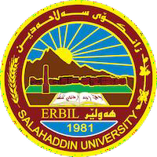
Academic Curriculum Vitae

Personal Information:

Full Name: Mr. Muhammed Zrar Bakir 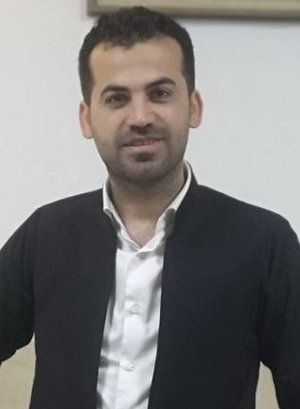
Academic Title: Assistance Lecturer
Email: muhammed.bakir@su.edu.krd Mobile: +964 750 7889848

Education:

- BSc Degree in (Agriculture Sciences/ Plant Protection) with a grade (very good), Salahaddin University - Erbil, College of Agriculture, Iraq, 2011.
- MSc Degree in plant pathology (Plant Protection/ plant pathology) with a grade (Very Good), Salahaddin University- Erbil, College of Agriculture, Iraq, 2017.

Employment:
- Permanent employment at Plant Protection Department, Agriculture College, Salahaddin University – Erbil since 24/11/2011 to date.

Qualifications

Administrative posts
- Manager of gradarasha field from 1/11/2020 to 25/6/2022

Scientific qualifications

Technician lab In the plant protection laboratory from 24/11/2011 to 20/10/2014.

Teaching qualifications
- Teaching methods course for university teachers by the Directorate of Continuing Education (Salahaddin University- Erbil), from 11/2017 to 4/2018 with a grade (Very Good).

IT qualifications
- Computer Proficiency Certificate, 28/2/2012.
- Qualified in Microsoft office.
- Statistic programs.

Language qualifications
- English Language course for six week in International University of Erbil, Level 2 (pre Intermediate), from 2013.
- English Language course for six week in International University of Erbil, Level 3 (Intermediate), from 2013
- English Language course for six week in International University of Erbil, Level 6 (Advanced), from 2013.
- IELTS degree with grade (5) from 2019
- Any professional qualification
- You could put any professional courses you have attended

Teaching experience:

State all teaching courses you delivered, stating undergraduate or post graduate
- Agriculture extension.
- Integrated pest management IPM.
- Seed borne diseases.
- Forest diseases.
- Graduation Research Project (4th stage).
- Seminar (4th stage).

Courses, trainings, lab supervision, etc.,
- Supervised (2) graduation research in the plant protection field (plant disease management) in the BSc level in the Colleges of Agricultural Engineering Sciences.

Research and publications
- Isolation and Identification of Xylella fastidiosa that Cause Oleander Leaf Scorch. Vol. 32, No. 1, pp.102- 109, 2023

Conferences and courses attended:
- The Second Scientific International Conference For Biology And Pure Science 19th 20th October 2022 College of Science University of Mosul
- First International Agri Sciences Conference, College of Agriculture Engineering Sciences, Salahaddin University- Erbil, 6-7/11/2019.
- Participating in Health and Safety course in 2014 in the College of Agriculture .
- Participating in Permaculture course in 2021.

Funding and academic awards:
- List any bursaries, scholarships, travel grants or other sources of funding that you were awarded for research projects or to attend meetings or conferences.

Professional memberships:
- Membership of Kurdistan Syndicate of Agriculture.

Professional Social Network Accounts:
- Research Gate: https://www.researchgate.net/profile/Muhammed-Bakir-3.
- LinkedIn: https://www.linkedin.com/in/muhammed-bakir-71a757241/.
- Google Scholar:
- https://scholar.google.com/citations?hl=en&user=c4_VW5sAAAAJ&citft=1&citft=2&citft=3&email_for_op=muhammed.bakir%40su.edu.krd&scilu=&scisig=AMD79ooAAAAAYqJB5UQkGhLFEyrAIbmCPm0r2E3ALD-v&gmla=AJsN-F4_gY4YYL7JF2vHQy8viDf8SQ3nLS_nNV_hKPUDL2Oqvf8_bUe7bEefQdt1pTk4LtE-zTpUCwVaSilASftvPzbS_h7MAo-S2bLPRf2xcAscf3XQqQc&sciund=6895638865184131669.

