**Blotting Techniques**

* **Blotting** is a technique by which a macromolecule such as DNA, RNA, or protein is resolved in a gel matrix (gel electrophoresis), transferred to a solid support (a carrier) (for example, a nitrocellulose, polyvinylidene fluoride or polyvinylidene difluoride (PVDF) or nylon membrane). After the blotting, the transferred proteins, DNA or RNA are then visualized by colorant staining (for example, silver staining of proteins), autoradiographic visualization of radiolabeled molecules, or specific labelling of some proteins or nucleic acids *i.e.*, detecting with a specific hybridization probe (Separation, Transfer and Hybridization).
* **(Purpose)** These powerful techniques allow the researcher to identify and characterize specific molecules in a complex mixture of related molecules.
* **For example**, identifying and measuring specific **proteins** in complex biological mixtures, such as blood, have long been important goals in scientific and diagnostic practice. More recently the identification of **abnormal genes** in **genomic DNA** has become increasingly important in clinical research and genetic counseling.
* They have been developed to be highly specific and sensitive and have become important tools in both biotechnology and clinical research.
* Some of the more common techniques include **Southern (DNA) blotting (It is used to detect DNA)**, **northern (RNA) blotting (It is used to detect RNA)**, **immunoblotting** (**for protein**; also known as **western blotting**) and **eastern blotting (? Homework).**

**SOUTHERN BLOTTING:**

* The technique was developed by **Edwin Mellor Southern** after publishing a paper describing this technique in 1975.
* The Southern blot is used to detect the presence of a particular piece of DNA in a sample.
* The DNA detected can be a single gene, or it can be part of a larger piece of DNA such as a viral genome.
* **Southern blotting** combines **agarose gel electrophoresis** for size separation of DNA with methods to transfer the size **separated DNA** to a **filter membrane** for **probe hybridization**.
* The key to this method is **Hybridization**.
* **Hybridization** - Process of forming a **double-stranded DNA** molecule between **a single-stranded DNA probe** and **a single-stranded target patient DNA**.
* **Probe** is a nucleic acid that can be labeled with a marker which allows identification and quantitation will hybridize to another nucleic acid on the basis of base complementarity.
* **Types of labels:** Radioactive (32P, 35S, 14C, 3H), Fluorescent, FISH: fluorescent *in situ* hybridization chromosomes and Biotinylated (avidin-streptavidin).

**PRINCIPLE** **OF SOUTHERN BLOTTING**

* 1. The mixture of molecules is separated.
  2. The molecules are immobilized on a matrix.
  3. The probe is added to the matrix to bind to the molecules.
  4. Any unbound probes are then removed.
  5. The place where the probe is connected corresponds to the location of the immobilized target molecule.

**STEPS IN SOUTHERN BLOTTING**

1. Digest the DNA with an appropriate **restriction enzyme**.
2. The complex mixture of fragments is subjected to **gel electrophoresis** to separate the fragments according to size.
3. The **restriction fragments** present in the gel are denatured with alkali and transferred onto a **nitrocellulose filter** or **nylon membrane** or **polyvinylidene fluoride (PVDF) membrane** by blotting. This procedure preserves the distribution of the fragments in the gel, creating a replica of the gel on the filter.
4. The filter is incubated under **hybridization conditions** with a specific **radiolabeled DNA probe**.
5. Excess probe is washed away and the probe bound to the filter is detected by **autoradiography**, which reveals the **DNA fragment** to which the probe hybridized. The **probe** hybridizes to the complementary **DNA restriction fragment**. Figure 1

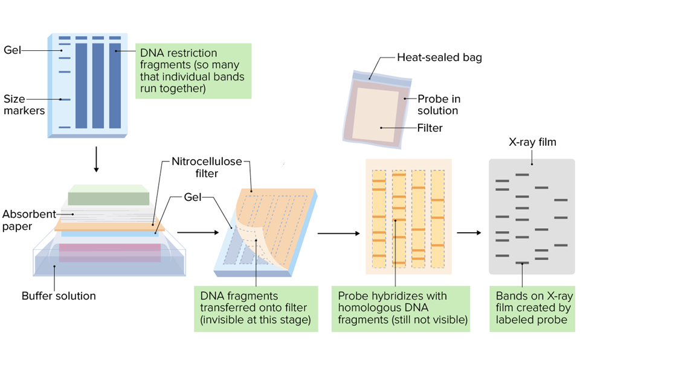

**Figure 1**

**Note: Autoradiography** is a technique using **X- ray film** to visualize molecules or fragments of molecules that have been radioactively labeled. **Autoradiography** has many applications in the laboratory.

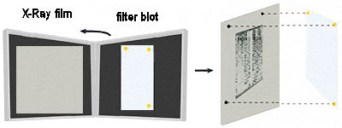

**APPLICATIONS OF SOUTHERN BLOTTING**

* **Southern blots** are used in **gene discovery,** **mapping**, **evolution and development studies**, **diagnostics and forensics** (It is used for **DNA fingerprinting, preparation of RFLP maps**).
* In regards to **genetically modified organisms**, **Southern blotting** is used for testing to ensure that a particular section of **DNA of known genetic sequence** has been successfully incorporated into the genome of the host organism.
* **Identification** of the **transferred genes in transgenic individuals**, etc.

**Northern Blotting**

* **Northern blotting** is a technique for detection of specific **RNA sequences**.
* **Northern blotting** was developed by **James Alwine** and **George Stark** at Stanford University (1979) and was named such by **analogy** to **Southern blotting.**

**Steps involved in Northern blotting**

1. **RNA** is isolated from several biological samples (*e.g.,* various tissues, various developmental stages of same tissue)   
   **\*** **RNA** is more **susceptible** to degradation than DNA.

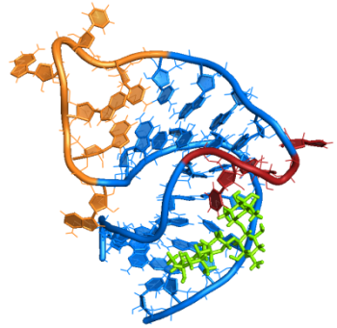

1. Samples are loaded on **gel** and the **RNA samples** are separated according to their size on an **agarose gel.** The resulting gel following after the electrophoresis run.
2. The **gel** is then blotted on a **nylon membrane** or a **nitrocellulose filter paper**/ **diazo benzyloxymethyl papers** by creating the **sandwich arrangement.**
3. The **membrane** is placed in a dish containing **hybridization buffer** with a **labeled probe**. Thus, it will hybridize to the **RNA** on the **blot** that corresponds to the sequence of interest.
4. The **membrane** is washed to remove **unbound probe.**
5. The **labeled probe** is detected via **autoradiography** or via a **chemiluminescence** **reaction** (if a chemically **labeled probe** is used). In both cases this results in the formation of a **dark band** on an **X-ray film**. Figure 2

**\***Now the **expression patterns** of the **sequence of interest** in the different samples can be compared**.**

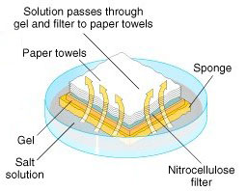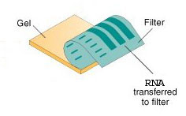

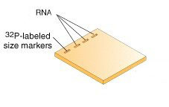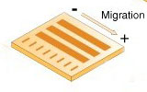

**Step 4 & 5**

**Step 6**

**Step 3**

**Step 1 & 2**

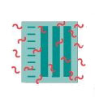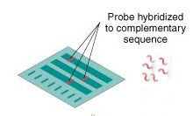

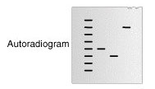

**Figure 2**

**Application of Northern Blotting**

* A standard for **the study of gene expression** at the level of **mRNA** (messenger RNA transcripts).
* Detection of **mRNA transcript** size.
* Study **RNA degradation**.
* Study **RNA splicing**.
* Study **RNA half-life**.
* Often used to confirm and check **transgenic / knockout mice (animals).**

**Disadvantage of Northern Blotting**

1. The standard **northern blot method** is relatively less **sensitive.**
2. **Often radioactivity is used.**
3. **The whole process of northern blotting takes a long time usually, from sample preparation through to detection.**
4. Detection with **multiple probes** is a problem.
5. If **RNA samples** are even slightly degraded by ***RNases,*** the quality of the data and quantitation of expression is quite negatively affected.

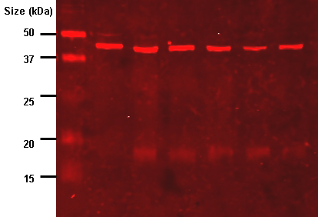

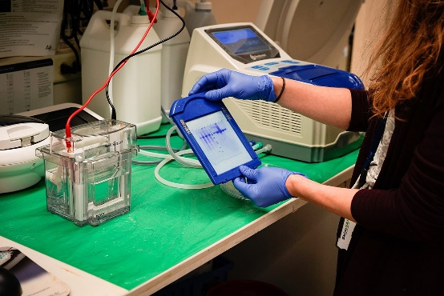

**Western Blotting (Protein Immunoblot)**

* It is a widely used analytical technique in molecular biology and immunogenetics to detect specific proteins in a sample of tissue homogenate or extract.
* **Western blotting** (1981) is an **Immunoblotting technique** which rely on the **specificity** of binding between a **protein** of **interest** and **a probe** (antibody raised against that particular protein) to allow detection of the **protein of interest** in a mixture of many other similar molecules.
* The **SDS PAGE technique** is a prerequisite for **Western blotting.**

**Steps in Western Blotting**

1. A **protein sample** is subjected to electrophoresis on an **SDS-polyacrylamide gel.**
2. **Electroblotting** transfers the separated **proteins** from the gel to the surface of a **nitrocellulose membrane**.
3. **The blot** is incubated with a **generic protein** (such as **milk proteins** or **BSA**) which binds to any remaining sticky places on the **nitrocellulose**.
4. An **antibody** that is specific for the **protein of interest** (**the primary antibody - Ab1**) is added to the **nitrocellulose sheet** and reacts with the antigen. Only the **band** containing the **protein of interest** binds the **antibody**, forming a layer of **antibody molecules.**
5. 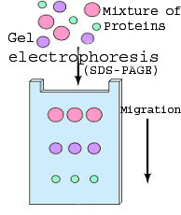After washing for removal of **non-specifically bound Ab1**, **second antibody (Ab2)** is added, which specifically recognizes the **Fc domain** of the **primary antibody** and binds it. **Ab2** is **radioactively labeled**, or is covalently linked to **a reporter enzyme**, which allows to visualize the **protein-Ab1-Ab2 complex**.

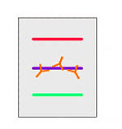

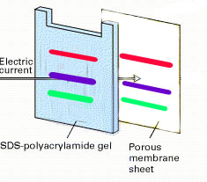

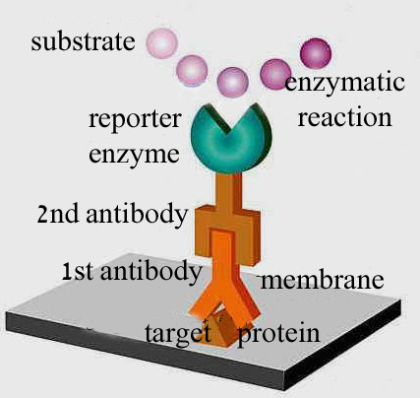



**Figure 3**

**Application of Western Blotting**

1. The confirmatory HIV test employs a Western blot to detect **anti-HIV antibody** in a human serum sample.
2. **Western blot** is also used as the **definitive test** for **Bovine spongiform encephalopathy (**BSE) and some forms of **Lyme disease** testing employ Western blotting.
3. Oncoprotein and Apoptotic protein Detection in Cancer Sample for example triple negative of breast cancer cell lines as shown in following figure 4:

E:\Western Blot Results Repaired data\New folder\Western GraphPad Data\Bax MF MDA MB 468 (R2) - Beta actin new.tif

**Figure 4. Western blot analysis** of **pro-apoptotic Bax protein** in **MDA-MB-468** cells. **MDA-MB-468** cells were treated with IC50 concentration of *F. zagrica* methanol extract and control cells (0.1% DMSO) for indicated times. β-actin was used as loading control. Densitometry analysis **showed time-dependent up-regulation** of **Bax protein**. The expression **of Bax protein** increased as early as 2 hours.