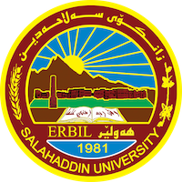
Academic Curriculum Vitae
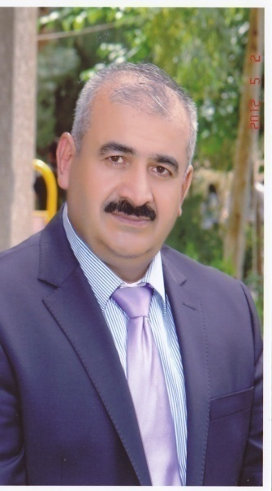
Personal Information:
Full Name: musa muhamad khidir
Academic Title: assistant professor
Email: (musa,khder. @su.edu.krd –musa khidir@yahoo.com
Mobile: 00964 – 750 4458486

Education:
(2005-2009) Salahaddin University/Erbil ,Iraq ,Phd In Islamic History.
(2001-2005)Salahaddin University/Erbil ,Iraq ,MA In In Islamic History).
(1990-1994) yazd university Iran , BA in history
Employment:
- Sallahadin university college of arts

Qualifications
- Word , excel ,access, power point
- language English certificate, Computer certificate
Teaching experience:
I teached in fourth stage of college of arts in salahaddin uneversity.
Research and publications

Conferences and courses attended
- Give details of any conferences you have attended, and those at which you have presented delivered poster presentations.

Professional memberships
- List any membership you hold of any professional body or learned society relevant to your research or other life activities.

Professional Social Network Accounts:

https://www.linkedin.com/in/arazu-yousf-105a29122/?original_referer=https%3A%2F%2Facademics.su.edu.krd%2F
https://www.researchgate.net/profile/Arazu-Hasn
https://currents.google.com/115400973605712600390
https://twitter.com/ArazuHasn
https://scholar.google.com/citations?hl=en&user=2nQM4KEAAAAJ&gmla=ABEO0Yocx4mmDGtK5_2R-DmDW3IqcLLTNWvBweCZ_68jnDQKaMOE0RhgGu6Sjdr_6SlTVb2GbLEPPmrLHw_zyHORvjOiwUjpj6nBjR76Wwg&sciund=8956651860937578115

It is also recommended to create an academic cover letter for your CV, for further information about the cover letter, please visit below link:
https://career-advice.jobs.ac.uk/cv-and-cover-letter-advice/academic-cover-letter/

