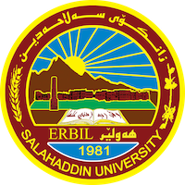
Academic Curriculum Vitae
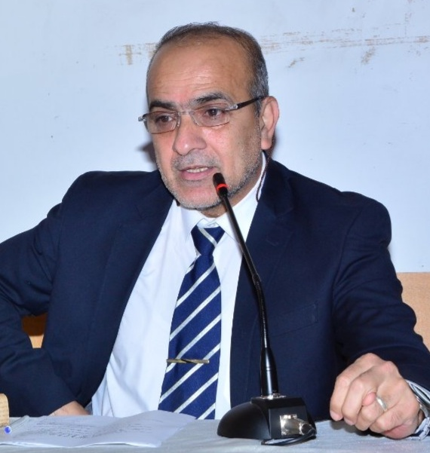
Personal Information:
Full Name: Dr. Mustafa Mohammed Karim
Academic Title: assistant professor
Email: Mustafa.karem@su.edu.krd
Mobile: 07504378191

Education:
Bachelor's Degree: 2007-2008 / Salahaddin University / College of Arts – Department of History

Master's Degree: 2012 – 2013 / Salahaddin University / College of Arts – Department of History

Master's thesis title: Iran's foreign relations during the reign of Nader Shah Afshar 1736 - 1747

Ph.D.: 2021– 2022/ Salahaddin University / College of Arts – Department of History

Ph.D. thesis title: Relations of the Safavid state with European countries during the reign of Shah Abbas I 1587-1629 AD
Employment:
- State employment starting from first employment

Qualifications
- Teaching qualifications
- IT qualifications
- Language qualifications such as TOEFL, IELTS or any equivalent
- Any professional qualification
- You could put any professional courses you have attended

Teaching experience:
- State all teaching courses you delivered, stating undergraduate or post graduate
- Courses, trainings, lab supervision, etc.,

Research and publications
- Political situation in Iran between 1524 – 1587 / Kurdish Academic Journal

- Shah Abbas I (1587-1629) and the Persian silk trade / Journal of Humanities of Salahaddin University

- The problem of Qajar succession between internal conflicts and competition of European countries / Journal of Humanities of Salahaddin University

- Crimean War ( 1853 1856 ) Causes and Consequences / Journal of History

- American War of Independence / History Magazine

- Safavid Tariqat Steps towards Building the Safavid State/ Journal of History

- Iran-Russia relations during the reign of Shah Abbas I / Qalay Zanst Journal

- Kandahar Province in the Political and Military Conflict between India and Iran during the Reign of the Mongol King Jahan/ Qalay Zanst Journal

Book: Published:

- Iran's foreign relations during the reign of Nader Shah Afshar 1736 – 1747 / Mukriyan Publishing House - 2014

- Research on the political history of the Safavid state ( 1501 – 1736) / Salahaddin University Printing House – 2018

- Political developments in the Barzan region during the years 1902 - 1932/ Publications of the Encyclopedia of the Kurdistan Democratic Party - 2022
Conferences and courses attended
- Give details of any conferences you have attended, and those at which you have presented delivered poster presentations.

Funding and academic awards
- List any bursaries, scholarships, travel grants or other sources of funding that you were awarded for research projects or to attend meetings or conferences.

Professional memberships
- List any membership you hold of any professional body or learned society relevant to your research or other life activities.

Professional Social Network Accounts:

- List your profile links of ReserchGate, LinkedIn, etc.

It is also recommended to create an academic cover letter for your CV, for further information about the cover letter, please visit below link:
https://career-advice.jobs.ac.uk/cv-and-cover-letter-advice/academic-cover-letter/

