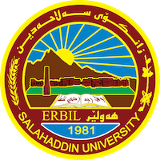

**Academic Curriculum Vitae**

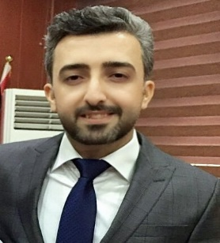

**Personal Information:**

Full Name: Nabaz Ismael Hamad

Academic Title: Lecturer

Email: (nabaz.hamad@su.edu.krd)

Mobile: 07502191314

**Education:**

- BA degree in English Language, Department of English College of Languages, Salahaddin University-Erbil, in 2009.

- MA Degree in English Language and Linguistics at the University of Manchester, the UK, in 2013.

- PhD degree in English Language and Linguistics in Department of English College of Languages, Salahaddin University-Erbil, in 2019.

**Employment:**

* Researcher assistant in 2010.
* MA in 2013
* Assistant lecturer academic title in 2014
* PhD in 2019
* Lecturer academic title in 2019

**Qualifications**

* I have been teaching at university of Salahaddin-College of Languages-English Department for 11years. I have also translated thousands of articles, documents and written papers. I have published 9 researches in the international academic journals nationally and internationally.
* IELTS: 7, PTE: 73
* IT: Microsoft Word programs

**Teaching experience:**

Teaching the following subjects at Salahaddin University College of Languages- English Department:

* A.   Morphology
* B.   Conversation
* C.   Grammar
* D.   Vocabulary
* E.   Comprehension
* F.    Composition
* G.   Translation

Being the English Department Coordinator to do the followings:

* H.   Arranging the department’s timetable.
* I.     Being the head of the department whenever the head is not present.
* J.     Supervising the three employees of the department.
* K.   Arranging the department’s meetings.
* L.   Cooperating with the department’s scientific committee.
* Managing all the other issues of the department.
* I have also taught these courses At Language and Translation Centre:
* Elementary (3) times
* Pre-intermediate (4) times

**Research and publications**

1. A Syntactic-Semantic Study of Compound Nouns in English and Kurdish.
2. The Causes of *Do*-Insertion Proliferation in Interrogative Constructions in Modern English Period (1500-1700): A Corpus-based Study.
3. The Misuse of Synonymous Verbs by the Kurdish Learners of English Language. A Case of six Verbs.
4. A Semantic Analysis of the Semi-Modal *be to* in Modern English: A Corpus Based Study
5. A Cognitive Semantic Study of Reference in Meaning Construction in Shaw’s ‘Man and Superman’ and ‘Candida’
6. An Analysis of the Figures of Speech in Mental Spaces: A Cognitive Semantic Study
7. A Cognitive Semantic Study of Oxymoron in Nali’s Collection of Poems.
8. A Cognitive Semantic Study of Verbal Irony in Harold Pinter’s The Birthday Party.
9. The Role of Perspective Schematic System in Meaning Construction in Khushwant Singh’s Train to Pakistan

**Professional memberships**

1. Kurdistan Teachers Union
2. Iraqi Translators Association

**Professional Social Network Accounts:**

* Research Gate:

<https://www.researchgate.net/>

* Google scholar

<https://scholar.google.com/citations?hl=en&user=jnMTGtoAAAAJ&scilu=&scisig=ANI4uE0AAAAAZsSLdIIUfinM7AV0w_e-UJBYmQE&gmla=AC6lMd8z4RFnIyg8Co1DOUdqJQcKsoNAXd-Ty5QPGJO4569A4frMENmy8MZZejlVjacSSRx9IIpIW3pl145cM7RHpNGYin9_a21bakPLrFk&sciund=2377598766413359942>