Engineering Geology
Q1) Correct the wrong statements:-
- The clay and sand grain in a non-cohesive soil attract each other even in the absence of water .
- The first step in an investigation is Data collection .
- Kaolinite requires more water for change neutralization .
- The well-graded gravel must have a Cu a value greater than 5 and Cc value between 2-4 .
- There is no relation between soil development and parent material .

Q2) Complete the followings :-
1- Water content % = ----------------------------------------------------------
2- The methods of grain size analysis are---------------------------------------
3- If Fine-grained percent(60%) , coarse grain percent (40%) , liquid
limit percent less than (50) percent ,the soil classified as ---------------.
4- Soils consisting of particles that stick together in either a dry or wet
state this type of soil called ---------------------------------------------------
5-In Hydrometer method ( Rc ) = ---------------------------------------------
6-In the unconfined compressive strength cohesion= -----------------.
7-Toppling is -------------------------------------------------------------------.
8-Types of engineering geologic investigation are ---------------------.
9- void ratio = ------------------------------------------------------------------.
10-Comperisibility is ----------------------------------------------------------.
11-The engineeering properties are especially important to many
types of engineering works and situations involving soil these
types are ---------------------------------------.

12- The radius of the Mohr’s circle in triaxial test = ---------------------.

13 Circular failures ----------------.

14porosity= --------------------------------------.

15 The percent retained on a given sieve is determined by ------.

Q3) Discuss with sketch the Atterberg limits in relation to increasing
water content .

Q4) Write about :
1- Factors which effect shear strength in non cohesive soil.
2- The causes of overconsolidation .

Q5) Determine failure angle for this sketch if Ø (19.45) .
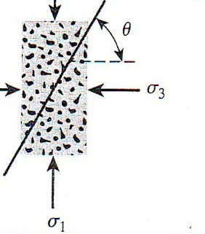

Q6) How can classified the soil according to unified soil classification system

Q7) Compare between drained and undrained state in non cohesive soil

Q8)The fine grain percent of soil (70%)gm , coarse grain(30%)gm ,
correction factor(a) (0.99) . Determine corrected finer percent if
Rc (43) .
Q9) Discus the figures below . ( 3 marks )

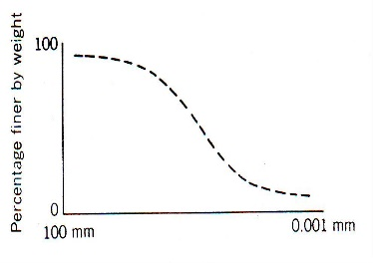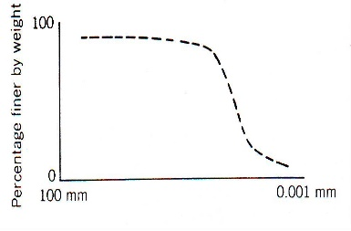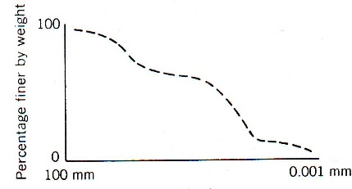
diameter diameter diameter
(figA ) (fig B) (fig C )

Q10) Compute the coefficient of uniformity and concavity if the effective size
D₁₀ (0.096), D₃₀(0.16) D₆₀ (0.24)
Q11) Compute plastic limit if the weight of wet soil with
can(40.10)gm , weight of dry soil with can(35)gm and weight
of can(14.89)gm .
Q12) What are the engineering properties which are important
to many types of engineering works and situations involving soil.
Q13) Write about Prefix & suffix according to unified soil classification system.
Q14) The particle-size distribution curve indicates that about 3%of the soil is
finer than 0.075 mm (N0.200 sieve), also (50%) of the soil is sand and
(47%)is gravel. If D₁₀ (0.085), D₃₀ (0.12) and D₆₀ (0.135). Classify the soil
according to USCS.
Q15) Classify activity of clay, if percent of clay (17) %, liquid limit (54) and Plastic
limit data are: - weight of can. (9.5), weight of can. with moisture soil (21.2)
and weight of can. with dry soil (18.4).
Q16) Why Kaolinite are non-expansive clay minerals
Q17) Write about Soil development.
Q18) Compute corrected finer percent for the soil if the fine grain
percent (70%)gm, coarse grain percent (30%)gm, Ra (48), Z.C.(9)
C_{T} (-0.5) and correction factor(a) (0.93).
Q19) Determine friction angle if failure angle between principle stress and plane
of failure ( 35 ) .
Q20) Write about Expansive soil
Q21) Why uniformly and gap graded curves are poorly graded curve
Q22) Write about Atterberg limits with sketch
Q23) Compute water content if the weight of wet soil with can(28.3)gm , weight
of dry soil with can (24.1)gm and weight of can(12.5)gm.
Q24) Compute diameter of the soil grains at (15mint) at hydrometer analysis, if
L(9.7)cm and k(0.01386).
Q25) Determine failure angle between principle stress and plane of failure if Ø
(20) .
Q26) Write about Problematic soil.
Q27) Why Calcium-rich montmorrillanite has a lower PI than does Sodium rich
montmorillanite because
Q28) Write about coarse grain soil classification according to unified soil
classification system
Q29) Determine the plasticity index. If the liquid limit (35.9) and the plastic limit
data are:-weight of can. with moisture soil(17.2), weight of can. with dry
soil(15.6) and weight of can. (8.3).
Q30) Write about the important structural groups of clay minerals for
engineering purposes
Q31) prove failure angle (θ) = 45 + Ø /2
Q32) Write about Clay mineralogy is the dominant factor in controlling the
plasticity of a clay soil.
Q33) From the grain size distribution curve the percent of Clay (10%), also (60%)
of the soil is Gravel and Sand (30%). If D₁₀ (0.075), D₃₀ (0.15) and D₆₀ (0.145).
Classify the soil according to USCS.
Q34)A shear box test was performed to give the following results for a cohesive soil
sample, Normal stress (150) kN/m², Shear stress at failure (110) kN/m² and
tan Ø (0.1) . Compute friction angle and Cohesion. Use Mohr-Coulomb
equation
Q35) Write about Factors effected shear strength

