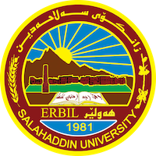
Academic Curriculum Vitae

Personal Information:
Full Name: Naema Kamal Ali
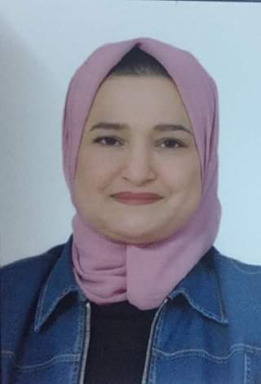
Academic Title: Assistant lecturer
Email: (university email) Naema. Ali@su.edu.krd.
Mobile: 07504201403

Education:
- B. A. degree in Law, 2012, College of Law and Political Sciences/ University of Salahaddin – Erbil
- M.A. degree in Law (Private Law), 2017/ College of Law and Political Sciences/ University of Salahaddin – Erbil.
- P.H.D. Student in Private Law/ 2020 up to date.
Employment:
I Worked as Assistant Law in the Department of Law for three years at College of Law, from 2018 working as academic staff I am currently an assistant lecturer at College of Law; teach the Arabic language to the first stage students.
Qualifications :
- I attained a courses of, IELTS to learn English language, the languages I master
- Kurdish: Mother tongue
- Arabic: v. good( in reading and writing, speaking).
- English:good
- Persian: good
Teaching experience:
Commitment sources/ The second stage students / 2018-2019
Civil contracts/ The fourth stage students / 2019- 2020
Implementation law/The Fifth stage students / 2020- 2021
Arabic language/The first stage students/ 2022-2023

Research and publications
I have a published research about the problems of concluding a musataha contract and its implementation in Iraqi law. Published in the Journal of Law and Politics, No.(30), June 2021. joint research
This research was about the contract of Musataha which is an im portents contract since it is one of the important sources for investing funds and real estate wealth.
Conferences and courses attended Workshop Challenge in Academic Publication), University of Salahaddin – Erbil/2022
- Workshop.( Artificial intelligence in Life and Research), that was organized by the General Directorate of Scientific Research Center of University of Salahaddin – Erbil./2021.
- Conference. Tisk international Conference, organized by the faculty of Law –Tisk international University,/2021.

- Conference . Al-Zalmi and his jurisprudence in Sharia and law, Held between the Faculties of Law and Islamic Sciences/ at University of Salahaddin – Erbil/ 2019.

Funding and academic awards
- List any bursaries, scholarships, travel grants or other sources of funding that you were awarded for research projects or to attend meetings or conferences.

Professional memberships.
- I am a member of the Kurdistan Jurists Union.

Professional Social Network Accounts:
- Research Gate: https://www.researchgate.net/profile/Naema-Ali-2
- Google Scholar: https://scholar.google.com/citations?hl=en&view_op=list_works&gmla=AJsN-F5QbfriuxcOV8B7pllZ5f-rG4OPjnuJsXD-OWXS-Qvw5TM2YqtQxcuk2B7J3n2iWvUOiS4vbIgOd2UOxOHoxTp_uvqAiw&user=9V8P2wYAAAAJ
- Facebook: https://www.facebook.com/messages/t/2377420615690381
It is also recommended to create an academic cover letter for your CV, for further information about the cover letter, please visit below link:
https://career-advice.jobs.ac.uk/cv-and-cover-letter-advice/academic-cover-letter/

