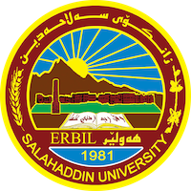
Academic Curriculum Vitae

Personal Information:
Full Name:nahlah hussain taha 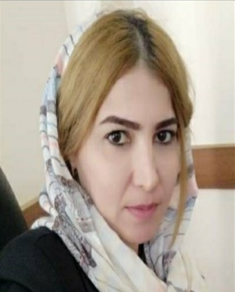

Academic Title: Lecturer

Email: (nahla.taha@su.edu.krd)
Mobile:000000

Education:
- Salahaddin university/ Arabic department/ Master,s degree in Arabic language / 22-12-2013
- Salahaddin university/ Arabic department/ Bachelor,s degree in Arabic language / 21-07-2007
- Assistant Lecturer / Faculty of Education – Shaqlawa/
- Obtaining the scientific title Lecturer / Faculty of Education-Shaqlawa / 2022

Employment:
- Director of Human Resources Unit / College of Languages
- Head of the Department of Arabic Language / Faculty of Education - Shaqlawa
- Director of the Registration Unit / Faculty of Education - Shaqlawa
- Quality Assurance and Curriculum Development Officer / Faculty of Education – Shaqlawa

Qualifications
- English Language Course / Language Center / Salahaddin University 2010
- Teaching Methods Course / Continuing Education Center / Salahaddin University 2013

Teaching experience:
- I have been teaching in the Department of Arabic Language / Faculty of Education - Shaqlawa since 2015 and until now I have studied many subjects with the supervision of many undergraduate students
- Lectured at the Faculty of Education - Makhmour for two academic years (2017/2018)

Research and publications
- The Foundations of the Textual Consistency in Surat Al-Iftar / Glai Zanst Magazine / Lebanese French University / Summer 2021
- Communication in the Novel "Papa Sartre" for the Novelist Ali Badr/ Journal of Arts, Literature and Humanities / Emirates College of Educational Sciences / Issue 33 - January 2019 .
- The Deictic References in Moses’ story in quran/Researcher Magazine / University of Soran - Iraq / Issue 4 Fall 2019

Conferences and courses attended
- Give details of any conferences you have attended, and those at which you have presented delivered poster presentations.

Professional memberships
- List any membership you hold of any professional body or learned society relevant to your research or other life activities.

Professional Social Network Accounts:

- Nahla hussain taha‬ - Google Scholar‬
- Nahla Hussain (researchgate.net)

