Academic Curriculum Vitae
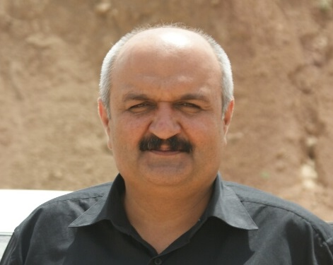
Personal Information
Full Name: Dr Nahro Othman Maulood
Academic Title: Lecturer
Email: nahro.maulood@su.edu.krd
Mobile: 07504346701

Education:
Certificate | Field of Specialization | Name of Institution | Average | Date Received
PhD | Literature / African American Drama | University of Sulaimani / College of Basic Education | Very Good | June, 2019
MA | Linguistics / Functional Grammar | University of Koya / Faculty of Humanities and Social Sciences | Very Good | Jan, 2009
BA | English Language & Literature | University of Salahaddin / College of Languages | Good | July, 2005

Employment:
Title of Position | Field of Specialization | Date |  | Name of Institution
 |  | From | To
Assistant Lecturer | Literature | 2009 | 2019 | Salahaddin University College of Languages – English Dept.
Lecturer | Literature | 2019 | Now | Salahaddin University/College of Languages – English Dept.

Qualifications & Experience
Training Courses: I received teaching training courses in the US (2011) and the UK (2014)

Work Experience:
Dec, 2009 – present University of Salahaddin
Assistant Lecturer + Lecturer

Feb, 2009 – Dec 2009 Ministry of Higher Education
Head of Translation Department
- Translating documents from English into Kurdish and vice versa

Dec, 2006- Feb, 2008 ACTED [A French Humanitarian Organization]
Administrator
- I was performing the following tasks in addition to human resources:
- IT: computer maintenance, networking…etc.
- Coordinator: arranging meetings for expatriate staff, booking hotel…etc.
- Translator: acting as translator for the expatriate during the official meetings.
- Recruiter: interviewing applicants, short listing and choosing the best candidate.
- Finance: for the last two months I was acting as finance as our finance left his post.
April, 2000- Sept, 2006 Ministry of Health
- IT and Computer Operator
- Computer operator in Media Dept. (for three years)
- Typing & revising articles for (Health Magazine) and (Psych Magazine)
- Supervising publication of many posters, pamphlets and folders about health education in general
- Acting as Data entry for Minister’s Bureau for one year
- Acting as head of Minister’s Bureau (for one month during the vacation of the head)
- Acting as head of Media Dept (for three months)
- Working as IT (computer maintenance, networking and estimating computer prices before purchasing)

Teaching experience:
A. Undergraduate Studies
Level | Title of Course
Second Year | English Poetry- 16th Century
Third Year | Romantic and Neo-Classical Poetry/ Victorian Novel/ Translation
Fourth Year | Victorian and Modern Poetry / Classical and Modern Criticism/ Methods of Research / Modern Drama

B. Postgraduate Studies
Level | Title of Course | College/University | Year
Master's Degree | Computer / Ms Word /Ms Excel / Ms Powerpoint | Languages/ Salahaddin | 2021

Research and publications
No. | Title of Paper | Place of Publication | Date of Publication
1 | Trauma in August Wilson's The Piano Lesson | Koya University/Erbil  Koya University Journal of Humanities and Social Sciences | 2020
2 | The Trauma in Langston Hughes's Mulatto | Salahaddin University/Erbil  (Zanko Academic Journal) | 2019
3 | Trauma in Amiri Baraka's Slave Ship | Salahaddin University/Erbil  (Zanko Academic Journal) | 2019

