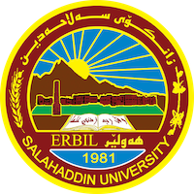
Academic Curriculum Vitae
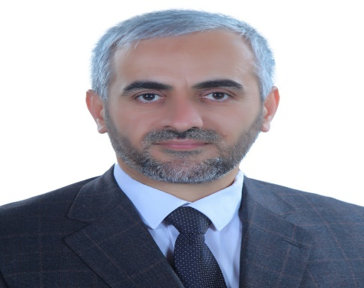
Personal Information:
Full Name: Namiq Ismael Mustafa
Academic Title: teacher
Email: (university email): namiq.mustafa@su.edu.krd
Mobile: 07504789132

Education:
- Bachelor's degree from the Islamic Studies/ College of adab/ Salahaddin University/ Erbil: 2001.
- Master's degree: Islamic Studies/ College of Islamic Sciences/ Salahaddin University- 2009.
- Doctorate: Presidency of the Sunni Endowment Diwan - The Great Imam University College - 2017.
- Employment:
- Date of first appointment / (2002).
- Self-Director at the College of Education, Shaqlawa (2019).

Qualifications
- English Language Course / Language Center / Salahaddin University (2008).
- Obtaining a certificate (Teaching Methods) from Salah Al-Din University / College of Law / (2012).
- Computer education course at Ibn Al-Haytham College Hawler– (2009).

Teaching experience:
- I have been teaching in the Department of Arabic Language / College of Education - Shaqlawa since 2020 and until now I have studied many subjects with the supervision of many undergraduate students
- Lectured at the Institute of Islamic Sciences Seven years.

Research and publications
- 1- The methodology of the Prophet (may God bless him and grant him peace) in urging marriage, with Dr. Kamal Sadiq Yassin.
- 2- (A Treatise on Paying Zakat to the Family of the House) by Ibn Al-Hajj Al-Kurdi - Study and Investigation -. With Dr. Yassin Tahseen Al-Bahrki.
- 3- (Risalat al-Mutaa) by Ibn al-Hajj al-Kurdi - study and investigation -. With Dr. Yassin Tahseen Al-Bahrki.
- 4- The purposes of divine names and attributes and the effect of acquiring them in rooting charitable work - an analytical study of purposes.
Conferences and courses attended
- The best graduate research project at Salahaddin University / Erbil 2022.
- With science and faith, the nation rises, Istanbul Foundation for Culture and Science / Türkiye 2023.
- The scientific conference of Sheikh Taher Al-Shushi / University of Duhok 2022.
Funding and academic awards
- List any bursaries, scholarships, travel grants or other sources of funding that you were awarded for research projects or to attend meetings or conferences.

Professional memberships
- Member of the Language and Literature Platform / Iraq / Erbil.

Professional Social Network Accounts:

- Namiq Ismael Mustafa‬ - Google Scholar‬‬‬‬‬‬‬‬‬‬‬‬‬
- namiq.mustafa@su.edu.krd

