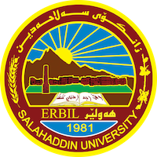
Academic Curriculum Vitae

Personal Information: 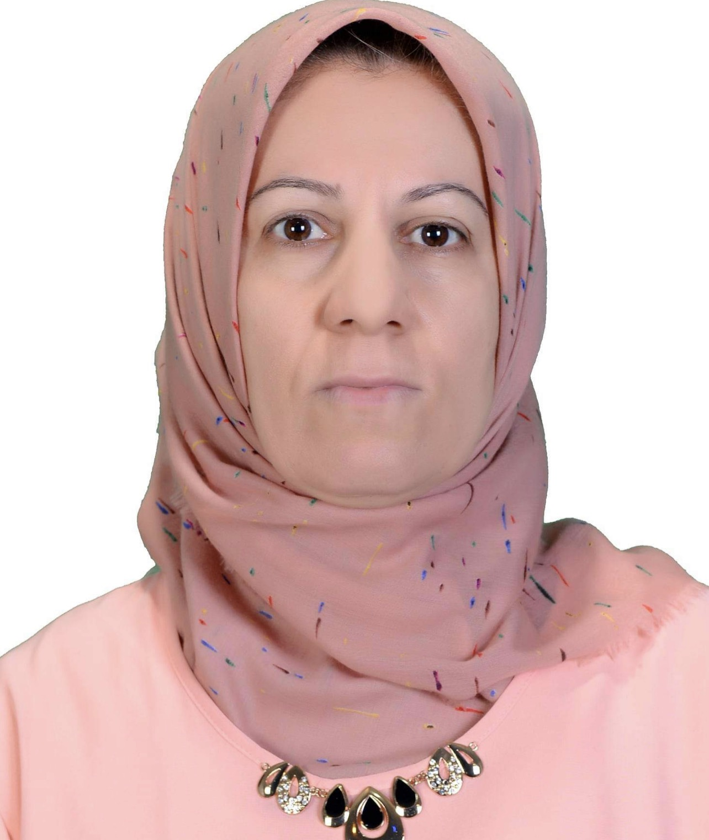
Full Name : Narmin Sadullah Abdullah
Academic Title: Lecturer
Email: (narmin.abdullah@su.edu.krd)
Mobile:07504995070

Education:
From | Degree | College-university | Country
1992-2023 | M.Sc in analytical chemistry-Department of chemistry | College of science-University of salahaddin | Iraq
1987-1990 | B.Sc. chemistry-Department of chemistry | College of science-University of salahaddin | Iraq

Employment:
From | Post | Department-College | university
2015 up to date | Lecturer | Chemistry Department-college of science | Salahaddin University
1997-2015 | Assistant Lecturer | Chemistry Department-college of science | Salahaddin University
1992 -1996 | Assistant Chemistry | Chemistry Department-college of science | Salahaddin University
2015 | Member of Examination committee | Chemistry Department-college of science | Salahaddin University

Qualifications
1-Profile: I can teach anything related to the chemistry
2- Language: Kurdish, Arabic, English, Turkish
3-Computer skills: Window 2003, 2007, Excel, internet, power
Point.
Teaching experience:
From-To | Subject | Stage-College | University
1997-up to date | Analytical chemistry | 1St -4th  Grade Students/chemistry department-college of science  1st grade students/Geology department  College of science | Salahaddin university
2017-2020 | Analytical chemistry/theory | 1st grade students/Geology department  College of science | Salahaddin university
2020-2022 | Instrumentalanalysis/practical | Third grade student / Environmental Science and  Health Department | Salahaddin university

Research and publications

1- Spectrophotometreic determination of Bromate in bread by the oxidation of Dyes.( Journal of Kirkuk university ,2009)

2-Kinetic study of adsorption-desorption of Simazine on agricultural soils. (International Journal of Engineering Research and Development, Vol.4, Issue 12(November 2012),pp 01-09).

3- Spectrophotometric determination of chlorthalidone in pharmaceutical formation using different order derivative methods. (Arabian journal of chemistry/king Saud University, 2014).

4-Spectrophotometric methods for determination of Metronidazole in pharmaceutical formulations. (Zanco journal of pure and applied sciences) 2018,30(5);89-100.

5-Use of flow injection analysis with chemiluminescence detection for determination of sunset yellow (E110) in drink samples (journal of the Iranian chemical society,2020

6- Effects of heating on comparative study of grape seed polyphenols extraction ,2012 ,vol.24(3),p 89-95

Professional memberships
1-Member in chemist’s syndicate
2-Member in teacher syndicate
Professional Social Network Accounts:
Research gate :https://www.researchgate.net/profile/Narmin-Abdullah
LinkedIn: https://www.linkedin.com/in/narmin-sadullah-a55170163/
Google scholar: https://scholar.google.com/citations?hl=en&user=N1RwegEAAAAJ
Academic Profile: https://academics.su.edu.krd/profile-admin/index.php?p=profile

