Academic Curriculum Vitae

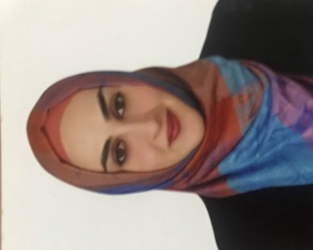
Personal Information:
Full Name: Nask Sherzad Salh
Academic Title: Assist. lecturer
Email: nask.salh@su.edu.krd
Mobile: 07507176155

Education:
- State all educations accomplished
- BSc: 2009 college of agricultural engineering science
- MSc: 2015 college of agricultural engineering science
Employment:
- State employment starting from first employment
- 29/10/2009 Salahaddin university /Erbil

Qualifications
- Teaching qualifications:
- IT qualifications: word, excel, power point
- Language qualifications IELTS: 5.5
- Any professional qualification: NONE
- You could put any professional courses you have attended:
- English language center course ,
- Gap (Genomic and Proteomic course.

Teaching experience:
- State all teaching courses you delivered, stating undergraduate:
- Principles of plant pathology ,
- Postharvest Diseases,
- Microbiology,
- Field crop diseases ,
- Phytobacteriology.

Lab supervision
Lab of plant pathology/ plant protection department

Research and publications
Conferences and courses attended
- Give details of any conferences you have attended, and those at which you have presented delivered poster presentations.

Funding and academic awards
None
Professional memberships
- List any membership you hold of any professional body or learned society relevant to your research or other life activities.

Professional Social Network Accounts:
profile links: https://academics.su.edu.krd/profile-admin/index.php?p=profile
Research Gate: https://www.researchgate.net/profile/Nask-Salh
Google scholar: https://scholar.google.com/citations?hl=en&user=wReBK3IAAAAJ&scilu=&scisig=AMD79ooAAAAAXv3S4eRcTsUIrwltDjcsmkYadm3akQ3M&gmla=AJsN-F4Zqiuypq8o5GQ5jqUaNw2xyskMXoO6bah1PLJPpiHmrOwC_BXnbnE5I13DZW_DNYEtce-O0cH1Vjv9YKMF_iIJZ1xJc4aE9MePBP62m9fiOJVn1tk&sciund=15536152721703386418

It is also recommended to create an academic cover letter for your CV, for further information about the cover letter, please visit below link:
https://career-advice.jobs.ac.uk/cv-and-cover-letter-advice/academic-cover-letter/

