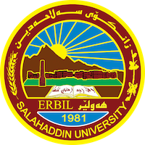
Academic Curriculum Vitae

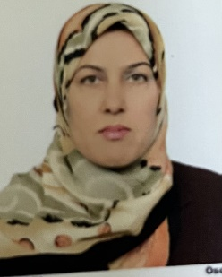
Personal Information:
Full Name:Nasreen Rauf Smail
Academic Title:مامۆستای یاریدەدەر
Email: (university email) زانکۆی سەلاحەددین nasreen.ismail@su.edu.krd
Mobile:07502475764

Education:
پەیمانگای مامۆستایان(هەولێر)-١٩٨٨
بەکالۆریۆس-کۆلێژی پەروەردە -بەشی کوردی -زانکۆی سەلاحەددین-١٩٩٩
ماستەر-ئەدەبی کوردی- کۆلێژی پەروەردە-زانکۆی کۆیە-٢٠٠٧
قوتابی دکتۆرا کۆلێژی زمان- زانکۆی سەلاحەددین - ٢٠٢٢- ٢٠٢٣

Employment:
- مامۆستای سەرەتایی
- مامۆستای دواناوەندی
-مامۆستای زانکۆ-کۆلێژی زمان- زانکۆی سەلاحەددین-بەشی کوردی
Qualifications
- Teaching qualifications
- IT qualifications
- Language qualifications such as, IELTS or any equivalent

Teaching experience:
- ڕێگاکانی وانەوتنەوە

Research and publications
- کتێب(ئەرکی شیعر لەئەدەبی کوردیدا١٩٢٠-١٩٥٨)

Conferences and courses attended
- Give details of any conferences you have attended, and those at which you have presented delivered poster presentations.

Funding and academic awards
- List any bursaries, scholarships, travel grants or other sources of funding that you were awarded for research projects or to attend meetings or conferences.

Professional memberships
- List any membership you hold of any professional body or learned society relevant to your research or other life activities.

Professional Social Network Accounts:
nasreen.ismail@su.edu.krd

