Emmentale cheese production
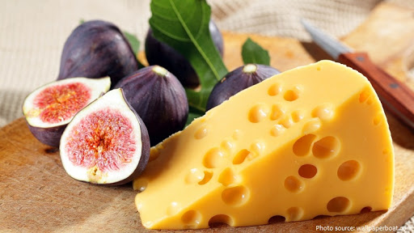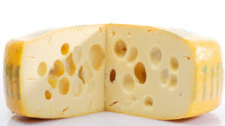

Emmentale:it's also called Emmenthaler. It's Swiss cheese that originated in Switzerland in the Emme River Valley, Traditionally first made in the 13th century from fresh unpasteurized milk from cows fed on grass and hay, with no additives or genetically modified ingredients.
Swiss Emmental AOP certification demands that No preservatives or ingredients from genetically modified organisms are used in the making of this type of cheese.
The AOP (Appellation d’Origine Protegée) is a mark of high-quality products that are sourced and manufactured in the region of origin. The Emmental cheese variety has this seal of approval.
Emmentale has air pockets (holes or "eyes") formed by gases due to the action of starter which consist of (streptococcusthermophilus+Lactobacillushelveticus+Propionibacterium shermaniiorPropionibacterium freudenreichii) as the cheese cures within six Months .In general, the larger the eyes in a Swiss cheese, the more pronounced its flavor.

Emmental characteristic:
1-Medium-hard and uniformly yellow, slightly salty, nutty, buttery, slightly fruity taste that sharpens as it ripens,
Firm and elastic.
2-It has good melting properties, it's easy to slice and often has a thin rind covered by paper with the cheese maker's name on it.
3-Emmental cheese is produced in large, wheel-shaped barrels. Each barrel is marked with a unique code which helps the manufacturer trace the origin of the milk back to the supplie.
4-It has a relatively high fat content and is rich in calcium, as well as copper and phosphorous.
5-Emmentale is authentically made in large wheel shapes
each wheel measures between 80 to 100 centimeters and weighs anywhere from 75 to a 125 kilograms.
6-The bacteria present in the cheese produce carbon dioxide which is responsible for the varying sizes of holes (eyes) in the cheese.
Emmental cheese classified according to ageing
1-Classic Emmentale is aged for at least four months. It has a golden yellow rind and a mild, nutty, delicate taste.
2-Emmentale AOP Réserve , or Réserve Emmentaler, is aged for eight months. it has an aromatic, spicy, strong flavor and a dark yellow rind.
3-Emmentaler AOP Extra is ripened for at least 12 months and has a dark brown rind. It has a strong spicy taste and a crumbly texture.
4-Emmenthaler AOP Cavern is aged—at least some of the time in a cave—for about 14 months. It's very aromatic, with a dark brown to black rind.
The original Emmental is produced in small rural dairies with raw cow's milk, adding only natural ingredients (water, salt, natural starter cultures and rennet); preservatives or ingredients from genetically modified organisms are not allowed.

Procedure
1-Standardize milk to P/F = 1.1 by removing cream or adding skim milk. Do not add skim milk powder
2-Pasteurize then cool the milk to 37°C.
3-Add starters through a fine mesh screen, especially if the starter was made with reconstituted skim milk. {Use 0.1%S. thermophilus, 0.1%L. helveticusand 0.005%Propionibacterium shermanii}. Ripen briefly (10 -15 min.) at 37°C.
4-Measure 190 ml rennet per 1,000 kg milk. Dilute the rennet with 10 volumes of water and add the mixture to the milk.
5-After coagulation cut the curd using (6.4 mm)knives.
continue cutting until curd size is reduced to the size of
ricegrains. If curd is forming clumps, cut more vigorously and
beginagitation as soon as rice grain particles are
achieved. Cutting speed is increased as the curd becomes less
fragile. Too much cutting initially will cause dusting.
The cutting processshould take about 5 min. Do not allow the curd to clump.
6-Stir out the curd with vigorous agitation until the curd
is firm about (30 -60 min.).There should be little acid development at this point
(pH 6.55 -6.50).
7-Cook the curd from 37°Cto 52°Cin 30 min.
Heat slowly because rapid heating causes "case
hardening" also curd cooked too slowly may also be
too acid. Continue vigorous agitation to prevent matting until
the pH is 6.3 -6.4. at whey separation.
8-Stop agitation, allow the curd to settle anddrain the
Wheyinto the moulding vat.When transferring the whey is ended , pump the curd and whey into the moulding vat.
9-Cover the surface of the cheese with a double layer of
cloth and place the press plates on top. Add weights
(up to 6 bar) and let stand for 15 –30 min. then drain the whey from the moulding vat.Let stand for 1 hr. Remove the press plates and the surface then replace the cloths, Press for 12 -18 hrs.at room temperature (at least 22 °C).
10-Remove the press plates and cloths, and cut the
cheese into blocks( Cheese pH at this time should be
5.2 -5.4). Place the curd in the brine solution (at least 23%) and
liberally salt the surface(using dry salt)for one week
with turning, after that, immerse the cheese in the
brine solution to remove salt particles from the surface
and then store at 10°Cto dry the surface.Vacuum the blocks in pouches sufficiently large to permit expansion (15 -20%) during eye formation.
11-Store at 10°C for 8 -10 days for cooling and pre-
ripening. Then, transfer to the warm room (23°C) for curing
and eye formation.
12-When eye development is complete (2 -3 weeks),
place the cheese in the finishing cooler (2 -5°C) to
stop eye development and to firm the cheese in
preparation for cutting. Flavor development continues in the finishing cooler.
13-Age the cheese at 8°C and 80% humidity.
