Yogurt production and processing
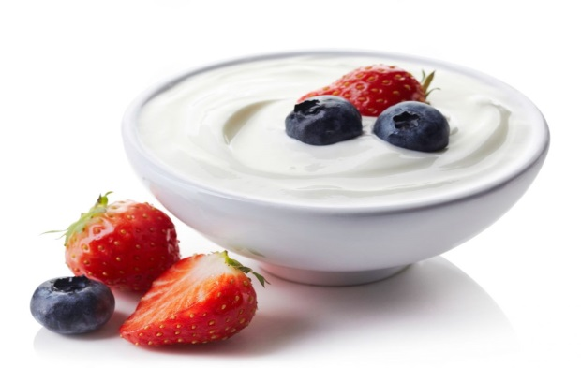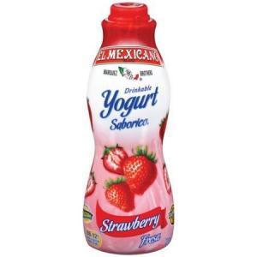
Yogurt is the coagulated milk product obtained by lactic acid fermentation through the action of Lactobacillus delbrueckii ssp. bulgaricus and Streptococcus thermophilus from milk and milk products. The microorganisms in the final product must be viable and abundant.
Yogurt is produced from the milk of cow, buffalo, goat, sheep, yak, and other mammals. In industrial production of yogurt, cow’s milk is the predominant starting material.
Yogurt is a semisolid fermented product made from a heat-treated standardized milk mix by the activity of a symbiotic blend of Streptococcus thermophilus and Lactobacillus delbrueckii subsp. bulgaricus.
Industrially, yogurts can be largely divided into two types. A set-style yogurt is made in retail containers giving a continuous undisturbed gel structure in the final product . On the other hand, stirred yogurt has a delicate protein gel structure that develops during fermentation
The main ingredient in yogurt is milk. The type of milk used depends on the type of yogurt – whole milk for full fat yogurt, lowfat milk for lowfat yogurt, and skim milk for nonfat yogurt. Other dairy ingredients are allowed in yogurt to adjust the composition, such as cream to adjust the fat content, and nonfat dry milk to adjust the solids content. The solids content of yogurt is often adjusted above the 8.25% minimum to provide a better body and texture to the finished yogurt.
Stabilizers may also be used in yogurt to improve the body and texture by increasing firmness, preventing separation of the whey (syneresis), and helping to keep the fruit uniformly mixed in the yogurt. Stabilizers used in yogurt are alginates (carageenan), gelatins, gums (locust bean, guar), pectins, and starch.
Sweeteners, flavors and fruit preparations are used in yogurt to provide variety to the consumer.
The main (starter) cultures in yogurt are Lactobacillus bulgaricus and Streptococcus thermophilus. The function of the starter cultures is to ferment lactose (milk sugar) to produce lactic acid. The increase in lactic acid decreases pH and causes the milk to clot, or form the soft gel that is characteristic of yogurt. The fermentation of lactose also produces the flavor compounds that are characteristic of yogurt.

General Yogurt Processing Steps

1. Adjust Milk Composition & Blend Ingredients Milk composition may be adjusted to achieve the desired fat and solids content. Often dry milk is added to increase the amount of whey protein to provide a desirable texture. Ingredients such as stabilizers are added at this time.

2. Pasteurize Milk The milk mixture is pasteurized at 185°F (85°C) for 30 minutes or at 203°F (95°C) for 10 minutes. A high heat treatment is used to denature the whey (serum) proteins. This allows the proteins to form a more stable gel, which prevents separation of the water during storage. The high heat treatment also further reduces the number of spoilage organisms in the milk to provide a better environment for the starter cultures to grow. Yogurt is pasteurized before the starter cultures are added to ensure that the cultures remain active in the yogurt after fermentation to act as probiotics; if the yogurt is pasteurized after fermentation the cultures will be inactivated.

3. Homogenize The blend is homogenized to mix all ingredients thoroughly and improve yogurt consistency.

4. Cool Milk The milk is cooled to 108°F (42°C) to bring the yogurt to the ideal growth temperature for the starter culture.

5. Inoculate with Starter Cultures The starter cultures are mixed into the cooled milk.

6. Hold The milk is held at 108°F (42°C) until a pH 4.5 is reached. This allows the fermentation to progress to form a soft gel and the characteristic flavor of yogurt. This process can take several hours.

7. Cool The yogurt is cooled to 7°C to stop the fermentation process.

8. Add Fruit & Flavors Fruit and flavors are added at different steps depending on the type of yogurt. For set style yogurt the fruit is added in the bottom of the cup and then the inoculated yogurt is poured on top and the yogurt is fermented in the cup. For swiss style yogurt the fruit is blended with the fermented, cooled yogurt prior to packaging.

9. PackageThe yogurt is pumped from the fermentation vat and packaged as desired.

