Rennet coagulation 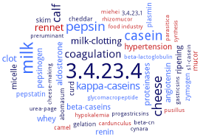 Rennet
All cheese manufacture depends upon formation of curd by the action of rennet or similar enzymes.
Coagulation of casein is the fundamental process in cheese making. It is generally done with rennet, but other proteolytic enzymes can be used, as well as acidification of the casein to the iso-electric point (pH 4,6).
The active principle in rennet is an enzyme called chymosine, and coagulation takes place shortly after the rennet is added to the milk.

The form of a solution with a strength of 1:10 000 to 1:15 000, which means that one part of rennet can coagulate 10 000 – 15 000 parts of milk in 40 minutes at 35 °C.

The three stages of enzyme coagulation:

(1) Primary Stage
In the first stage, the enzyme (rennet) cuts off a specific fragment of one of the caseins, namely, -casein. At the natural pH of milk, about 80% of -casein must be cleaved to permit aggregation of the micelles to proceed.

(2) Secondary Stage
The next stage is the physical process of aggregation of casein particles (micelles) to form a gel. After losing its water soluble tail, -casein can no longer keep the casein particles separated, so they begin to form chains and clusters. The clusters continue to grow until they form a continuous, three dimensional network which traps water inside, and forms a gel, something like Jell-O.

(3) The third stage
Refers to an ongoing development of the gel network.

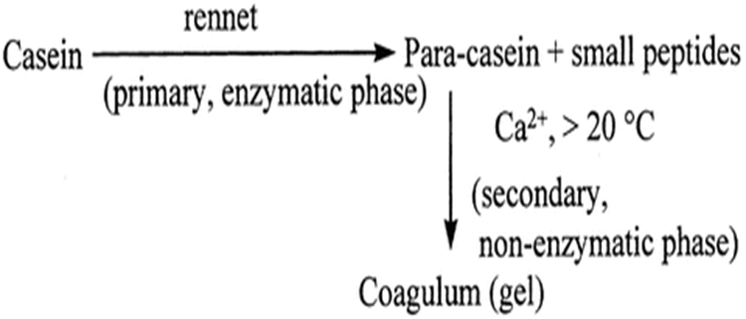

Effect of temperature optimum coagulation temperature of milk for most cheese varieties is 30-32 °C. At the temperature less than 30 °C the gel is weak and difficult to cut without excessive yield loss. At temperatures less than 20 °C the second stage of renneting, coagulation, do not occur, but the primary stage goes to completion.
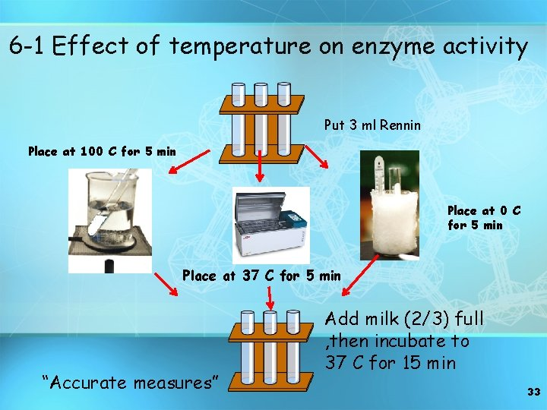
Effect of pH
