Cream

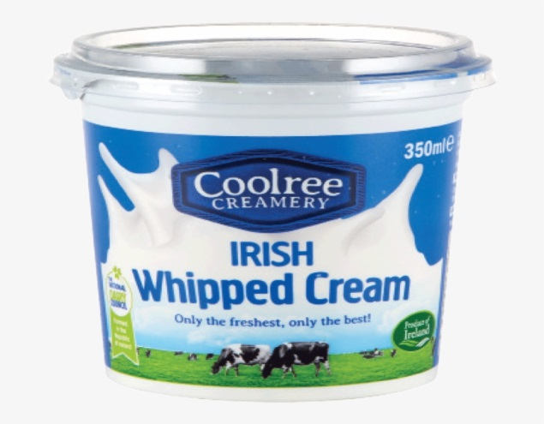

Cream from Greek chrisma is the sweet, fatty liquid skimmed from the top of milk before homogenization. In un-homogenized milk, over time, the lighter fat rises to the top. In the industrial production of cream this process is accelerated by using centrifuges called "separators".

The yield and the physical, microbiological and chemical properties are controlled by the quality of the raw materials, the effectiveness of processing, packaging and storage operations, and subsequent distribution and marketing conditions. To meet the quality attributes demanded by the consumer, the first consideration for producing a desirable cream with no defects, is to ensure the quality of the raw milk. Cream must have a clean smell, free of any foreign odor, and taste sweet, fresh and free from taints.

The texture must be smooth and rich. It should contain no sediment; have no discolorations or visible phase separation. Before processing, the raw product must be held at < 5◦C for as short a time as possible to limit the growth of spoilage micro-organisms and prevent the formation of enzymes such as lipases, proteinases and phospholipases. Provided post-heat treatment microbial contamination is low, the shelf-life of cream should be at least 8 to 10 days at 6 to 8◦C.
Chemical Composition of Cream
Fat 15- 85 %
Protein 2.5- 3 %
Lactose 3- 4 %
Ash 0.4- 0.6 %
Water 100- other components

Types of cream

1- Half-and-Half: is a product consisting of a mixture of milk and cream which contains not less than (10.5 %) milk fat.
2- Light cream, coffee cream or table cream: is cream which contains not less than (18%) but less than (30%) milk fat.
3- Medium cream: is cream which contains (25%) milk fat
4- Whipping Cream: is cream which contains not less than (30%) milk fat and air or gas has been incorporated.
5- Double cream: is cream which contains (48%) milk fat.
6- Plastic cream: is cream which contains 80% milk fat.
7- Sour cream: is a dairy product rich in fats(contains from 16 to 21 % milk fat) obtained by fermenting a regular cream by certain kinds of lactic acid bacteria.
8- Clotted cream: means “cream which has been produced and separated by the scalding, cooling, and skimming of milk or cream, contains (≥55%) milk fat.
9- Sterilized cream: means “cream which has been subjected to a process of sterilization by heat treatment in the container in which it is to be supplied to the consumer.
