**Milk Separation**

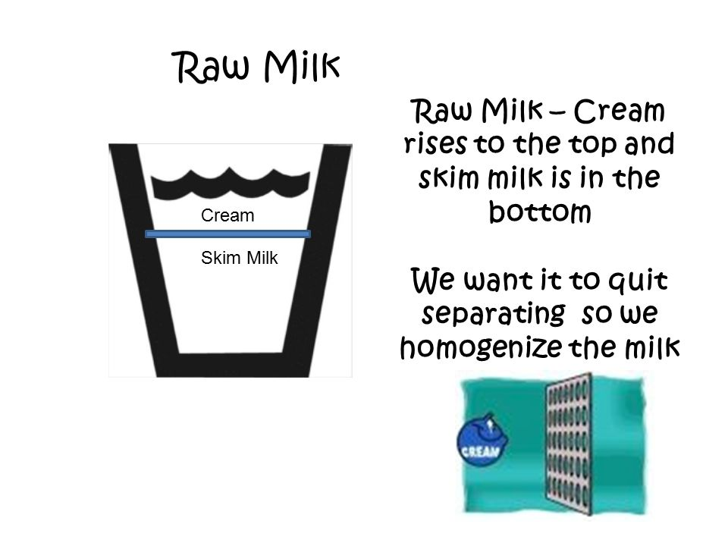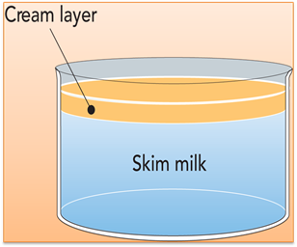

The fat fraction separates from the skim milk when milk is allowed to stand for 30 to 40 minutes. This is known a `**creaming'**. The creaming process can be used to remove fat from milk in a more concentrated form. A number of methods are employed to separate cream from milk. An understanding of the creaming process is necessary to maximize the efficiency of the separation process.

***A) Gravity separation***

Fat globules in milk are lighter than the plasma phase, and hence rise to form a cream layer. The rate of rise (V) of the individual fat globule can be estimated using Stokes' Law which defines the rate of settling of spherical particles in a liquid:

***V = { r2 (d1 –d2 )g} / 9η***

Where r = radius of fat globules

d 1 = density of the liquid phase

d2 = density of the sphere

g = acceleration due to gravity, and

η = specific viscosity of the liquid phase

***\*Batch separation by gravity:***Cream can be separated from milk by allowing the milk to stand in a setting pan in cool place. There are two main methods.

***A. Shallow pan:*** Milk, preferably fresh from the cow, is poured into a shallow pan 40 to 60 cm in diameter and about 10 cm deep. The pan should be in a cool place. After 36 hours practically all of the fat capable of rising by this method will have come to the surface, and the cream is skimmed off with a spoon or ladle (Figure 1). The skim milk usually contains about 0.5 to 0.6% butterfat.

***B. Deep-setting:*** Milk, preferably fresh from the cow, is poured into a deep can of small diameter. The can is placed in cold water and kept as cool as possible. After 24 hours the separation is usually as complete as it is possible to secure by this method. The skim milk is removed through a tap at the bottom of the can (Figure 1). Under optimum conditions, the fat content of the skim milk averages about 0.2 or 0.3 %. The pans should be rinsed with water immediately after use, scrubbed with hot water and scalded with boiling water.

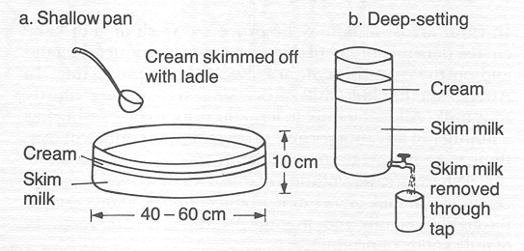

**Figure 1. *Batch separation of milk by gravity: (a) Shallow pan method, (b) deep-setting method***

***B) Centrifugal separation*:-**

**Principles of Centrifugation:-** Centrifugation is based on [***Stoke's Law***](http://www.foodsci.uoguelph.ca/dairyedu/glossary.html#stokes).



Where : v = particle velocity.

d = particle diameter. *R* = radius of the centrifuge .

W = revolution rate**.** ρ = density .

η = viscosity . p = milk plasma . f = fat **.**

**The velocity of fat globule increases with:**

1- High centrifugal acceleration **(*Rw*²)** .

2- Increasing diameter of fat globule.

3- Increasing difference in density between milk plasma and fat

4- Decreasing viscosity of the milk plasma.

5- Increasing the temperature because temperature affects, and also .

***Study of Milk Cream Separator***

**Objective:**

1. To study the parts of mechanical cram separator.
2. To assembling and dismantling of the cream separator.

**Mechanical Cream Separator:** In mechanical cream separation the cream separator is the major machine used, it may be hand operated or power operated.

**Study of Cream Separator:**

Construction: The modern centrifugal cream separator consists of

1. A bowl which can be rotated at a high speed (5000-6000rpm) by means of suitable gears and power transmission mechanism.
2. Arrangement for supplying milk to the bowl.
3. Removing the cream and skim milk.
4. Driving the machine.

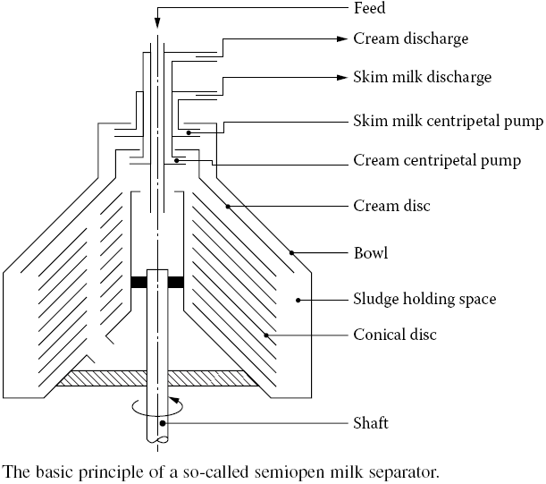

***Study of Cream Separation***

**Objectives:**

1. To get acquainted with working of the cream separator Separation of cream.
2. To find out per cent efficiency and working capacity of the cream Separation.

**Relevant Information:**

The principle mechanism of cream separation has been explained in the earlier sub-unit. In order to accomplish the separation phenomenon, the milk (may be from cow or buffalo) is passed through the bowl, where upon the forces are allowed to act resulting in partitioning of cream and skim milk. The efficiency of separation depends upon various factors and those factors are appropriately manipulated for efficient conductance of the phenomenon.

**Precaution:**

1. Machine should be fitted on a strong foundation to avoid jerks, vibration perfectly leveled position.
2. Speed of the bowl should be 5000-6000 rpm.
3. Milk should be free from sediment. The temperature of milk should be between 30-40 ºC.

**Material Required:**

1. Milk 2. Wash water 3. Gear oil 4. Muslin cloth

**Apparatus:**

1. Centrifugal cream separator.
2. Milk cans 30-40 lit capacity.
3. Stainless steel bowl with cover for collecting the cream (10-15 lit capacity).
4. Weighing balance
5. Thermometer & 6. Hot water bath

**Procedure:**  
**Separation of Cream:**

1. Assemble all the clean and dry parts of the separator
2. Check that the cream screw is in normal positions. For obtaining thick cream rotate the screw towards outside.
3. Flush the separator with clean water (50-60 ºF) when separator is running.
4. Record the weight of the milk meant for separation. Filter the milk. Warm the milk to 40 ºC. Take representative sample for fat estimation. Start the cream separator machine and maintain the rated speed of the bowl.
5. Pour the (warm) milk in the supply can. Now start separation. Note the time required for separation.
6. Receive cream in the owl and skim milk in the clean dry cans. Record the weight.
7. Take representative sample of cream and skim milk for fat test.
8. When all the milk has been separated pour about one liter of warm water over the float in order to wash out the inside bowl parts.
9. Disjoint the parts of cream separator. Wash them cleanly and dry.