Milk Compositions:-
Milk Composition:
The role of milk in nature is to feed and provide immunological protection for the mammalian young. Milk has been a food source for humans since early times. The nutritional value of milk is high. Milk is also a very complex food with over 100,000 different molecular species found. There are many factors that can affect milk composition such as Species, breed variations, cow to cow variations, herd to herd variations - including management and feed considerations, seasonal variations, Stage of lactation, age and health status and geographic variations.
Milk constituents:-
A classification of the principal constituents of milk is given below. The principal chemical components or groups of chemical components are those present in the largest quantities. The quantity (in grams) is not principal in all respects. For example, vitamins are important with respect to nutritive value; enzymes are catalysts of reactions; and some minor components contribute markedly to the taste of milk.
Approximate composition of Cows’ milk is given below:-
(Weight \ 1kg milk)
1-Water (range of 860-880gm)
2- Total Solids (range of 120-140gm)

A- Milk fat which includes:-
1-Mixture of triglycerides (range of 30-50gm)
2-Phospholipids (0.3gm)
3-Sterols (0.1gm)
4-cerebroside (Traces)
5-Carotens (0.1-0.6mg)
6-Vitamin-A (0.1-0.5mg)
7- Vitamin-E (1mg)
8- Vitamin-D (0.4µg)
9- Vitamin-K (Traces)

B- Milk Proteins which includes:-
1-Caseins (25gm)
2-Beta- Lactoglobulin (3gm)
3-Alpha-Lactoalbumin (0.7gm)
4-Blood Serum Albumin (0.3gm)
5-Other Albumins and Globulins (1.3gm)
6- Fat Globule Membrane (0.2gm)
7- Enzymes (peroxides, Catalyase, phosphatase, Lipase ,Protease,
Xanthinoxidase.
C- Components dissolve in water:-
1-Carbohydreate
A-Lactose (range of 40-50gm)
B-Glucose (50mg)
C-Galactose (Traces)
2- Minerals
A-Phosphate ( PO4) (2.1 gm)
B- Citrate (2 gm)
C-Potassium (K)(1.5 gm)
D-Calcium (Ca)(1.3 gm)
E-Chloride(Cl)(1gm)
F-Sodium(NaCl) (0.5gm)
G-Bicarbonate(HCO3) (0.2gm)
H- Fat Globule Membrane (0.2gm)
I-Magnesium(Mg)(0.1gm)
J-Sulphate (SO4)(0.1 gm)
K-Lactate(0.2 gm)

3-Water Soluble Vitamins which includes:-
A-ThamineB1 (0.4 mg)
B- Riboflavin B2 (1.5 mg)
C-Niacin B5(0.2-1.2 mg)
D-Pyridoxine (0.7mg)
E- Pantothinic Acid (3mg)
F-Biotin (50 µg)
G-Folic Acid (1 µg)
I-Cynocobalamine B12 (7 µg)
J-Ascorbic Acid(20mg)

4-Nitrogenous compounds(Non Protein Compounds) (NPN) (250mg) which includes the
compounds are partially intermediate products of the protein
metabolism of the animal (e.g., ammonia, urea, creatine, creatinine,and uric acid).

5-Gases:-
A-Co2 (100 mg)
B- O2 (7.5 mg)
C-N2 (15 mg)
6- Trace elements are elements of which not more than a trace is found in milk. Of these, some are present in the highest concentration(e.g., Zn,Cu.Mn,Fe,Ba, , whereas the other elements are present in far lower concentrations(e.g. Se,I,B. Sn,Ti,V,Li,Al,Co, Ag,Cr,F,Mo,)

Milk Variability: -
Fresh milk varies in composition and structure, and in properties. The causes are variation in genetic makeup of the animal (especially species), its physiological conditions (especially stage of lactation), and in environmental factors (especially feed). Milk variability affected on its nutritional value which related with milk price.

Factors affecting milk composition:-
1-Species: -
Different mammals produce milk varying widely in composition. Table below gives an overview of the variation.
Composition of different species of milk
Species | Percentage of Composition
 | Water | Fat | Protein | Lactose | Ash
Buffalo | 84.2 | 6.6 | 3.9 | 5.2 | 0.8
Camel | 86.5 | 3.1 | 4.0 | 5.6 | 0.8
Cow | 86.6 | 4.6 | 3.4 | 4.9 | 0.7
sheep | 80.1 | 7.9 | 6.7 | 4.3 | 1.0
Goat | 86.5 | 4.5 | 3.5 | 4.7 | 0.8
Human | 87.7 | 3.6 | 1.8 | 6.8 | 0.1
Mare | 89.1 | 1.6 | 2.7 | 6.1 | 0.5

Notes:-
1-Cow and Goat milk have similar contents% of all constituents.
2-Milk of sheep and buffalo contain much fat and protein than cow & goat milk.
3- Human milk has low protein%, ash % and high lactose% than cow milk.
4- Mare milk has low protein %, fat% and high lactose% than cow milk.
5-Goats' milk, cheese tends to ripen by lipolysis (fat breakdown) more than cows' milk cheese.
6-Goats' milk has smaller fat globules which allows higher fat recovery and possibly a smoother texture of dairy products.
7- Goats' milk is also contains low level of alpha-S1 casein compared to cow milk.
8-When sheep’s milk compared with cow's milk, sheep’s milk contains a higher protein and fat % , caseins micelles of sheep’s milk have a small size, it has higher natural titrable acidity (about 0,2%) and higher calcium chloride (CaCl2) than cow's milk, all these characteristics are very important parameters affecting milk processing.
2-Breed: -Milk composition varies among breeds of dairy cattle: Jersey and Guernsey breeds give milk of higher fat and protein content than Shorthorns and Friesians. Zebu cows can give milk containing up to 7% fat.

Table 2. Composition of milk from the main breeds of dairy cattle
Breed | Fat % | Protein % | Lactose %
Ayrshire  Brown Swiss  Guernsey  Holstein  Jersey | 4.1  4.0  5.0  3.5  5.5 | 3.6  3.6  3.8  3.1  3.9 | 4.7  5.0  4.9  4.9  4.9
3-Seasonal Variations: -
Seasonal variations in milk composition are commonly observed with dairy cattle in temperate regions.
In general, milk fat and solid-not-fat percentages are highest in winter and lowest in summer. Milk fat and protein percentages are lower (by 0.2-0.4%) in summer than winter, while the percentage of sodium and chloride are increased in summer. because in summer when the temperature raises to (40c° or more) the consumption of feed becomes little but the consumption of water becomes more and the secretory tissue becomes inactive.
Effect of seasonal variation on fat content (%) of cow's raw milk
Season | Min. | Max | Mean ±S.E
Winter | 3.2 | 4.2 | 3.6 ± 0.055
Spring | 2.8 | 3.6 | 3.27±0.053
Summer | 2.6 | 3.5 | 3.1 ±0.058
Autumn | 3.1 | 3.8 | 3.4 ± 0.049
Effect of seasonal variation on protein content (%) of cow's raw milk
Season | Min. | Max | Mean ±S.E
winter | 3.2 | 3.9 | 3.5 ± 0.046
spring | 2.7 | 3.4 | 3.1 ±0.060
summer | 2.5 | 3.5 | 3.0. ±0.045
Autumn | 2.9 | 3.8 | 3.35 ± 0.063
Effect of seasonal variation on total solids content (%) of cow's raw milk
Table 1: effect of seasonal variation on fat content
of cow's raw milk
Season Min. Max Mean ±S.E
winter 3.2 4.2 3.6 ± 0.055
spring 2.8 3.6 3.27±0.053
summer 2.6 3.5 3.1 ±0.058
Autumn 3.1 3.8 3.4 ± 0.049
Table 1: effect of seasonal variation on fat content
of cow's raw milk
Season Min. Max Mean ±S.E
winter 3.2 4.2 3.6 ± 0.055
spring 2.8 3.6 3.27±0.053
summer 2.6 3.5 3.1 ±0.058
Autumn 3.1 3.8 3.4 ± 0.049
Table 1: effect of seasonal variation on fat content
of cow's raw milk
Season Min. Max Mean ±S.E
winter 3.2 4.2 3.6 ± 0.055
spring 2.8 3.6 3.27±0.053
summer 2.6 3.5 3.1 ±0.058
Autumn 3.1 3.8 3.4 ± 0.049
Season | Min. | Max | Mean ±S.E
winter | 11.8 | 13.0 | 12.4 ± 0.071
spring | 11.1 | 12.2 | 11.5±0.073
summer | 10.4 | 11.9 | 11.1 ±0.092
Autumn | 11.7 | 12.6 | 12.1 ± 0.055

2-Disease:-
The main disease that affects milk yield and composition of dairy cows is mastitis. It impairs the ability of secretory tissue synthesize milk components and destroys the secretory tissues and consequently lowering milk yield. Disease Mastitis is an inflammation of the udder, typically caused by a microbiological infection.
- Staphylococcus aureus (is a common cause of this disease),
- Streptococcus uberis,
- Streptococcus agalactiae,
- Corynebacterium bovis,
- Escherichia coli,
- Escherichia klebsiella
Concentrations of fat, solids-not-fat, lactose, casein, β-lactogolbulin and α-lactalbumin are lowered and concentrations of blood of blood serum albumin, sodium, and chloride are increased. In severe mastitis, the casein content may be below the normal limit of 78% of total protein and the chloride content may rise above the normal maximum level of 0.12%. Mastitis is also responsible for differences observed in milk composition from different quarters of the udder.There is an inverse relationship between concentration of lactose and chloride, which is the basis of Koestler s’ lactose – chloride test for abnormal milk
Koestler s’ number= [(100 X Cl) ÷ lactose]

A Koestler s’ number less than 2 indicates normal milk while a value greater than 3 is indicates abnormal.
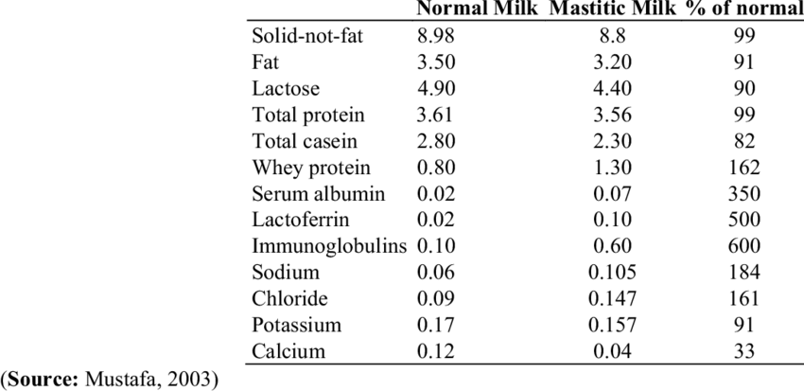

3-Age and body weight at calving:-
The amount of milk produced by the cow increases with advancing lactations (age). This is due in part to an increase in body weight, which results in a larger digestive system and a larger mammary gland for the secretion of milk. Another reason for increased milk-production with age is due to the effects of frequent pregnancies and lactations.

4-Stage of lactation:-

This is by far the most important physiological variable. The fat, lactose and protein contents of milk vary according to stage of lactation. Solids-not-fat content is usually highest during the first 2 to 3 weeks, after which it decreases slightly. Fat content is high immediately after calving but soon begins to decrease, and continues for 10 to 12 weeks, after which it tends to rise again until the end of the lactation. The variation in milk constituents throughout lactation is shown in table below.

Composition of colostrum, transitional milk and milk.
Time after calving Casein% Globulin% Fat% Lactose % Ash% Total solids%
At once 5.00 11.07 6.55 2.90 1.22 26.74
6 hours 3.50 6.60 7.82 3.29 0.97 22.18
12 hours 3.12 2.86 4.10 3.88 0.88 14.84
18 hours 3.00 2.14 4.00 3.75 0.85 13.74
24 hours 2.61 1.91 3.64 3.82 0.85 12.83
36 hours 2.86 1.32 3.58 3.68 0.84 12.10
72 hours 2.77 1.10 3.52 4.41 0.84 12.64
5 days 2.74 1.00 3.55 4.79 0.83 12.91
10 days 2.62 0.68 3.57 4.92 0.82 12.61
The end lactation milk has salty test due to the high contents of Cl and Na.
By definition, only the secretion of the first milking after calving should be referred to as colostrum. Secretions from the second to the eighth milking (fifth day of lactation) are called transitional milk because the composition gradually becomes gradually similar to that of whole milk. In addition to its high nutritive value, colostrum provides antibodies needed to protect newborn calves from many infections that may lead to diarrhea and death. The concentration of antibodies in colostrum averages 6% (6 g/100 g of colostrum). In contrast, the concentration of antibodies in whole milk is about 0.1%.

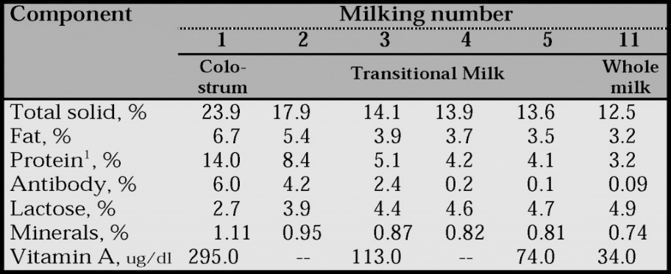
Composition of milk and colostrum
component | Colostrum | Whole Milk
Water% | 73 | 87
Total Solids% | 27 | 13
Total Proteins% | 17.57 | 3.5
Casein% | 5.8 | 2.8
Whey Proteins % | 11.4 | 0.7
%Fat | 5.1 | 3.7
%Lactose | 2.19 | 4.9
%Ash | 1.01 | 0.7
Vit.A µg\ 100ml | 295 | 34
Vit.D IU\100gm | 90-180 | 40
Vit.B2 mg\100ml | 0.48 | 0.15
Choline µg \100ml | 70 | 13
lgG\100ml | 8.1 | <0.2
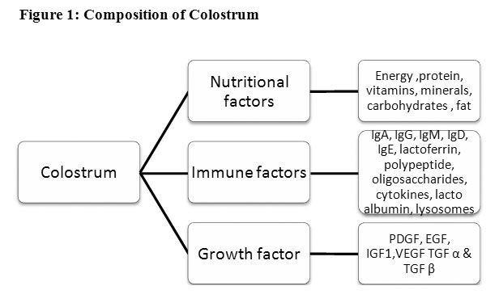

5-Interval between milking:-
The fat content of milk varies considerably between the morning and evening milking because there is usually a much shorter time between the morning and evening milking than between the evening and morning milking. If cows were milked at 12-hour intervals the variation in fat content between milking would be negligible, but this is not practicable on most farms.
Table: Range of values for fat and total solids content of morning milk and evening Milk
Components | Morning milk | Evening Milk
Fat % | 2.6-4.2 | 3.1-4.9
Total solids % | 10.9-12.9 | 11.6-13.8

6-Completeness of milking:-
The first milk drawn from the udder is low in fat while the last milk is always quite high in fat. Thus it is essential to mix thoroughly all the milk removed, before taking a sample for analysis. The fat left in the udder at the end of a milking is usually picked up during subsequent milking, so there is no net loss of fat. Milk fat % increases continuously during the milking process. This is because of the low density of the fat globules which leads it to trap in the alveoli. Thus after incomplete milking, milk fat content will be lower than normal.

7-Feeding regime:-

Underfeeding reduces both the fat and the SNF content of milk produced, although SNF content is more sensitive to feeding level than fat content. Fat content and fat composition are influenced more by fiber intake. Of all milk components, milk fat is the most influenced by dietary manipulations. Most of changes in milk composition due to dietary manipulation are related to changes in ruminal acetate: propionate ratio. Several nutritional factors can influence milk composition. These include plane of nutrition, forage: concentrate ratio, forage quality (e.g. particle size), level and type of dietary fat.
The SNF content can decrease if the cow is fed a low-energy diet, but is not greatly influenced by protein deficiency, unless the deficiency is acute.

