Milk constituents:-
1--Water
The water content of dairy products ranges from around 4 to 88% (w/w) and is the principal component by weight in most dairy products, including milk, cream, ice-cream, yogurt and most cheeses. The moisture content of foods {Water activity (a_{w})} is an index of the availability of water for microbial growth & multiplying if water is unavailable for pathogenic or spoilage-causing bacteria to growth & multiply, food is well preserved and has a longer shelf life., (a_{w}) is defined as the ratio between the vapor pressure of the water in a food system (p) and that of pure water (Po). (aw) plays a very important role in food technology. Water is the most important diluents in foodstuffs and has an important influence on the physical, chemical and microbiological changes which occur in milk & dairy products.
Milk Lipids:
Milk lipids (3 to 5%) exists as a globules emulsified in the aqueous phase (87%) of milk.fat-in-water emulsion. The lipids content of milk is importance include
1- Lipids in milk provide a major source of energy value: Milk fat - 9.3 C/g.
2- Economically because milk is sold on the basis of fat.
3- Nutritive value, milk lipids play a positive role in the diet as a source of fat-soluble (A, D, E, K.) and essential fatty acids (fatty acids which cannot be synthetized by higher animals spatially linoleic acid C18:2).
4-Milk lipids also contribute to the palatability of the diet.
5- Milk lipids Plays a significant role in flavor, rheological properties of milk and milk products, it imparts a soft body, smooth texture and rich taste to dairy products.

Milk lipids compositions:
Lipids of fresh milk are complex mixture of many fractions widely differ in chemical structure but all are dissolve in non-polar solvents(Diethyl ether, petroleum ether, benzene, chloroform….) and not dissolve in polar solvents (water).
Lipids | percentage | Position
Triglycerides: | 98.3 | Core of Globule
Phospholipids | 0.8 | Core of Globule, Globule Membrane, Milk Plasma
Sterols | 0.32 | =
Free fatty acids | 0.1 | Core of Globule, Milk Plasma
Cerebrosides | 0.1 | Globule Membrane, Milk  Plasma
Carotenoids | 0.02
Waxes | Traces | Core of Globule
Fat solubleVitamins | µg\gm fat
Vitamin A | 7-8.5
Vitamin E | 2-50
Vitamin D | Traces
Vitamin K | Traces

Milk fat globule:-
More than 95% of the total milk lipid is in the form of a globule as an oil-in-water emulsion ranging in size from 0.1 to 22 microns in diameter.

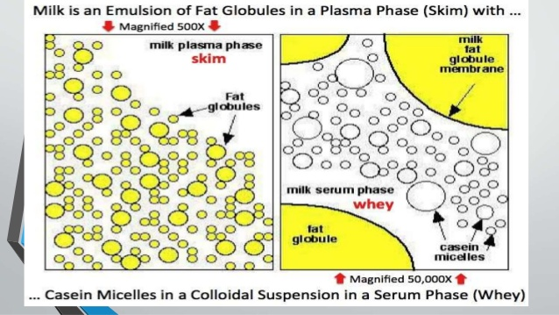

These fat droplets are formed by the endoplasmic reticulum in the epithelial cells in the alveoli and encapsulate by very thin bilayer member with diameter of (8-10 nm) as surface material consist of (proteins, phospholipids, cerebrosides, enzymes and bound water). When secreted, they are enclosed with the plasma membrane of the cell. The composition and structure of the milk fat globule membrane (MFGM) is not known in detail but it is mainly composed of polar lipids and membrane-bound and associated proteins. The lipid fraction comprising approximately 30% of the membrane material consists of lipids such as phospholipids (25%), cerebrosides (3%) and cholesterol (2%). The remaining 70% of the membrane material are proteins, many of them being enzymes.
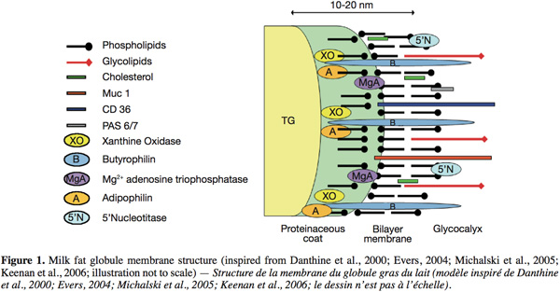
-MFGM Provides stabilization for fat globules as emulsion in the aqueous environments of milk serum.
-when ruptured, the fat globules join together into solid mass of fat.(This is what happens during the production of butter).
-Protects fat from enzymatic action.
- Helps prevent fat globules to coalescence and flocculation.
It is well known that if raw milk or cream if left to stand, it will separate. Stokes' Law predicts that fat globules will cream due to the differences in densities between the fat and plasma phases of milk. However, in cold raw milk, creaming takes place faster than is predicted from this fact alone. IgM (agglutinin) an immunoglobulin in milk, forms a complex with lipoproteins. This complex, known as cryoglobulin precipitates onto the fat globules and causes flocculation. This is known as cold agglutination. As fat globules cluster, the speed of rising increases and sweeps up the smaller globules with them. The cream layer forms very rapidly, within 20 to 30 min., in cold milk.
Homogenization of milk prevents this creaming by decreasing the diameter and size distribution of the fat globules; homogenization causes the formation of a recombined membrane which is much similar in density to the continuous phase.
Milk Fatty acid (FA) compositions.
Milk fat triacylglycerols (Triglycerides) are synthesized from more than 400 different fatty acids, which make milk fat the most complex of all natural fats. Nearly all of these acids are present in trace quantities and only about 12
acids at the 1% level or higher.
Many factors are associated with the variations in the amount and fatty acid composition of bovine milk lipids. They may
be of animal origin, i.e. related to genetics (breed and selection), stage of lactation, mastitis and ruminal fermentation, or they may be feed-related factors, i.e.
related to fibre and energy intake, dietary fats, and seasonal and regional effects.

Fatty acid Weighted SD Lowest value Highest value Seasonal
mean 2001 observed observed variation
4:0 4.4 0.1 4.0 5.1 n.s.

6:0 2.4 0.1 2.1 2.9 n.s.
8:0 1.4 0.1 1.2 1.9 n.s.
10:0 2.7 0.2 2.4 3.5 *
12:0 3.3 0.2 3.0 4.1 **
14:0 10.9 0.5 10.0 12.1 ***
15:0 0.9 0.0 0.8 1.1 n.s.
16:0 30.6 0.9 28.7 34.1 **
17:0 0.4 0.0 0.4 0.5 **
18:0 12.2 0.4 10.3 3.3 n.s.
20:0 0.2 0.0 0.2 0.2 n.s
S.F.A total 69.4 1.7 67.1 74.4 ***
10:1 0.3 0.0 0.2 0.4 n.s.
14:1 0.8 0.4 0.4 1.3 **
16:1 1.0 0.0 0.9 1.8 n.s.
17:1 0.1 0.0 < 0.1 0.3 n.s.
18:1 22.8 1.0 19.7 24.7 ***
Mono- 25.0 1.0 22.2 26.7 **
U.S.F.A.
cis, total

18:2 1.6 0.1 1.4 1.8 n.s.
18:3 0.7 0.0 0.6 0.9 **
Poly-U.S.F.A. 2.3 0.1 2.0 2.5 n.s.
, cis,total
16:1t 0.4 0.1 0.3 0.4 ***
18:1t 2.1 0.7 2.0 3.3 ***
18:2t 0.2 0.0 0.1 0.5 n.s.
Trans F.A 2.7 0.7 0.6 3.9 ***
Total CLA 0.4 0.1 0.3 0.5 ***

Some notes about milk fat fatty acids:-
1-The content of saturated fatty acids is lowest in the summer when the cows are grazing, and highest in the winter due to indoor feeding. The content of the unsaturated fatty acids shows the opposite pattern with the highest amount in the summer. when the cows are grazing, and lowest in the winter due to indoor feeding.
2-butyric fatty acid
CH3(CH2)2COOH
is specific for milk fat of ruminant animals and is responsible for the rancid flavor when it is cleaved from glycerol by lipase action.
3-The saturated fatty acids present in milk accounts for approximately 70% by weight.
4-The most important fatty acid from a quantitative viewpoint is palmitic acid (16:0) CH3(CH2)14COOH
which accounts for approximately 30% by weight of the total milk fat fatty acids.
5-Myristic acid (14:0) CH3(CH2)12COOH
& stearic acid (18:0) CH3(CH2)18COOH
make up 11 and 12% by weight, respectively of the saturated fatty acids.
6- short-chain fatty acids comprise about 10.9% of total milk fatty acids which include:
1-(C4:0 Butyric CH3(CH2)2COOH
2-C6:0 Caproic CH3(CH2)4COOH
3-C8:0 Caprylic CH3(CH2)6COOH
4-C10:0) Caprylic CH3(CH2)8COOH
Also named as volatile fatty acids

7-Approximately 25% of the fatty acids in milk are mono-unsaturated
Oleic acid (18:1)
CH3(CH2)7CH=CH(CH2)7COOH.
accounting for 23.8% by weight of the milk total fatty acids.
8-Poly-unsaturated fatty acids comprise about 2.3% by weight of the total fatty acids
the main poly-unsaturated fatty acids are linoleic acid (18:2cis Δ^{9,12})
omega-6 and ɑ-linolenic acid (18:3cis Δ^{9,12,15}) omega-3
accounting for 1.6 and 0.7% by weight of the total fatty acids..
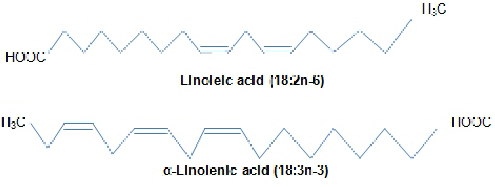

9-The ratio between omega-6 and omega-3 fatty acids is about
2.3:1 .
10-Approximately 2.7% of the fatty acids in milk are trans fatty acids with one or more trans-double bonds.
The main trans 18:1 isomer is vaccenic acid (VA), (18:1 t, Δ¹¹)
.
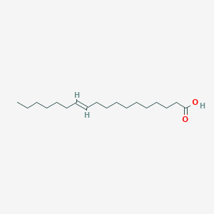
11-Milk fat contains also conjugated linoleic acid (CLA), with many different isomers including rumenic acid (RA) (18: cis-9, trans-11 CLA) which predominates (75_90% of total CLA).
