Milk fat compositions
A- Triglycerides or Triacylglycerol (TAG):-
The main milk lipids are a class called triglycerides which are esters comprised of a glycerol backbone binding up to three different fatty acids.
The composition of TAG is usually defined in terms of the kinds and amounts of FA present. The of TAG structure also includes the distribution of FA within the TAG molecule and
among the TAG molecules, as well as the identification of the individual molecular species of TAG.
The structure of the TAG influences the action of lipolytic enzymes and, therefore, absorption; it also influences the flavor of cheeses .The structure of milk TAG is responsible for the melting points, crystallization behavior, and rheological properties of MF as globules.
Bovine ML contains 12 FA in amounts greater than 1%. Therefore,
it would be theoretically possible to have 12 cubed (12 × 12 × 12) or 1728 TAG species if all the acids were randomly distributed. . In general, the SN1 position binds mostly longer carbon length fatty acids, and the SN3 position binds mostly shorter carbon length and unsaturated fatty acids. For example:C4 - 97% in SN3, C6 - 84% in SN3, C18 - 58% in SN1
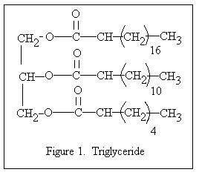
The most abundant TAGs found in milk
4:0-16:0-C18:1,
4:0-16:0-16:0,
4:0-16:0-14:0
16:0-16:0-C18:1

B- Mono- , diglycerides, The small amounts of and free fatty acids in fresh milk may be a product of early lipolysis or simply incomplete synthesis.
Some physiochemical properties of milk fat:-

Refractive index | 1.4527-1.4566
Solubility of water in fat | 0.14%
Melting Point | 30-41°C
Saponification number | 210-233
Polenske number | 12-24
Reichert-Meissl number | 17-35
Acid value | 0.4-1.8
Some properties of triglycerides:
1-Refractive index:
Refractive index of milk fat ranged between 1.4527 to 1.4566 The value of milk fat RI is less than that of oils because milk fat contain more saturated and less un- saturated fatty acids than oils.
2-Spicific Gravity:-the specific gravity of milk fat at 20°C is (0.93) .
3-Solubility:-Milk fat is readily dissolved by ethyl ether, chloroform, carbon tetrachloride and benzene. It is moderately soluble in acetone, slightly in alcohol and insoluble in water.

4-Melting point:
The melting point of milk is not sharp (30°C-41°C) because it is a result of the melting points of the individual fatty acids(complex mixture of individual fatty acids differ in no. of carbon atoms C4-C20 and degree of unsaturation double bond).
5-Saponification Number
The saponification value of milk fat is (210-233) , it is the number of mg of potassium hydroxide required to saponify the fatty acids in 1 g of milk fat. The saponification number is a measure of the average molecular weight of the triglyceride in a sample. Saponification value of milk fat is higher than that of oils because it contain high level of short and medium chain length fatty acids.
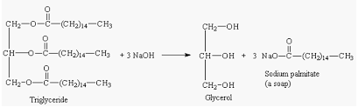
The saponification number of milk fat is( 231), peanut oil (190) corn oil (191),soy bean oil (192).Other fats as ole oil, lard and tallow ranged around (192-203).
6-Acid value
The acid value (AV) is milligrams of potassium hydroxide required to neutralize the free acids present in 1 g of milk fat.
acid value of fresh milk fat = 0.4-0.56
Significance
-Acid value is the measure of hydrolytic rancidity which increase more than normal value (milk fat deterioration). In fresh butter, the ADV will range between (0.4-0.56). When milk has an ADV more than (1), its flavor has been injured.
7-Iodine value
The iodine value is expressed as the grams of iodine absorbed per 100g of milk fat. Iodine value (I.V.) is directly related to the degree of unsaturation (Number of double bonds. I.V. of milk fat is less than that of oils because it contains less amount of un saturated fatty acids compared to oils.
An increase in I.V. indicates high exposure of lipid to oxidative rancidity due to high degree of unsaturation.

Type of fat or oil | Iodine Number
Butter | 30-34
Tallow | 35-40
Lard | 48-64
Olive oil | 77-91
Cotton seed oil | 104-116
Lin seed oil | 175-201
oils have greater degree of unsaturation than the fats , being higher in such fatty acids as oleic and linoleic .milk fat contains less of unsaturated fatty acids than tallow or lard and therefore has a lower iodine number. The iodine number of milk fat increases quite sharply during pasture season and when oily feeds are fed in quantities. It is also increasing during the last few weeks of the lactation period. Thus, any factors increase the proportion of unsaturated fatty acids, increases the iodine number.
8-Reichert Meissl Number
Is the number of milliliters of 0.1 N alkali (such as potassium hydroxide )required to neutralize the volatile water -soluble fatty acids in 5 g. milk fat. The Reichert Meissl test determines the amount of butyric and caproica cids .The Reichert value is an indicator of how much volatile fatty acids
Reichert Meissl of milk fat= 17-35
It is high compared to other lipids because, milk fat contains high amount of short chain volatile fatty acids. This number is an important means of distinguishing milk fat from other fats. It varies with season of year being highest in March, dropping during the summer and reaching its lowest point in October.
9-Kirschner value: It is the number of milliliters of 0.1 N of sodium or potassium hydroxide solution required to neutralize steam volatile water-soluble fatty acid distilled from 5g of milk fat which forms water soluble silver salts distilled from 5g fat under specified conditions. The Kirschner value is a measure of butyric acid.
Kirschner value = 22-26
It is high compared to other lipids because , milk fat contains high amount of butyric acid.
10-Polenske number
Is the number of number of milliliters of 0.1 N of sodium or potassium hydroxide to neutralize the volatile ,water –insoluble fatty acids ,alcohol soluble fatty acids which are present in 5 g. of milk fat.It is measure of the steam volatile and water insoluble fatty acids,chiefly caprylic, capric and lauric acids present in milkfat. Milk fat Polenske Number is range of (1.2-2.4).

Crystallization Behavior:
Milk fat is liquid above 40˚C and completely solid below-40˚C. Between these extremes milk fat is a mixture of crystals and oil. Milk fat contains a large number of tirglycerides as milk lipids contains different type fatty acids have different forms with different melting point, making the process of crystallization complex.
The kinetics of crystallization in lipids is dependent on the
1-triacylglycerol (TAG) composition, higher ratios of higher-melting triacylglycerols led to higher crystallization rate, 2-the position of the fatty acid residues in the triglyceride molecules considerably affects the crystallization behavior of milk fat 3- processing conditions (temperature, cooling rate, agitation rate, storge conditions etc.).
Milk fat largely determines the consistency of high-fat dairy products, There are three forms that milk fat crystals can occur in; alpha, ß , ß ' the alpha form is the least stable and is not often observed in slowly cooled fat.
The importance of the crystallization process of milk fat comes from the following:
1 - Affects the consistency and texture of high-fat dairy products such as butter.
2 - Affects the mouthfeel with high-fat dairy products, such as butter.
3- Affects the physical stability of dairy products, especially the partial coalescence process of fat globules together.
The crystallization process of milk fat goes through three stages.
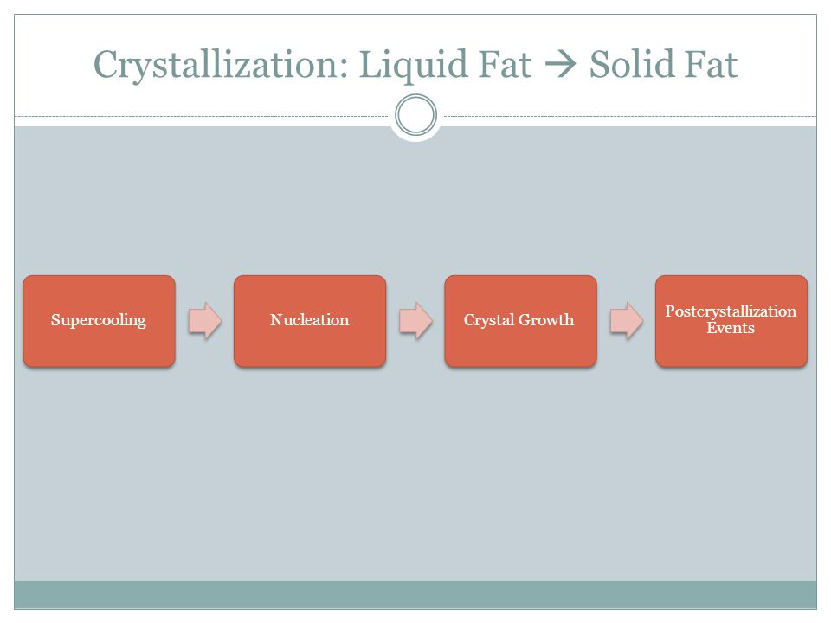

Deterioration of Milk Fat
1-Hydrolytic rancidity of milk fat:

The hydrolysis of triglycerides (hydrolytic rancidity or lipolysis) in milk produces free fatty acids (FFAs) .
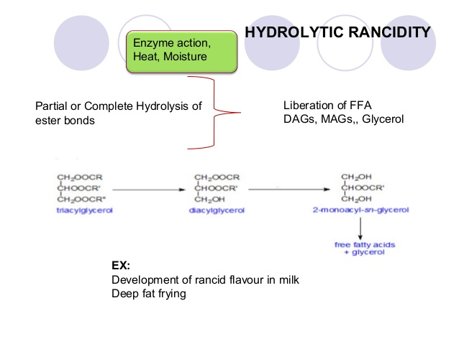
Lipolysis which have both harmful and desirable effects.
The extent of lipolysis in milk and dairy products is usually measured by the content of FFA.
-The harmful effects are due to the unpleasant flavors or flavor defect (off- flavors) of short-chain fatty acids mainly (C4:0 & C6:0) when present at high concentrations.
- under some conditions and usually at lower concentrations, the short-chain FFAs mainly (C4:0 & C6:0) impart desirable flavors to dairy products. For example, the characteristic flavor of some cheese varieties is due to their FFA content.
Lipolysis is caused primarily by lipases, which may be caused by
- The indigenous milk lipoprotein lipase
- or it caused by bacterial lipases, which are produced mainly by psychrotrophic bacteria such as Pseudomonads growing in milk before heat treatment.
Milk lipase is destroyed by pasteurization, but the bacterial lipases are heat-stable and hence can remain active in processed milk and dairy products and cause lipolysis during storage.
Lipolysis takes place at oil water interface.
The factors which influence enzyme activity are.
1- Surface area available.
2-Permeability of the emulsion.
3-Fatty acids type of triglyceride.
4- Position of fatty acids in triglyceride
5- The physical state of the substrate ( complete solid, complete liquid or liquid-solid).
6-Degree of agitation of the reaction medium.
7- pH.
8- Temperature,
9- The presence of inhibitors and activators,
10-Concentration of the enzyme and substrate.
2-Autoxidation:
Lipid oxidation in fluid milk and number of its products has been alarm of the dairy industry .To prevents this defect low-temperature refrigeration of butter, inert gas or vacuum packing of dry whole milk.
Chemical reactions involved autoxidation of milk fat are grouped in to
three steps.

1-Initiation:
The initial step in the autoxidation of unsaturated fatty acid and their ester is the formation of free radical. the reaction is initiated by the removal of hydrogen atom from the methylene group of adjacent to the double bond as a result of pro-oxidant which includes metals ions such as Cu and Fe, Reactive oxygen, light ,temperature .2-propagations:
The resulting free radical stabilized by adds oxygen to form peroxide containing free radicals these in turn react with another mole of unsaturated compound to produce two isomeric hydroperoxides in addition to free radicals capable of continuing the chain reaction.
3-Termination:
Hydroperoxides formed due to autoxidation being unstable they readily decompose forming the aldehydes, ketones , hydrocarbons which impart characteristic off-flavours in the products(“painty”, nutty, melon-like, grassy, tallow,oily, card board, fishy, cucumber etc.)

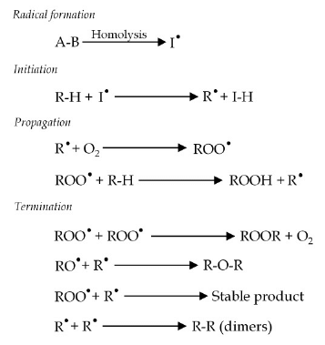

The rate of autoxidation is influenced by
1-The composition of milk and dairy products.
2- The physical state of the product (liquid, solid, emulsion, etc.).
3- The presence of natural anti-oxidants (vitamin E ,vitamin C ).
4- The presence of pro-oxidants such as light, oxygen, metal ions (Cu &Fe), moisture.
5- Processing, manufacturing and storage conditions
B-Di- and Monoglycerides of milk fat
Some of these occur in fresh milk fat. Lipolysis increases their quantities. Diglycerides are mainly a polar and do not differ much from triglycerides in
properties. Monoglycerides, present in far smaller quantities, are somewhat polar;
they are surface active and thus accumulate at an oil–water interface.
Most lipolytic enzymes, including that of milk, especially attack the 1- and the
3-position of the triglyceride molecule. This means that most monoglycerides have a fatty acid residue at the 2-position, and that most of the free fatty acids formed originate from the other positions, including the short-chain types that are mostly in the 3-position.
C-Free Fatty Acids
These already occur in fresh milk and lipolysis increases their amount. Especially
the shorter acids are somewhat soluble in water. In water, the acids can,
dissociate into ions; In milk plasma, they are mainly in the ionized form (i.e., as soaps), and these are much more soluble in pure water than the pure fatty acids.
Fatty acids dissolve well in fat, though only in the non ionized form. Moreover,
they tend to associate into dimmers, by forming hydrogen bonds.
The partition of the acids over the fat and water
the shorter free fatty acids (C4 and C6) are mainly in the plasma, the longer ones
(from C14 – C20) in the fat. The other acids are distributed between both fractions,
though more go into the fat with decreasing pH (with ionization becoming
weaker).

