**D- Compound Lipids:-**

These are also called polar lipids, because they contain charged (Most of the compound lipids have an acidic and a basic group). They are strongly amphipolar at neutral pH.. They are highly surface active and form the typical bi-layers that are the basic structure fat globule membrane. Compound lipid are absent in the core of milk fat globule.

**1-Phospholipids:**

**1-Phospholipids:-**

Phospholipids (PLs) are basic constituents of natural membranes; their amphiphilic properties derive from the presence of both a hydrophobic tail and a hydrophilic head. This characteristic affects their role, **behavior and function.** They belong to the class of polar lipids and are defined as “lipids containing phosphorus”. Polar lipids are fundamental in milk for the **emulsification of fat in water, because together with proteins**, they are the main constituents of the milk fat globule membrane (MFGM), which encloses the lipid droplets secreted by the mammary gland cells. they are Lipids contain fatty acids, alcohol, and phosphoric acid residue as additional groups. They frequently have nitrogen containing base and other substituents.

**Glycerophospholipids and sphingolipids**

are the most important PLs in milk. They represent about 0.5%–1% of milk fat and about 60%–70% of the PL in milk are in the MFGM, placed mainly in the external bilayer membrane. It is hypothesized that most PLs containing choline (PC)(Lecithin) and SM (Sphingomyelin) are located on the outside of the membrane, whereas PE(cephaeline), PS (phosphatidyl serein)and PI(phosphatidyl inositol ) are mainly placed on the inner surface of the membrane .

**Table below shows the phospholipids compositions of bovine milk**

|  |  |
| --- | --- |
| **Phospholipids** | % |
| **Glycero-phospholipids** | |
| phosphatidyl choline(lecithin) | 34.5 |
| phosphatidyl ethanolamine(cephalin) | 31.8 |
| phosphatidyl inositol | 4.7 |
| phosphatidyl serine | 3.1 |
| Plasmalogens | 3 |
| **Sphingo-phospholipids** | |
| Sphingomyelin | 25.2 |

As it is clear from the table above the most abundant phospholipids in milk is **phosphatidyl choline(lecithin)**

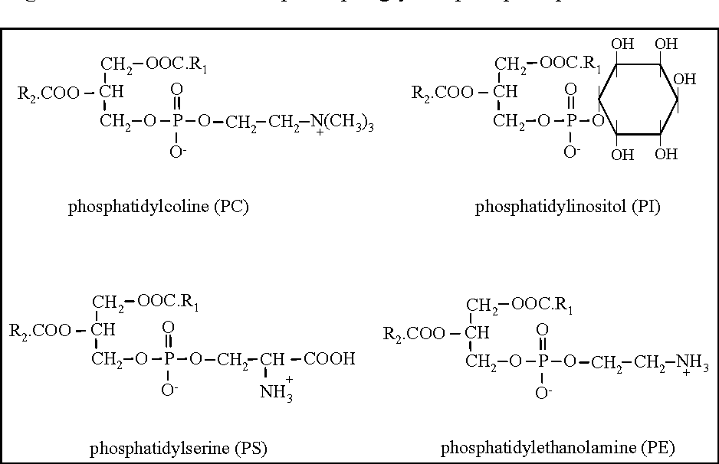

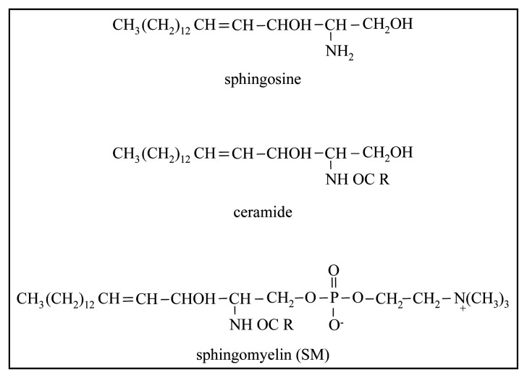

Although phospholipids are quantitatively less but they play a very important role in

1-the formation and secretion of the milk fat apart from forming a stable emulsion in aqueous solution.

2-These lipids play an important role during storage and processing of milk due to their susceptibility to oxidation of the polyunsaturated fatty acids.

3-Phospholipids are also found as lipoprotein complexes in skim milk. The skim milk phase may contain 30-50% of the phospholipids in milk.

**2-Cerebrosides:**

They are glycolipids consist of sphingosine as alcohol, long chain fatty acids and sugar. Cerebrosides which contain glucose and lactose have been isolated from milk by some research workers. They found 1.7 mg / 100ml in the globule membrane and 0.8 mg / 100 ml in skim milk. The membrane bound cerebrosides contained mainly fatty acids of 20 to 25 carbons and those in skim milk contained 18 carbon or less .



**E-Milk sterols:**

These compounds are found in the unsaponifiable fraction of milk lipids consists mostly of cholesterol which represents about 95% of the sterols in milk. Research workers who have come with dry saponification have reported that the content of sterols were 0.33 to 0.36% of fat milk.

The chemical structure of cholesterol is:

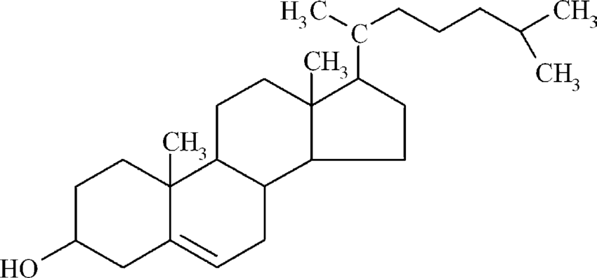

Cholesterol is a source of bile acids and some hormones

Especially sexual and a source of vitamin, and increase the proportion of cholesterol Blood leads to atherosclerosis.

Cholesterol in milk is either free or in the form of esters Cholesterol (by binding to a fatty acid).

The locations of cholesterol in milk are:

1- In the lipid portion inside the fat globule.

2- As part of the fat globule membrane complex.

3- Complex with milk proteins in the non-fat portion.

Further investigations in this field have revealed the presence of two new constituents named dihydrolanosterol and β sitosterol.