Milk Proteins: قؤناغى سى بيشه سازى خؤراك
Amino acids are the building blocks of proteins. Generally, all amino acids contains an alpha carbon atom (Except for proline). The general structure of amino acids is:
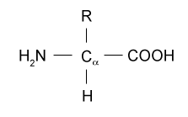
The amino acids differ from each other in their side chain(R)
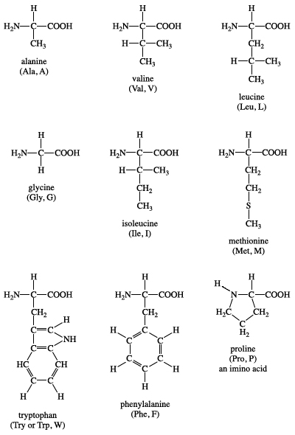
:
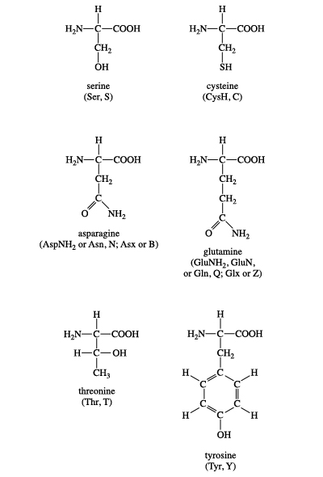
The amino acids are bound together in a protein by peptide bonds which are produced by the reaction of the carboxyl group in an amino acid with the amine group of another amino acid, with loses of water molecule.

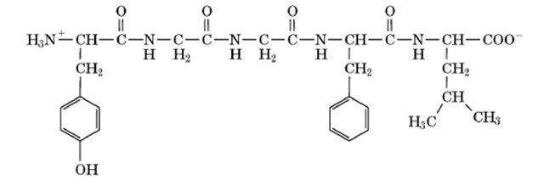
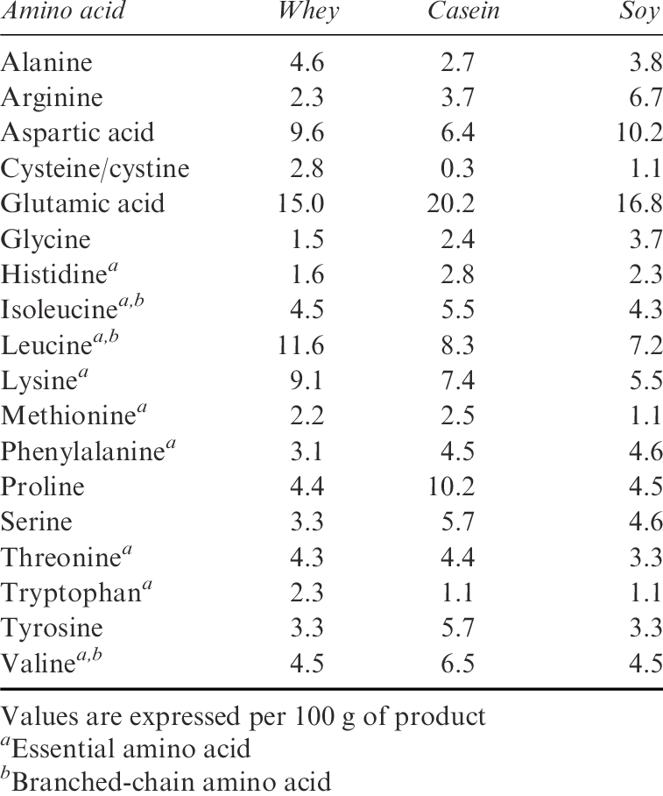
Milk proteins: -
Milk proteins consist of two major groups of proteins called caseins and whey proteins. Of the approximately 3.6% protein in milk, approximately 80% is casein and 20% is whey protein.

Milk Protein Fractionation
The nitrogen content of milk is distributed among caseins (75%), whey proteins (18%), miscellaneous proteins (2%) and non-protein nitrogen (5%). This nitrogen distribution can be determined by the Rowland fractionation method:
- Precipitation at pH 4.6 - separates caseins from whey nitrogen
- Precipitation with sodium acetate and acetic acid (pH 5.0) - separates total proteins from whey NPN
Ninety-five percent of the nitrogen is associated with protein. The average concentration of proteins in milk is as follows (although there can be considerable natural variation):

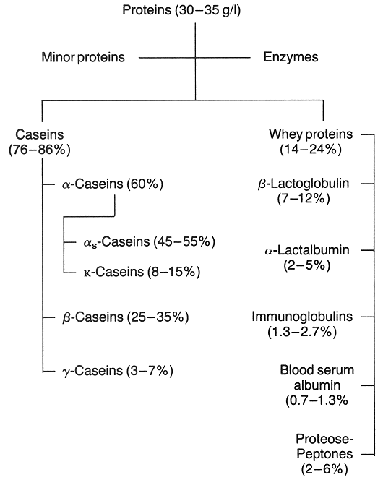

The average concentration of proteins in milk is as follows:
 | % of total protein
Total Protein | 100
Total Caseins | 78.8
alpha s1-casein | 32.4
alpha s2-casein | 8.5
beta-casein | 26.1
kappa-casein | 9.4
gamma-casein | 2.4
Total Whey Proteins | 19.4
alpha lactalbumin | 3.6
beta lactoglobulin | 9.8
BSA | 1.2
Immunoglobulins | 2.4
Proteose peptone | 2.4
Miscellaneous | 1.8

Milk Casein:-
The casein content of milk represents about 80% of milk proteins. The principal casein fractions are α(s1) and alpha(s2)-caseins, ß -casein, and kappa-casein in a percentage ratio of 40:10:40:10. Table below shows some differences between casein fractions:

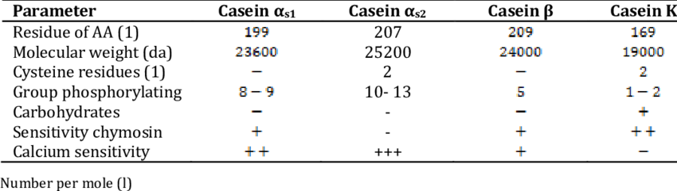
The characteristic properties of all caseins are
1- Their low solubility at pH 4.6.
2-The common compositional factor is that caseins are conjugated proteins, most with phosphate group(s) esterified to serine residues mainly, to a lesser extent, amino acid threonine. The percentage of phosphate in total casein is 0.85 %, αs-casein considered the richest caseinate in phosphates as it contains 0.6 % phosphate, then β-casein contains 0.18%, and K-casein 0.11%.

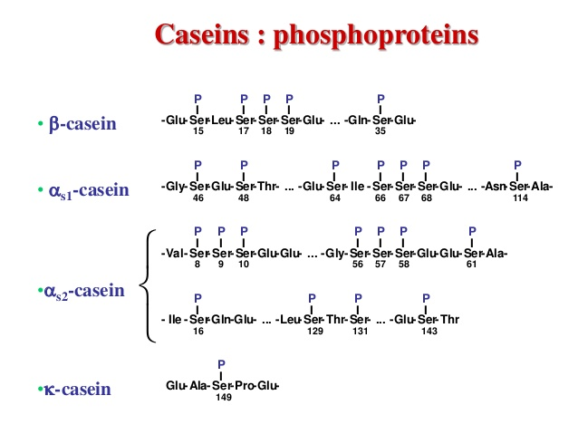

The importance of phosphate in casein can be explained by:
- These phosphate groups are important to the structure of the casein micelle. Calcium binding by the individual caseins is proportional to the phosphate content.
- From a nutritional point of view, phosphates have the ability to bind
large quantities of calcium and zinc ions.
- Phosphates increase casein solubility.
Phosphates are covalently bound to protein, and phosphates can be removed from
Casein by severe heat treatments or pH elevated or by the enzyme phosphatase.
3-The conformation of caseins is much like that of denatured globular proteins. The high number of proline residues in caseins causes particular bending of the protein chain and inhibits the formation of close-packed, ordered secondary structures. When proline is in a peptide bond, it does not have a hydrogen on the α amino group, it cannot donate a hydrogen bond to stabilize an α helix.
- proline led to produce partially folding α helix or naturally un folded protein (naturally denatured proteins) with high resistant against heat treatment this is cause why casein is very resistant against heat treatment. 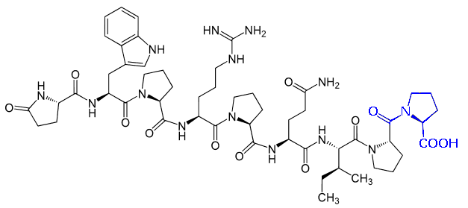
4- Casein is low in sulfur (0.8%) while the whey proteins are relatively rich (1.7%). The sulfur of casein is present mainly in methionine, with low concentrations of cysteine and cystine; in fact the principal caseins contain only methionine.
5-Caseins contain no disulfide bonds. As well, the lack of tertiary structure accounts for the stability of caseins against heat denaturation because there is very little structure to unfold. Without a tertiary structure there is considerable exposure of hydrophobic residues.
Casein micelles components and structure: -
About 85-95% of the casein in normal milk is in the form of colloidally dispersed particles, known as micelles containing on a dry basis of
94% protein(caseins)
6% colloidal calcium phosphate (CCP), which is comprised of
Calcium 3%
Magnesium 0.11%
Phosphate 2.26%
Citrate0.4%
In one of the most commonly accepted models, the casein micelles consist of spherical subunits or submicelles of the different caseins (αs1, αs2, β and k) held together by calcium phosphate bridges and hydrophobic interactions between proteins on the inside, surrounded by a layer of k-casein which helps to stabilize the micelle in solution. There are two main types of submicelles: one consisting of αs - and β -caseins, that constitutes the hydrophobic center of the submicelle, and another type consisting of αs - and k-caseins, which is distributed outside of the micelle with the hydrophilic part (the sugar residues of k-caseins) forming an outer “hairy layer”
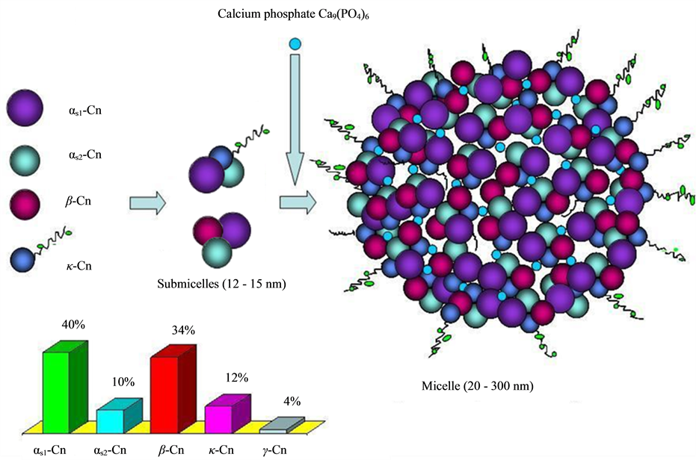

Casein Micelle Stability

Colloidal calcium phosphate (CCP) acts as a cement between the hundreds or even thousands of submicelles that form the casein micelle. Binding may be covalent or electrostatic. Submicelles rich in kappa-casein located a surface position, whereas those with less are found in the interior. The resulting hairy layer, at least 7 nm thick, acts to prohibit further aggregation of submicelles by steric repulsion.
The following factors are responsible of the casein micelle stability:

1-Role of Ca++:
More than 90% of the calcium content of skim milk is associated in some way or another with the casein micelle. The removal of Ca++ led to reversible dissociation of ß -casein without micellular breakdown. The addition of Ca++ leads to aggregation.
2-Hydrophobic interactions
There is presence of large number of hydrophobic residues clustered together in αS1‐, β‐, and k‐casein as found by amino acid sequence analysis of these proteins. Since these are among the most hydrophobic proteins, role of hydrophobic bonding in the stabilization of casein cannot be ignored. The ability of β‐casein to self‐associate was reduced after removal of isoleucine and valine at C‐terminal end of protein which normally self‐associate in the absence of calcium. Additionally, the ability of β‐casein to form polymers was destroyed completely after removal of 20 amino acids at C‐terminal which are mainly hydrophobic in nature. Various investigators have found that αS1‐, β‐ and k‐caseins diffuse out of the micelle at low temperature due to decrease in hydrophobic interactions .
3-Electrostatic interactions
There are many potential sites for strong ion bonding in a polar environment that might play a role in the stabilization of casein micelles. It is not possible to exactly assess the role of various inter‐ and intramolecular ionic bonds present in αs‐, β‐, and k‐casein in stabilization of casein micelle structure. The ability of k‐casein to stabilize the αS1‐casein is eliminated when there is carbamylation of lysine residues in k‐casein which further demonstrate that ionic interactions play a role in the casein micelle structure . Modification of arginine side chains also affects the casein micelle stability and chymosin‐induced coagulation.
4-Hydrogen bonding
The α‐helical and β‐pleated structures in many globular and fibrous structures are stabilized by hydrogen bonding along the polypeptide chain. Since casein proteins possess very little secondary structure, the degree of stabilization by α‐helix and β‐structure is very low. Hydrogen bonds between the various components of casein during the formation of highly aggregated casein micelle are possible
5-Disulfide bonds
Disulfide bonds between cysteine residues during folding of pleated sheet structures, helix, structures lead to the formation of tertiary structure. Both αS2‐ and k‐casein contain cysteine but the degree of disulfide cross‐linkages which are normally present in the casein micelle is controversial. It has been reported by many investigators that disulfide cross‐linkages contribute to the overall stability of the casein micelle but they are not the main force for the formation of casein micelle. Slattery found that larger micelles have higher molecular weight disulfide‐bonded polymers of k‐casein. These k‐casein molecules are thought to be contiguous with each other and form disulfide‐linked aggregates which compose the casein micelle structure.
There are several factors that will affect the stability of the casein micelle system:

Salt content:
affects the calcium activity in the serum and calcium phosphate content of the micelles.

pH:
lowering the pH leads to dissolution of calcium phosphate until, at the isoelectric point (pH 4.6), all phosphate is dissolved and the caseins precipitate.

Temperature:
at 4° C, beta-casein begins to dissociate from the micelle, at 0° C, there is no micellar aggregation; freezing produces a precipitate called cryo-casein.

Heat Treatment:
whey proteins become adsorbed, altering the behavior of the micelle.

Dehydration:
by ethanol, for example, leads to aggregation of the micelles.
When two or more of these factors are applied together, the effect can also be additive.
Methods of caseins precipitation:
1 - Acid precipitation:
Addition of acid to milk leads to the transformation of calcium ions associated with caseins and with colloidal calcium phosphate, involved in the binding of caseins with each other to the dissolving and ionizing state, which leads to its separation of colloidal calcium from casein micelles and caseins precipitation due to reaching to their isoelectric point. Acidification causes the casein micelles to destabilize or aggregate by decreasing their electric charge to that of the isoelectric point. At the same time, the acidity of the medium increases the solubility of minerals so that organic calcium and phosphorus contained in the micelle gradually become soluble in the aqueous phase. Casein micelles disintegrate and casein precipitates.
Ca-casein micelles + HCl H-caseinate + CaCl₂
Precipitate at pH 4.6
2- Ultra Centrifugal precipitation:
Casein micelles, phosphate, calcium and other salts contents precipitate by centrifugation, and in this method the proportion of dissolved casein is high
estimated about 5-20% of total casein.
3- Salting out:
the disadvantages of this method is that causes a precipitation of slight percentage of whey proteins with casein.
Casein + (NH4)₂SO₄ Casein Salts
26.4 g of (NH4)₂SO₄ / 100 ml milk

4- Precipitation with the addition of alcohol:
The alcohol pulls out the aqueous layer (Water of Hydration) surrounding casein micelles, which leads to their precipitation.
5-Enzymatic - chymosin (rennet) or other proteolytic enzymes as in Cheese manufacturing.
7- Age gelation. Age gelation is an aggregation phenomenon that affects shelf-stable, sterilized dairy products, such as concentrated milk and UHT milk products. After weeks to months storage of these products, there is a sudden sharp increase in viscosity accompanied by visible gelation and irreversible aggregation of the micelles into long chains forming a three-dimensional network.

