Fractionation of whey proteins
Separation of individual components of whey protein mixture was achieved by fractionations based on differences in solubility and by crystallization. At present the preferred methods of fractionation for both analytical and preparative purposes make use of gel filtration (which fractionates on the basis of molecular size) and ion exchange(which separates on the basis of net charge on protein). Gel filtration technique is particularly useful for fractionation of bovine whey proteins because of their great variation in their molecular size. The fact that β-lactoglobulin (MW = 18,277) forms a noncovalent dimer makes it readily separable from α-lactalbumin (MW = 14,175), as the latter does not aggregate.
- Whey proteins Have a compact globular structure
- whey proteins are globular, water-soluble
-Whey proteins Even distribution of hydrophilic and hydrophobic amino acids
-The major whey proteins :
α-lactalbumin and β-lactoglobulin
-The minor whey proteins :
Immunoglobulin, whey serum albumin, proteose peptones etc
- Whey protein diameters vary from as small as 1.6 nm for α-lactalbumin to 6 nm for immunoglobulins
- Overall whey proteins digest rapidly compared to casein and thus provide greater quantities of the amino acids such as cysteine ( 0.3%),((essential amino acids include , leucine (10.4%) and lysine (7.5%)).
- Whey proteins do not react with calcium and casein in the native states; however once denatured, whey proteins react with the casein micelle.
α-Lactalbumin
- α-La is a small globular protein that is relatively stable. It constitutes 21% of whey proteins.
- α-La consist of (4 α-helices, β-strands ,1 calcium)
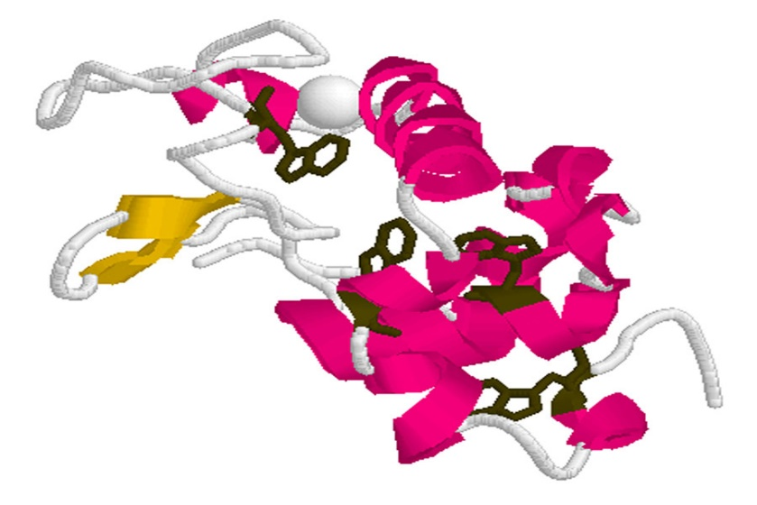
-isoelectric point of 4.8
- contain four disulphide bridges but no free cysteine
-This family of proteins consists of a major component and several minor components. Three genetic variants of α-lactalbumin have been identified. Two genetic variants, A and B, of this protein exist. They differ by a single substitution, A having Gln and B having Arg at position 10. In the milk of European breeds and yaks only B variant is observed while both A and B variants occur in the milk of Indian cattle.
- Some minor forms of bovine α-lactalbumin are revealed by electrophoresis. Some of these contain covalently bound carbohydrate groups; the major component of bovine α-lactalbumin is devoid of carbohydrate.
-Other minor components seem to have fewer amide groups than the major ones, and one minor α-lactalbumin containing three instead of four disulfides has been reported.
-The complete primary structure of the major α-lactalbumin has been determined Its genetic variant A has a molecular weight of 14,147 Da. Variant B has a molecular weight of 14,175 Da. α-La is composed of 123 amino acid residues.
-The amino acid sequence of α-lactalbumin is similar to that of lysozyme. Certainly, bovine α-lactalbumin B and chicken egg white lysozyme have identical amino acid residues at 49 positions, and the four disulfide groups are located identically ( positions between 6and 120; 28 and 111; 61 and 77; and 73 and 91, respectively) in α-lactalbumin. The two proteins have different biological activities without mutual interference.
-The biological activity of αlactalbumin is its interaction with galactosyltransferase to promote the transfer of galactose from uridine diphosphate galactose (UDP - galactose) to glucose to form lactose.
-The component of the lactose synthetase enzyme
Lactose synthetase
UDP-galactose + glucose lactose + UDP
- It has been shown that α-lactalbumin binds two atoms of Ca 2+. In fact it is probable that all preparations of this protein have carried this Ca undetected. Removal of the bound Ca with ethylenediamine tetraacetate renders α-lactalbumin more susceptible to denaturation by heat or by addition of guanidine.

β-Lactoglobulin
- Most abundant whey protein (not in humans) about 54% of whey proteins is β-lactoglobulin consists of 162 amino acids. (9 β -strands, 1 α-helix, 2 disulfides, 1 free sulfhydryl group (-SH))
- β -lactoglobulin (β-lg) is a globular protein with an isoelectric point of 5.1
- It is likely that considerable portions of the sequence of β-lactoglobulin exist in the α-helix and β-sheet structures. Regions that are most likely helical are residues21-37, 51-63, 127-143, and 154-159 respectively. β-sheet structures are likely in 2-19, 39-43,76-88, 91-99, and 101-107, while the structure of the sequence 114-125 is not clearly established.
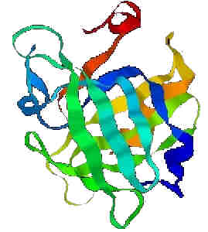
-there are two components of βlactoglobulin in the electrophoretic pattern of this protein in the western cattle. However, two more variants have also been identified by other workers. These genetic variants differ in their electrophoretic mobilities in starch or poly acrylamidegel in the ascending order as A > B > C > D. Bovine β-lactoglobulin consists of 162 amino acid residues. Their calculated molecular weight for monomer is 18,362 Da for variant A and 18,276 for variant B (B variant (Ala₁₁₈Val; Gly₆₄Asp), C variant (Gln₅₉His) ).
- β-Lactoglobulin exists naturally as a dimer of two monomeric subunits which is covalently linked with molecular weight of 36000. When more than one genetic variant is present, hybrid dimers are formed. The dimer contains five cysteine residues per mole, of which four are involved in disulfide linkages. Location of one disulphide bond always occurs between Cys residues at 66 to 160 positions and the other link is between 106 and119 or 121. Dissociation to the monomer occurs below pH 3.4. βLactoglobulin, associates to form an octamer at pH 4.5 and low temperature. The B variant (predominant in Western cattle) octamerizes to a smaller extent.
-The single free thiol appears to be equally distributed between Cys119 and Cys 121. The existence of this thiol group is of great importance for changes occurring in milk during heating, as it is involved in reactions with other proteins, notably κ-casein and α-lactalbumin.
Bovine serum albumin
-This protein, a major component of blood serum, is synthesized in the liver and gains entrance to milk through the secretary cells.
-it comprises only about 1.2% of the total milk protein. The protein as isolated from bovine milk could not be differentiated from that isolated from bovine blood. it has been assumed to be identical to that in blood.
- The protein isolated from blood consists of a single polypeptide chain of 582 amino acid residues. Its tertiary structure reveals three equal-sized globular domains. It has one free thiol and 17 disulfide linkages.
-There is no specific role of this protein in the function of mammary gland. The behavior of this protein in milk and milk products and its possible influence on their properties is not known.
Proteose peptone
-Rowland has defined the conditions and procedures for obtaining the various fractions of protein in milk and to quantify them. It was observed by him that if milk is heated, about 80% of the whey proteins consisting mainly of α lactalbumin and β-lactoglobulins which precipitate with the casein when it is precipitated by aciditification to pH 4.6.
-The remaining 20% is a separate protein to which he applied the name proteose-peptone. Proteose and peptones are the polymers of amino acids which are of lower molecular weight than proteins. They often are formed by the partial hydrolytic degradation of proteins.
-They are usually not heat denaturable and hence it was easy for Rowland to reason by analogy that the proteins of milk which remain soluble in acid after heating are proteoses and peptones.
- The nature of proteins in this fraction has not been clearly established. The issue is complicated by the fact that the fraction may consist in part of native proteins and in part of breakdown products resulting from heat treatment.

