**Reactions of monosaccharides:**

**1- Glycoside formation:**

In an acidic catalyzed reaction, the anomeric hydroxyl group (hemiacetal) of a monosaccharide condenses with alcohols to form compounds are called α and β glycosides. The bond so formed is known as a glycosidic bond.

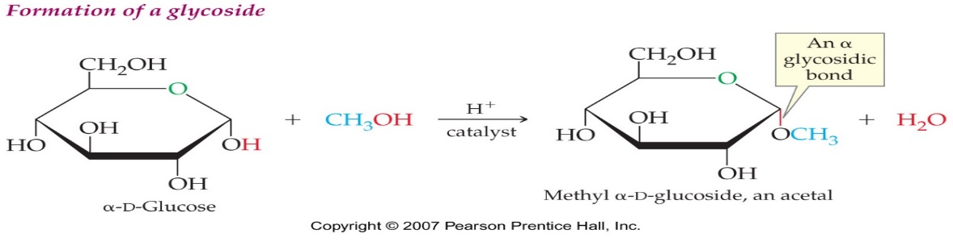

The monosaccharides held together by O- glycosidic bonds to form oligo or polysaccharides.

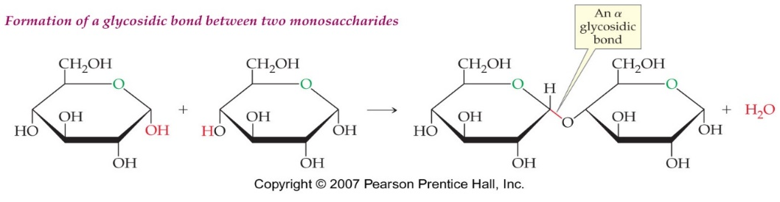

**2- Oxidation of sugar:**

a- Oxidation of functional group:

Under mild oxidation conditions, Bromine , Ag(I) (Tollen’s test) Fehling’s solution and ’s solution oxidizes aldehyde( functional group) to the carboxylic acid (aldonic acid) such as gluconic acid. Aldonic acids are named by appending the suffix –onic acid to the root of the parent aldose

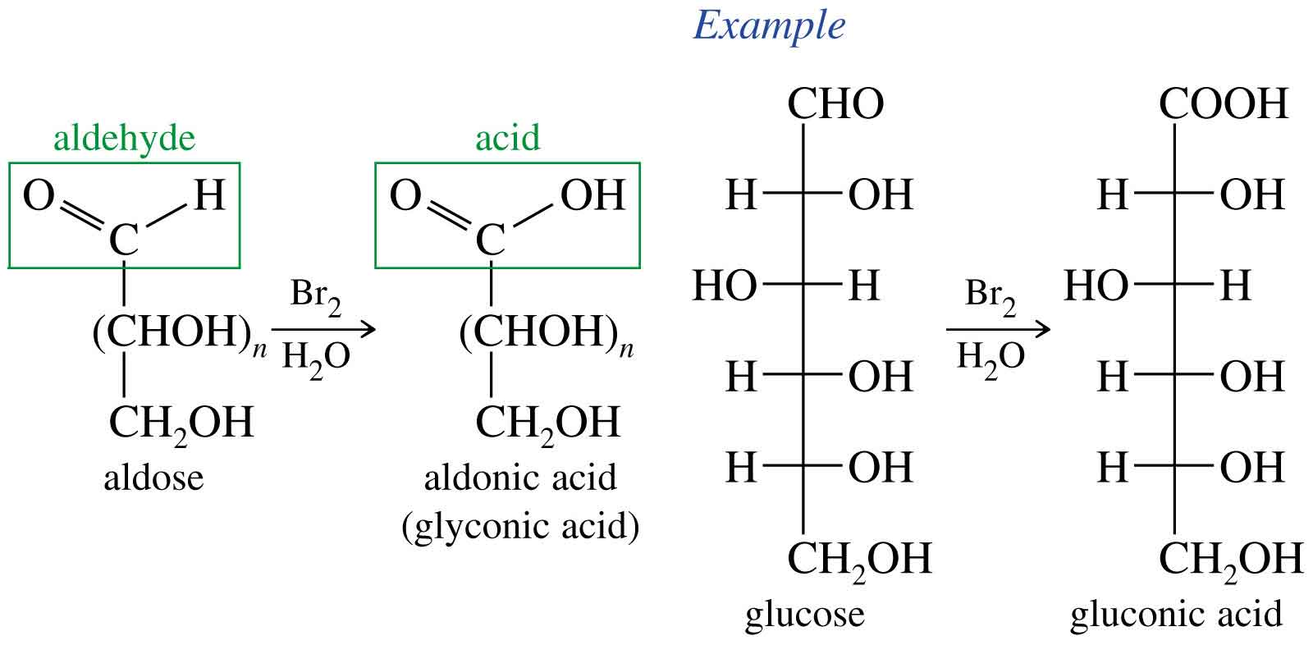

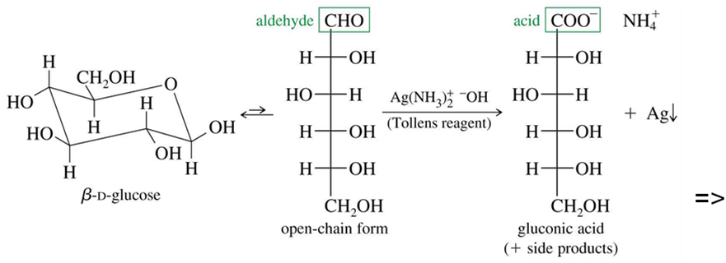

All those carbohydrates, which reduce Fehling’s solution and Tollens’ reagent, are referred to as reducing sugars. All monosaccharides whether aldose or ketose are reducing sugars.

In disaccharides, if the reducing groups of monosaccharides i.e., aldehydic or ketonic groups are bonded, these are non-reducing sugars like Sucrose. On the other hand, sugars in which these functional groups are free, are called reducing sugars, for example, maltose and lactose.

**b- Oxidation by Nitric Acid:**

Nitric acid oxidizes the aldehyde and the terminal alcohol forms aldaric acid. Aldaric acids are named by appending the suffix –aric acid to the root of the parent aldose

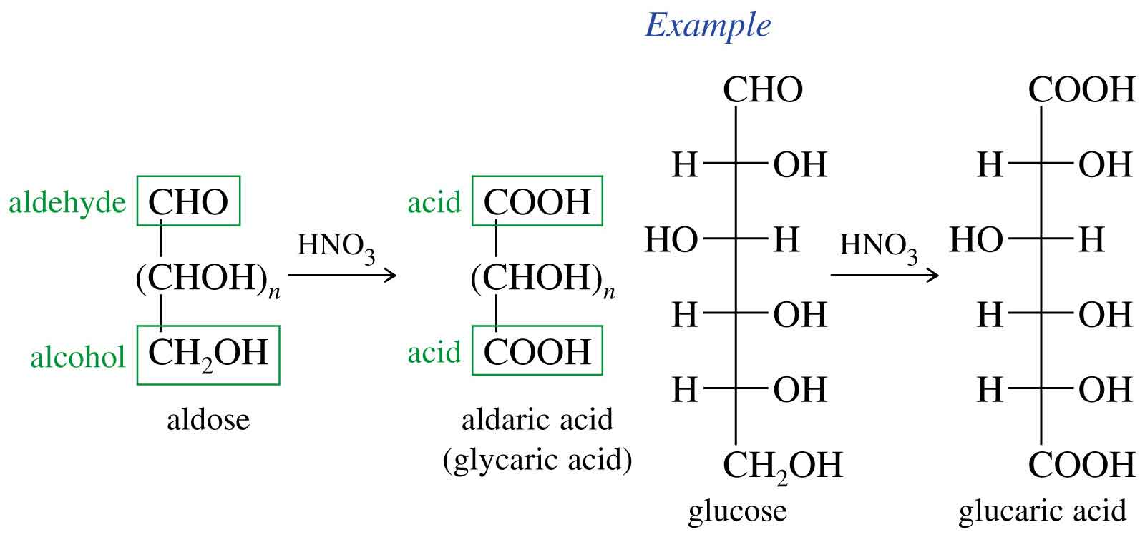

**c- Oxidation by Enzyme:**

Inliving cells system specific enzyme oxidizes the terminal alcohol forms

(alduronic acid. Aluronic acids are named by appending the suffix –onic acid to the root of the parent aldose D-Glucuronic acid, D-Galacturonic acid,

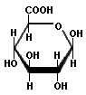

(a uronic acid)Glucuronic acid

**4-Reduction of Sugar:**

Sugars reduced in present of H2 (Hydrogen ) and chemical catalyst to produced sugar alcohols Sugar alcohols are not metabolically very active, but have some medical importance in that they are used as non glucose forming sweeteners in fruit stuffs for diabetics, sorbitol and xylitol are the most commonly used.

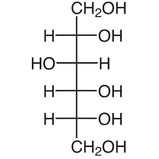 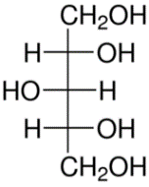 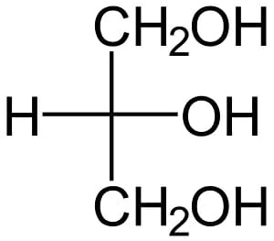

**5- Ester formation:**

Phosphate esters of glucose, fructose, and other monosaccharides are important metabolic intermediates, and the ribose moiety of nucleotides such as ATP and GTP is phosphorylated at the 5´-position

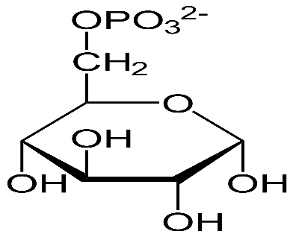

**Other Biologically important sugar derivatives of monosaccharide:**

Some important sugar derivatives of monosaccharide are:

**1- Amino sugar:**

Amino sugars have a hydroxyl group replaced by amino or an acetylated amino (acetyl amino) group. For example: glucosamine galactosamine …

Amino sugars are components of glycolipid (Ganglioside), glycoprotein

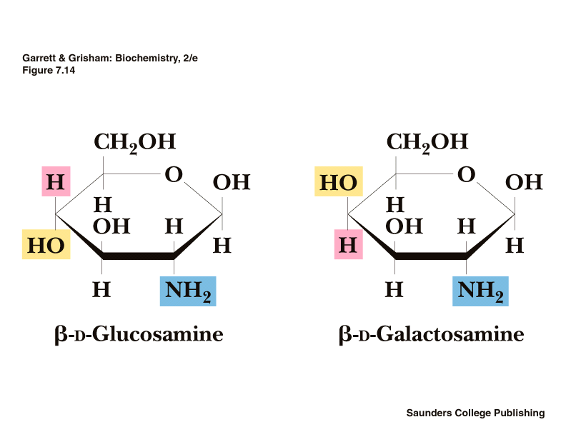

**2-Deoxy sugars:**

Deoxy sugars possess a hydrogen atom in place of one of their hydroxyl groups:

2-Deoxyribose (found in DNA)

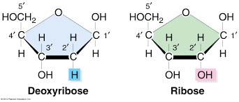

**Oligosaccharides:**

Oligasaccharides consist of short chains of monosaccharide units (two to ten units) joined by glycosidic linkages which is formed when OH group of one sugar reacts with the OH group of the anomeric carbon of the other sugar unit.

The oligosaccharides are composed of the disaccharides, trisaccharides, etc, depending on the number of monosaccharides, which are present.

**1-Disaccharides:**

Disaccharides consist of two monosaccharide units. Sucrose, maltose, and lactose are the most physiologically important disaccharides.

**Maltose:**

Maltose, often called malt sugar, is present in fermenting grains and can be prepared by enzyme-catalyzed degradation of starch.

In the body, it is produced during starch digestion by a-amylase in the small intestine and then hydrolyzed to glucose by a maltase enzyme.

It is a disaccharide, contains two glucose units, joined by α(1→4) glycosidic linkage between C-1 (the anomeric carbon) of one glucose residue and C-4 of the other glucose.

Maltose is not found in the free form in the body. It is formed during the digestion of his starch by the action of the enzyme α-amylase.

Maltose is a reducing sugar because it has one free hemiacetal hydroxyl group at C-1.

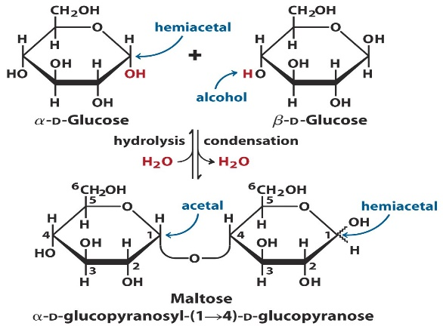

**Lactose:**

Lactose is a disaccharide found in the milk. Lactose contains one unit of β-D-galactose and one unit of β-D-Glucose that are linked by β (1→4) glycosidic linkage.

Lactose is hydrolyzed to glucose and galactose by lactase enzyme in human.

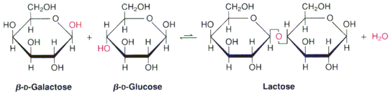

**Sucrose (Cane sugar, common table sugar or beet sugar):**

Sucrose is the sweetening agent known as cane sugar. It is present in cane sugar and various fruits.

Sucrose is a disaccharide contains α-D-glucose and β-D-fructose residues linked by α (1→2) glycosidic linkage. On hydrolysis, sucrose yields one molecule of D-glucose and one molecule of D-fructose by sucrase enzyme present in intestinal juice.

Sucrose has no hemiacetal group because a 1,2 link joins both anomeric carbon atoms. The absence of a hemiacetal group means that sucrose is not a reducing sugar.

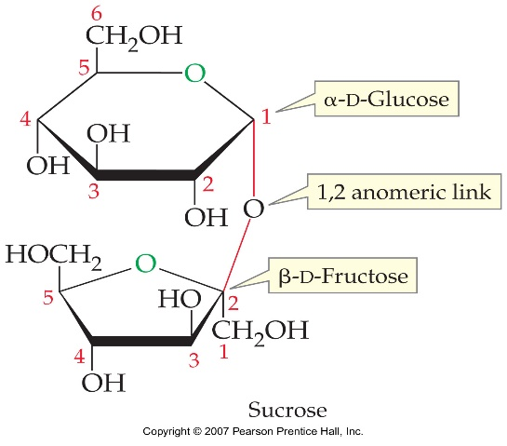

2-Trisaccharide: raffinose (glucose, galactose and fructose) .

Humans do not possess the α-GAL enzyme to break down RFOs and these oligosaccharides pass undigested through the stomach and upper intestine. In the lower intestine, they are fermented by gas-producing bacteria that do possess the α-GAL

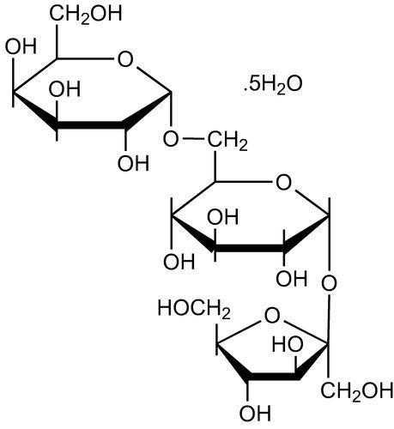

**Polysaccharides (Glycans):**

Polysaccharides contain more than ten monosaccharide units joined together by glycosidic linkages. These are the most commonly encountered carbohydrates in nature. They mainly act as the food storage or structural materials. Carbohydrates composed of more than ten monosaccharide units or their derivatives (like amino sugar) are called polysaccharides. Polysaccharides can be classified into:

1- Homo polysaccharides (homo glycans)

2- Hetero polysaccharides (hetero glycans)

**Homo polysaccharides (homo glycans):**

Polysaccharides having only one type of monosaccharide units are called homo polysaccharide. On hydrolysis, yield one type of monosaccharides. The most common homo glycans are starch, dextrin, glycogen, dextrons, inulin and dietary fiber cellulose.

Some homo polysaccharides serve as a storage form of monosaccharide used as fuel, like starch and glycogen. While others serve as structural elements in plant, like cellulose.

**Starch:**

Starch is the most common storage polysaccharide in plants, and its found in potatoes, rice, corn, Wheat, …….

Starch is consists of two types of polysaccharides:

1- Amylose (Water soluble 15-20%).

2- Amylopectin (Water soluble 80-85%).

**Amylose:**

Amylose is a liner polymer of D-glucose units joined by α(1→4) glycosidic linkage. The molecular weight ranges from several thousand to half a million. Amylose gives blue color with iodine solution. Amylose is hydrolyzed by α-amylase.

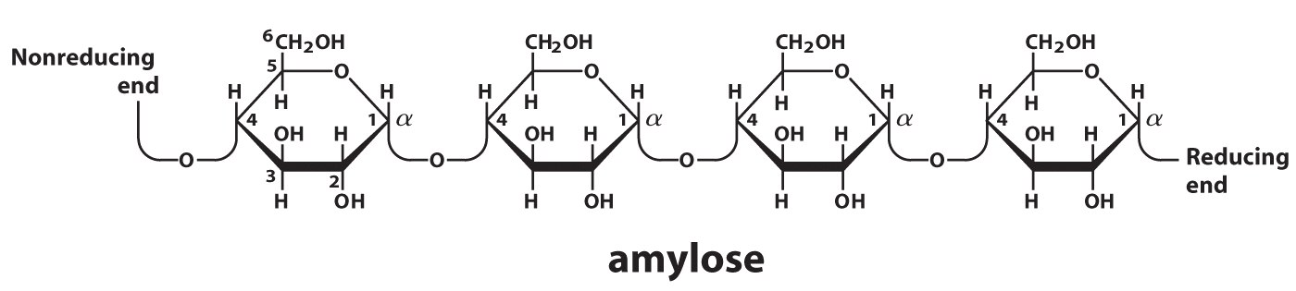

**Amylopectin:**

Amylopectin, the other component of starches, is highly branched chain of glucose unit. Branches occur in these chains on an average of 24 to 30 glucose units. The molecular weights of amylopectin molecules can range up to 100 millions. The linear linkages of amylopectine are α(1→4) glycosidic linkage, where as the branched linkages are α(1→6) glycosidic linkage. Amylopectin is water insoluble and gives violet color with iodine.

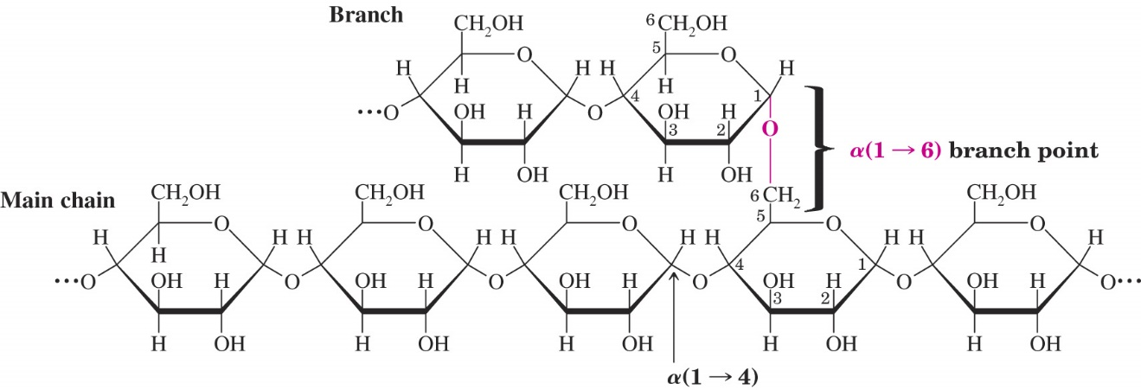

**Dextrin:**

Partial hydrolysis of starch by acid or α- amylase produces substances known as dextrins. Dextrins are present in the plant tissue during synthesis and degradation of starch. Dextrins formed from amylose have a liner chains, while these formed from amylopectins are branched. Dextrins are water soluble and react with iodine.

**Cellulose:**

Cellulose is the structural component of cell membrane of plants. Cellulose is a linear polymer of β-D-glucose units linked by a β (1→4) glycosidic linkage. On partial hydrolysis, cellulose yields β (1→4) disaccharide cellobiose. Cellulose is water insoluble and gives no color with iodine.

Cellulose cannot be digested by humans because it does not posses the cellulose an enzyme in the gastrointestinal tract which cleavage β (1→4) linkages. Then cellulose from fruits and vegetables serves as fiber in the diet and is now believed to be important for good health. But only a few animals such as cow, camel and goat are able to digest it, because these animals have, within their digestive tracts, microorganisms that produce the enzyme cellulose.

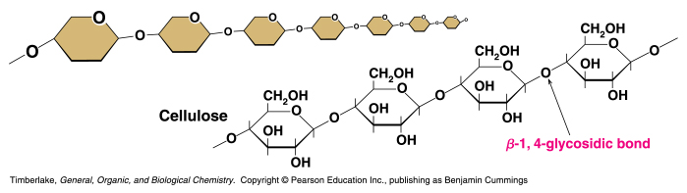

**Glycogen (Animal starch):**

Glycogen is the major storage polysaccharide in animals. Glycogen is found mainly in liver and muscle. About 5% by weight of liver and 0.5% by weight of s a muscle is glycogen. Glycogen is a highly branched chain in which glucose units in addition to linear α(1→4) are also linked by an α(1→6) at the branched points. This branching repeats after every 8-10 glucose unit. Glycogen is similar in structure to amylopectin except for more branch points. Glycogen can be hydrolyzed by both α and β- amylase yielding glucose and maltose, respectively as products.

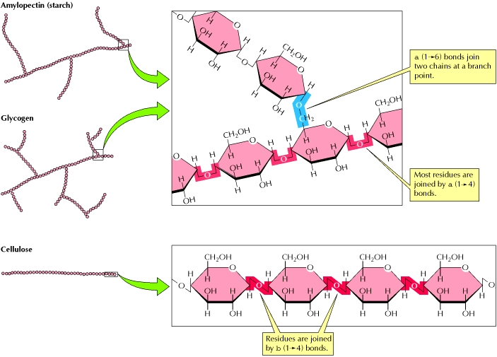

**Chitin**

-is the most abundant polysaccharide of nature after cellulose.

Chitin is a polymer of N-Acetyl-D-glucosamine units linked by β (1→4) linkages, (Note that the sugar oxygens flip with respect to each other) like cellulose. Chitin forms extended fibers similar to those of cellulose.

The cell walls of most fungi are chitin, Chitin also is the principal component of the hard exo skeletons of nearly a million species of arthropods (insects, crustaceans) shells of arthropods such as crabs and lobsters contain about 25 percent chitin. It is also found in certain structures of annelid worms, mollusks, and other invertebrate groups (e.g., jellyfishes, nematodes).

