Lipids

Introduction:
Lipids are a class of hydrocarbon-containing organic compounds. Lipids are soluble in nonpolar solvents (such as ether and chloroform) and are relatively insoluble in water.
Functions of lipids:
1- Lipids are a good source of energy for the body (9kcal/gm).
2- Lipids are major structural components of membranes, e.g., phospholipids, glycolipids and sterols.
3- Cholesterol, a sterol, is a precursor of many steroid hormones and is also an important component of plasma membrane.
4- Lipid helps in absorption of fat soluble vitamins
(A,D,E and K), it acts as a solvent for the transport of fat soluble vitamins.
5- Bile acids derived from cholesterol act as an emulsifying agent and help the digestion and absorption of lipids.
- Classification of lipids:
Lipids can be classified into:
1- Simple lipids.
a2- Compound lipids.
3- Derived lipids.
1-Simple lipids:
These are esters of fatty acids (F.A) with different alcohols.Simple lipids are classified into two types, depending on the type of alcohols:
A- Neutral lipids.
B- Waxes.

A-Neutral lipids:
Neutral lipids:
Esters of fatty acid with glycerol are called (glyceride).
Condensation
Glycerol + 3fatty acids ----------------------------→ triglyceride (fat) + water

Glycerol:-
Is a simple polyol compound,it has three hydroxyl groups. The glycerol backbone is central to all lipids known as triglycerides , glycrophospholipids & glycroglycolipids.

- Fatty acids:-
Fatty acids are long chain mono carboxylic acid. Fatty acids have hydrophilic (COOH) and hydrophobic (hydrocarbon chain) groups in the structure. Fatty acids serve as a major fuel for most cells and they are precursors of all other classes of lipid.
- Individual fatty acids can range in length from 4 to 22 carbons,
-Fatty acids may be saturated, which means that each carbon has a single bond to another carbon and 2 hydrogen atoms.

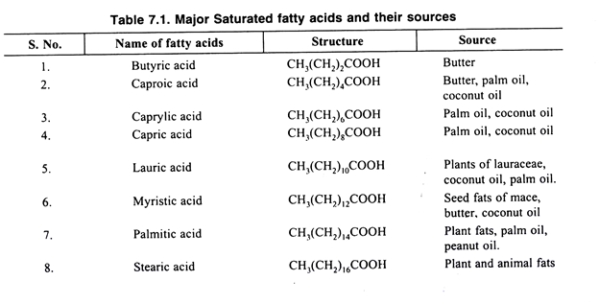
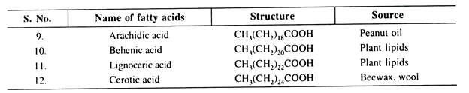

-fatty acids may be unsaturated, which means that a carbon has two bonds to the adjacent carbon, called a double bond, and a single bond to another carbon and a hydrogen atom.
-A monounsaturated fat has 1 double bond.
- A polyunsaturated fat has 2 or more double bonds in the carbon chain.
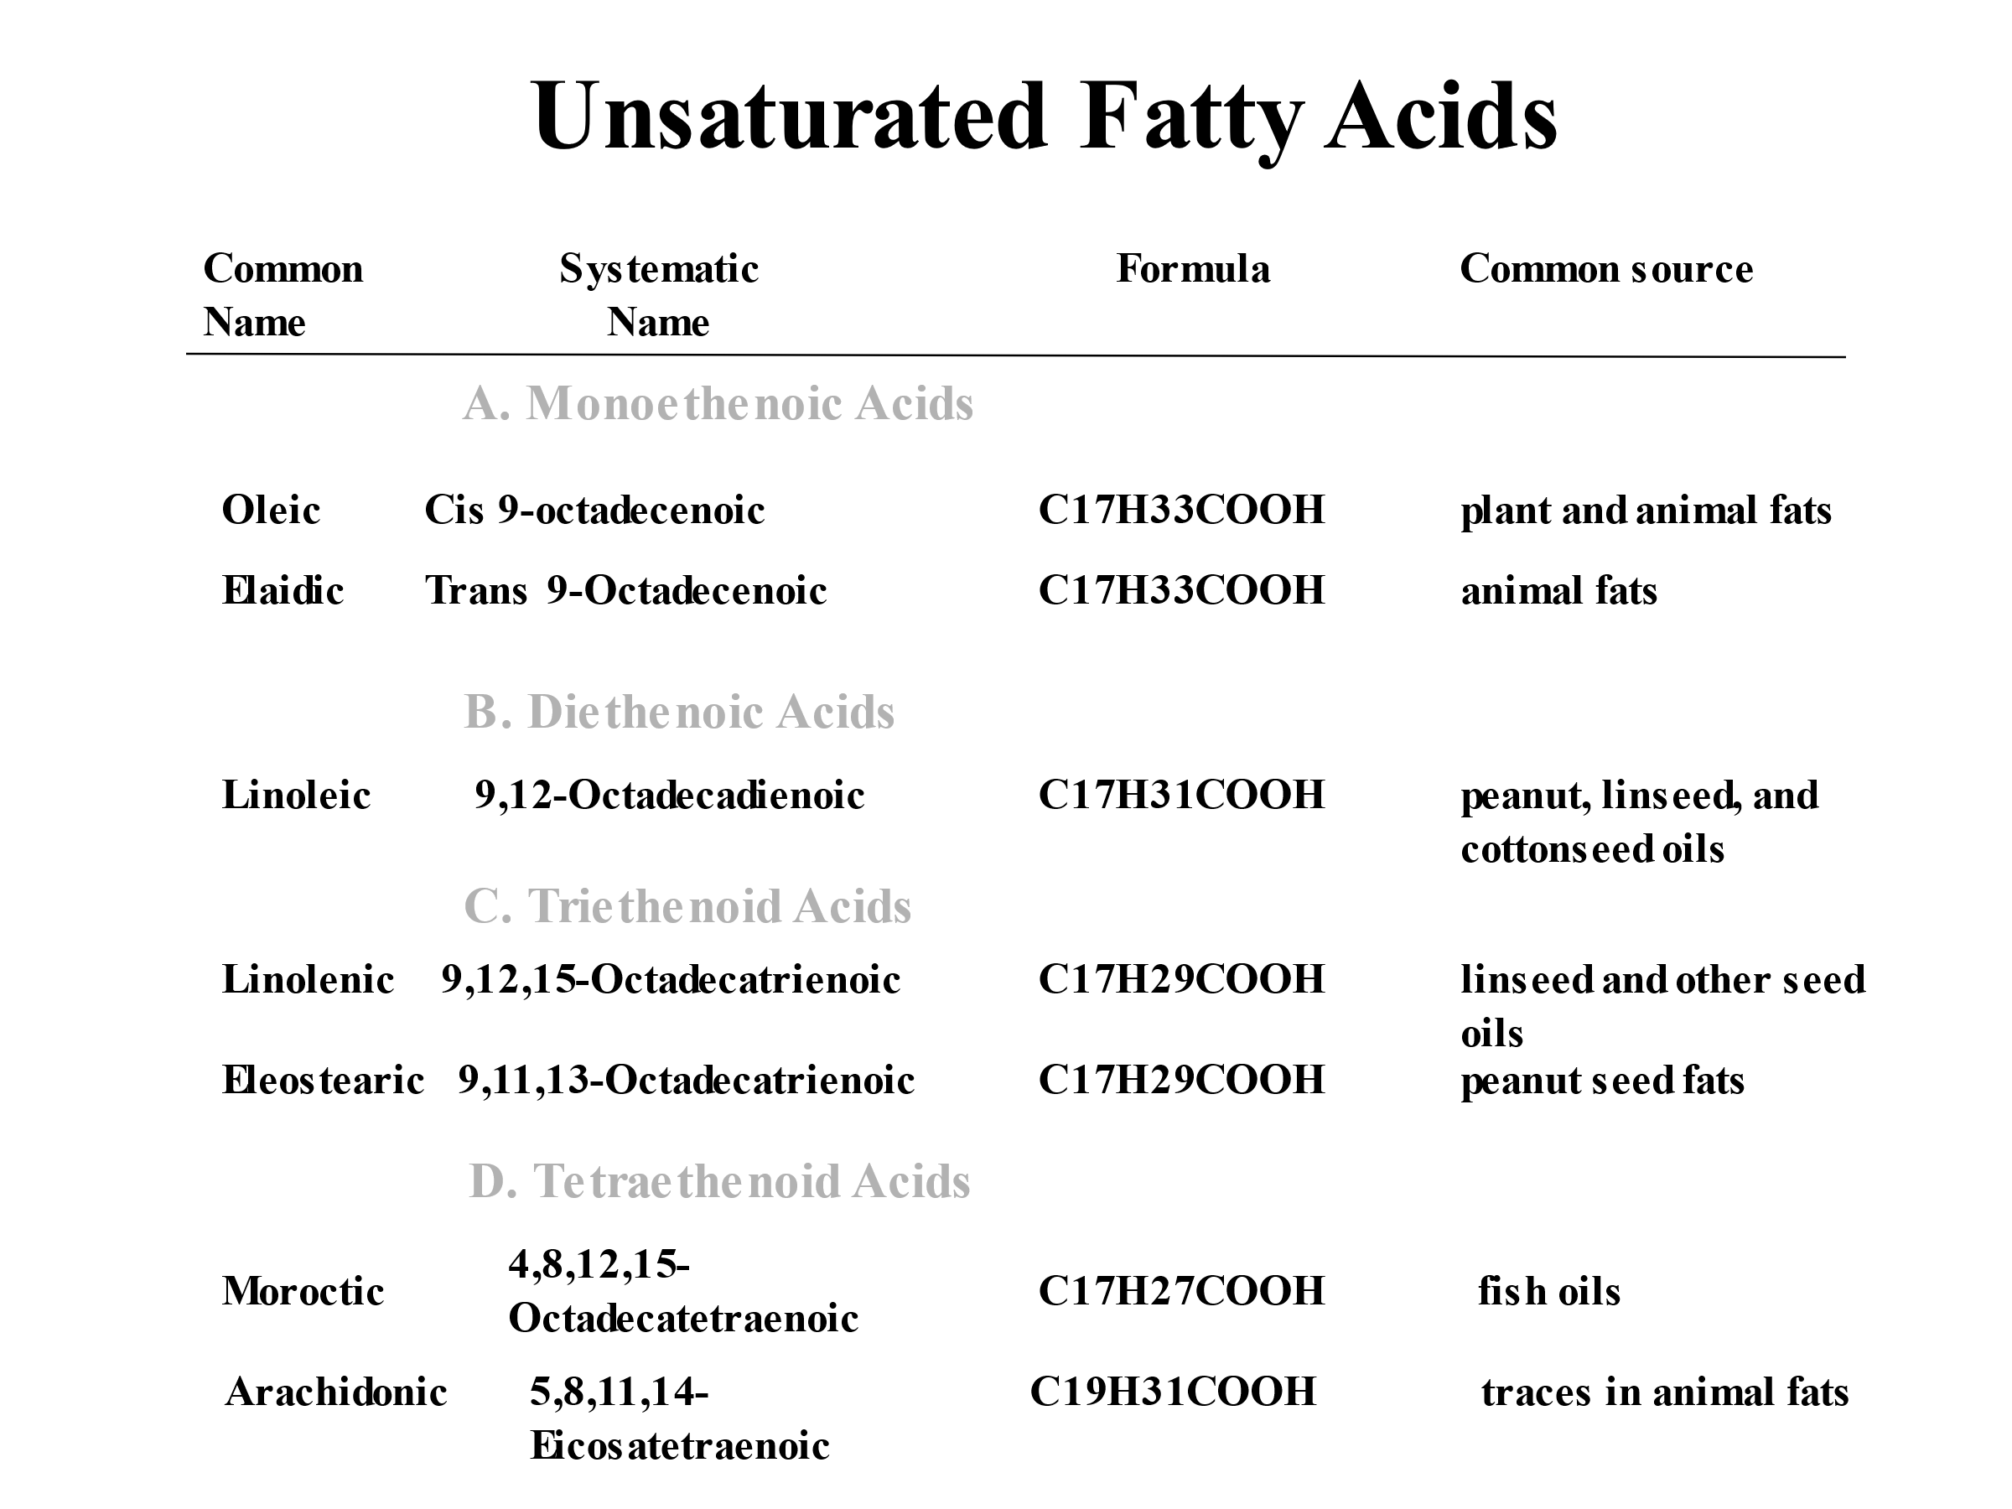
The melting point and hardness of the fatty acid is affected by:
- The length of the carbon chain.
- The degree of unsaturation.
- As chain length increases, melting point increases. As the degree of
- unsaturation increases, the melting point decreases.

