Amino acids and proteins
Amino acids:
Amino acids are small organic biomolecules. Amino acids in free form are found in small amount in living systems, but in the bulk exists as constituent units of protein. Even through more than 300 amino acids have been identified in nature, only 20 primary amino acids (19 amino acids and 1 imino acid) are found in protein).
Amino acids are molecules having two functional groups (carbonyl group COOH and amino group NH2) at α-carbon atom. Hence they are named as α-amino acids.
All amino acids have the general formula, but they differ in the side chains or R groups and can be H, aliphatic, aromatic or heterocyclic group.

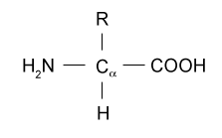
The α-carbon of all amino acids is a symmetric except in glycine where the α-carbon is symmetric.
All amino acid found in proteins are in the L-configuration. However,
Classification of amino acids based on their structure:

Amino acids can be classified into three groups depending on their structure:
1- Aliphatic
2- Aromatic
3- Heterocyclic
Classification of amino acids based on nature of polarity:
According to this type of classification, amino acids are classified into two major classes;
1- Hydrophobic or non polar amino acids:
The side chains of hydrophobic amino acids intract poorly with water like aliphatic or aromatic side chain.
Hydrophobic amino acids with aliphatic side chain: glycine, alanine, valine, leucine, isoleucine, proline and methionine.
Hydrophobic amino acids with aromatic side chain: phenyl alanine, tyrosine and tryptophane.
2-Hydrophilic or polar amino acids:`
The side chains of the hydrophilic amino acids contain polar groups that may be:
a- Charged Hydrophilic amino acids:
The charged side chains are of two types:
1-Negatively charge side chain like aspartic acid and the glutamic acid, the side chains of these compounds have the carbonyl groups that are the negatively charged within the physiological pH range.
2-Positively charge side chain like lysine, arginine and histine, the side chains of these compounds have the amino groups that are the positively charged within the physiological PH range.
b- Uncharged Hydrophilic amino acids:
The uncharged side chains of their amino acids have oxygen, sulfur or nitrogen atoms, enabling them to form hydrogen bonds with water. Although they are uncharged, these amino acids are hydrophilic.
Theronine and serine, with hydroxyl group (OH) in the side chain.
Aspargine and glutamine with amide group(CONH₂).
Cycteine with thiol group(SH).

Structure of amino acids:
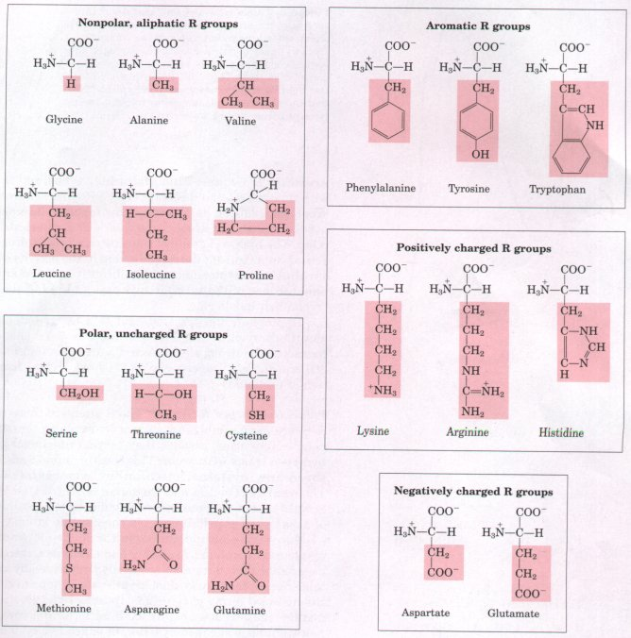

Amino Acids Can Act as Acids and Bases:
All amino acids contain at least two ionizable groups, the acidic; carboxylic group (COOH) and the basic; amino group (NH₂). At physiological PH (7.4), carboxylic groups exist as (COO⁻) and amino groups as (NH₃⁺).
When an amino acid is dissolved in water, it exists in solution as the dipolar ion, or zwitterion. Zwitterion molecules that contain equal number of positive and negative charge and therefore bear no net charge The characteristic pH at which the net electric charge is zero is called the isoelectric point ( pI).

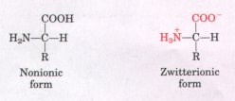

A zwitterion can act as either an acid (proton donor):
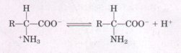
or a base (proton acceptor):
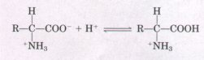

Properties of amino acids:
Amino acids are generally soluble in water and quite insoluble in non-polar organic solvents such as ether, chloroform and acetone.

Essential amino acids:
Some of the 20 standard amino acids are called essential amino acids because they cannot be synthesized by the body from other compounds through chemical reactions, but instead must be taken in with food. In humans, the essential amino acids are lysine, leucine, isoleucine, methionine, phenylalanine, threonine, tryptophan, valine.
Deficiency of one or more of these amino acids leads to impairs protein synthesis and abnormal growth.
Semi-essential amino acids:
These amino acids are not synthesized in sufficient quantity during growth. They include arginine and hitidine. They become essential in growing children, pregnancy and lacting women. But they are not essential for the adult individual.
Non essential amino acids:
Those are amino acids that can be biosynthesized in adequate amounts in the body and not required in the diet. These amino acids are derived from the metabolism of the lipid or carbohydrates or from the transformation of essential amino acids and include glycine, proline, serine, glutamic, glutamine alanine, tyrosine, cysteine, and aspartic.

Peptide formation:
The most important reaction of amino acid is peptide formation.
Two amino acid molecules can be covalently joined through a substituted amide linkage, termed a peptide bond, to yield a dipeptide. Such a linkage is formed by removal of the elements of water (dehydration) from the -carboxyl group of one amino acid and the –amino group of another

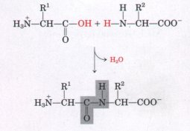
The amino acid residue at that end of a peptide having a free a-amino group is the amino-terminal (or N-terminal) residue; the residue at the other end, which has a free carboxyl group, is the carboxyl-terminal (C-terminal) residue.
Proteins:
Proteins are polymers of L-α-amino acids joined by peptide bonds, a type of amide linkage. Peptide bond is the covalent bond formed between α- carboxyl group of one amino acid and α- amino group of another amino acid.
All the different types of proteins are initially synthesized as polymers of 20 common amino acids.
Proteins are macromolecules varying in amino acid composition, structure, shape and properties. About half dry weight of living materials is protein.
Composition of proteins:
In addition to C, H and O which are present in carbohydrates and lipids, proteins also contain N. The nitrogen content is around 16% of the molecular weight of proteins.
Small amounts of S and P are also present. Few proteins contain other elements such as I, Cu, Mn, Zn, Fe,…
Structure of proteins:
Proteins have four levels of structure organization:

1- Primary structure of proteins:
Primary structure of proteins is the linear sequence of amino acids in a protein held together by peptide bonds, one end of the molecule will have a free α- amino group( N-terminal -in the left) and the other end will have a free carboxyl group ( C-terminal -in the right). The primary structure of proteins is important because any change in the sequence of amino acids leads to abnormal and may affect the function and properties of proteins. Like cancer diseases.
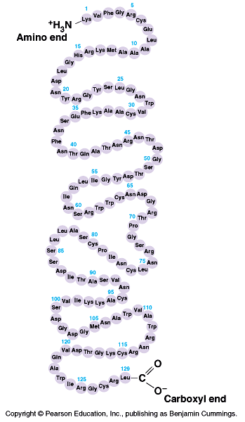
2- Secondary structure of proteins:
It refers to the structure with a polypeptides or a protein may resulting hydrogen bond interactions between amino acids residues near to one another in the linear sequence (primary structure). Right handed and left handed α-helical spiral which is stabilized by hydrogen bonds between amino acids in the same polypeptide chain.
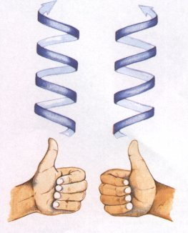
A similar stabilization occurs between amino acid in two neighbors polypeptide chains to form the β- pleated sheet.
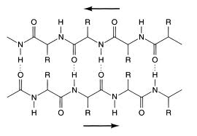

α- Helix: Is the one form of secondary structure in which amino acids in same polypeptide chain is stabilized by hydrogen bonds.
β- Pleated sheet: Is another form of secondary structure in which amino acids in two neibours polypeptide chain is stabilized by hydrogen bonds.
Tertiary structure of proteins:
The polypeptide chain (primary structure), will its secondary structure, may be further folded and coiled a bout itself forming a tertiary structure of protein. Folding occurs from interaction between amino acids relatively for a part in the sequence. The stabilization of this structure is due to the different bonds between groups of amino acids. But some proteins is stabilized by disulfide bonds between cysteine .
1- Hydrogen bonds:
Between
2- Ionic bonds (Electrostatic forces, salt linkage): Between R group of positive charge and R group of negative charge.
3-Hydrophobic bonds: Between non polar groups
4- Dipole-Dipole intraction: Between polar-unionized side chain.
5-Disulfide bonds(S-S linkage): Between two cysteine groups.

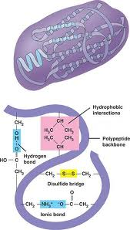

Quaternary structure of proteins:
Many proteins are made up of only one poly peptide chain, and are defined as monomeric proteins. However, others may composed of two or more poly peptide chains (subunits) and the rearrangement of these polypeptide chains (subunits) is called the quaternary structure of protein is called dimeric, if three subunits is called trimeric, if several subunits is called multimeric.
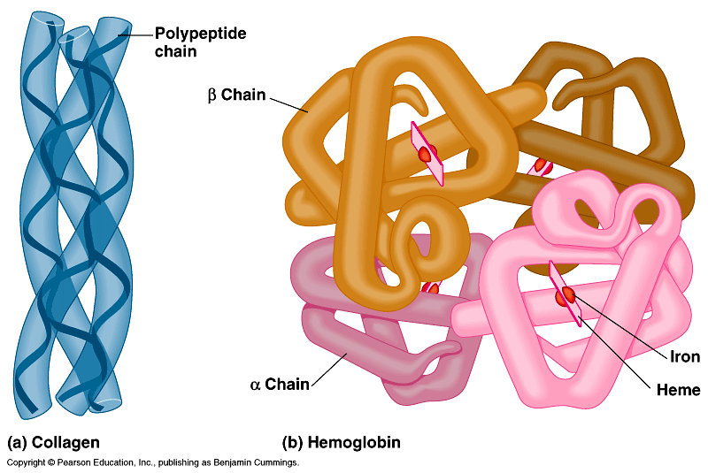

Denaturation of proteins:
Denaturation of proteins is the changes in the properties of a protein. In other words, it is the loss of biologic activity. Denaturation agents include physical and chemical agents or by mechanical action.
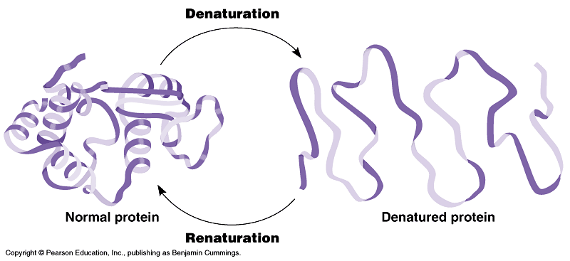

Classification of proteins:
Proteins have been classified in several ways, according of their:
1- Function
2- Shape and size
3- Chemical structure

Functions of proteins:
1- Biochemical catalysts known as enzymes are proteins and catalyze all the chemical reaction that occurs in living cells.
2- Proteins known as immunoglobulin serve as the first line of defense against bacterial and viral infections.
3- Some proteins present in cell membrane, cytoplasm and nucleus of the cell act as receptor.
4- Transport proteins carry materials from one place to another in the body. Like hemoglobin.
5- Under certain conditions protein can be catabolized to supply energy.
6- Storage proteins bind with specific substances and store them, like ferritin store iron, and casin in the milk, store amino acid. Also the seeds of many plants store proteins.
7- Regulatory proteins control cell function, include hormones such as insulin and glucagon.
8- Some proteins serve as structural materials or as important components of extracellular fluid. Like keratin of skin and hair, collagen of connective tissue.
2- Classification of proteins based on shape and size:
a- Fibrous proteins:
In fibrous proteins, the polypeptide chains are long, thin fiber or needle shaped. These proteins often serve structural roles in cells. Typically, they are insoluble in water or in dilute salt solution. Like -keratin (from hair, nail wool and skin), silkfibroin (fibroin, the protein of silk, is produced by insects and spiders), collagen (found in connective tissue such as tendons, cartilage, the organic matrix of bone, and the cornea of the eye.), and elastin (a component of some connective tissues).

2- Globular proteins:
Globular proteins also called spheroproteins are spherical in shape. Globular proteins are soluble in aqueous solution. This group includes albumin, many enzymes, protamines, globulin, histones and actin…..
Classification based on the structure of proteins:
Proteins can be classified according to their structure to:
1-Simple proteins:
These are proteins containing only amino acids. On complete hydrolysis yield only amino acids. Like:
Albumin(found in many animal tissues and liquids), globulins(found in blood and milk and muscle and in plant seed), glutelins(a simple protein found in the seeds of cereals), histones(present in cell nuclei in association with nucleic acids), protamins(found in fish) and prolamine(found in plants).
2-Conjugated or compound or complex proteins:
These are proteins liked with a non protein part called prosthetic group. The prosthetic group may be a metal or a compound. On hydrolysis with acids, yield the amino acids and prosthetic group. A number of proteins contain more than one prosthetic group. Usually the prosthetic group plays an important role in the protein’s biological function.
Holo protein = Protein (Apo protein) + non protein part (prosthetic group)

3-Derived proteins:
These are derivatives of proteins formed from simple and conjugated proteins. These proteins are produced by physical and chemical factors

