2. Compound Lipids:-
These are esters of fatty acid with alcohol containing additional (prosthetic) groups. These are sub classified according to the type of prosthetic group present in the lipid:
1- Phospholipids
2- Glycolipids
3- Lipoproteins
1-Phospholipids:
Lipids contain fatty acids, alcohol, and phosphoric acid residue as additional groups. They often have nitrogen containing base and other substituent’s.
Phospholipids may be classified on the basis of the type of alcohol present in them as:
a- Glycerophospholipids.
b- Sphingophospholipids.
A- Glycerophospholipids:
Glycerophospholipids, also called phosphoglycerides , are lipids in which two fatty acids are attached in ester linkage to the first and second carbons of glycerol, and a highly polar or charged group is attached through a phosphodiester linkage to the third carbon.
Glycerophospholipids are the most abundant phospholipid molecules found in cell membranes.
The simplest glycerophospholipid, phosphatidic acid, is the precursor for all other glycerophospholipid. Phosphatidic acid is composed of glycerol-3-phosphate that is esterified with two molecules of fatty acids at C-1 and C-2.
Glycerophospholipid are classified according to which alcohol becomes esterifies to the phosphate group.
Glycerolphospholipids contain both a polar and non polar end and therefore are amphipathic.
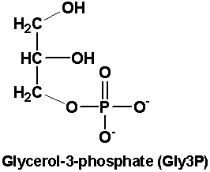

Examples on glycerophospholipids:
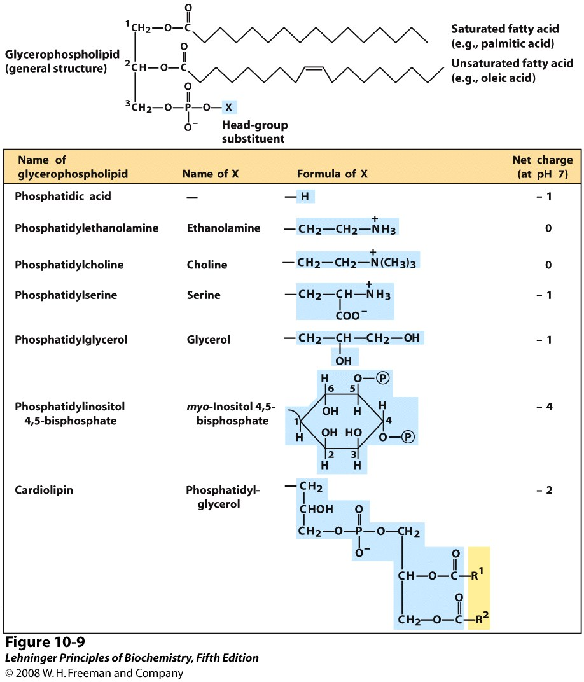
Phosphotidyl cholin (Lecithin):
These are glycerophospholipids containing glycerol, fatty acids,cholin. These are most abundant phospholipids of the cell membrane having both structural and metabolic functions. They occur in the liver, brain and in plasma as part of the lipoproteins. Lecithin contains both a polar head and non polar tails therefore are amphipathic.
Phosphatidyl ethanol amine (Cephalin):
Cephalin differs from lecithin in that the nitrogen base ethanol amine is present instead of cholin. Cephalin is also found in bio membranes and possesses amphipathic properties.
Phosphatidyl inositol:
The phosphatidic acid is esterified to inositol at C-3. Phosphatidyl inositol bisphosphate (PIP₂) is present in cell membranes. This compound plays a vital role in the medication of hormone action on cell membranes.
Phosphatidyl Serine:
The phosphatidic acid is esterified to serin at C-3.

b- Sphingophospholipids:
Phospholipids derived from alcohol sphingosine instead of glycerol are called sphingophospholipids.
Sphingophospholipids are amphipathic, having a polar head group and non polar fatty acid tails, and are structural components of cell membrane.

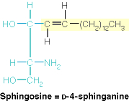

Sphingomyelins:
Sphingomyelins are phospholipids which contain sphingosine , one molecule of fatty acid, phosphoric acid and cholin.
Sphingo myelin is found in most animal cell membranes. They are found in abundance in the myelin sheath that surrounds and insulates cells of the central nervous system.
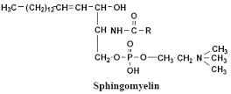

2-Glycolipids:
Glycolipids are molecules that contain carbohydrate and lipid. All glycolipids are derivatives of ceramides in which a long chain fatty acid is attached to the amino alcohol sphingosine. They are, therefore called glycosphingolipids.
Glycosphingolipids are essential components of all membranes in the body, but they are found in greatest amounts in nerve tissue.
The simplest glycosphingolipids are the cerebrosides.
Cerebrosides are cereamide monosaccharide that contain either a galactose (galactocerebroside- the most common cerebroside found in membranes of brain cells), or glucose (glucocerebroside found in the membranes of macrophages {cells that protect the body ingesting and destroying foreign microorganisms})
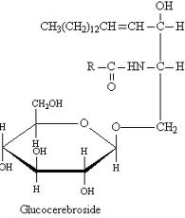

Derived lipids:
Sterols:
Sterols are a class of steroids. Sterols are structural lipids present in the membranes of most cells. Cholesterol is the major sterol in animal tissues.
Cholesterol is amphipathic, with a polar head the OH group at C-3 and a non polar, the steroid nucleus and hydrocarbon side chain at C-17.
Most of the cholesterol in the body exist as a cholesterol ester, with a fatty acid attached the OH at C-3.
Cholesterol is a major structural constituent of the cell membranes and plasma lipoproteins. Cholesterol is a precursor in the biosynthesis of all steroid hormones (likeTestosterone), vitamin D and bile salts.
