**Laboratory examination :**

The laboratory technique and procedure are necessary to make and accurate diagnosis and definitive the specific disease agent.

**The laboratory examinations include the following:**

1. **Direct smear**: is classified in to two type
2. **Staining smear :** its prepare by spared small amount of fresh specimen (exudate , bile and mucosa) on a slide surface as thin layer ,then staining with proper stain after drying.
3. **Wet smear:** this type is prepare by mixing few drops of normal saline with fresh specimen on a slide and examine directly after putting on cover slip.

**# coccidosis:** observe the sub serosa make wet amount smear of mucosal scraping from various segment of intestine and ceca contain and examine directly under the microscope for suspected oocyst and merozoite**.**

**# Enterotoxaemia:** smear from intestinal surface with gram stain to see the high number of bacteria.

**#Blood smear:** in suspected case of acute cholera, staining the blood smear with methylene blue or with gram stain to see the double polar bacteria.

1. **Impression smear**:

Impression smear with the sterilized slide can be taken from internal organ after incising the affected organ and making smear from the inside surface the smear is left for drying by room air then stain.

1. **Bacterial culture:**

They can be making from unexposed surface of the viscera without searing the surface. If the contamination has occur on the surface of the organ should be seared with hot iron before inserting the sterile culture loop.

**Example:** definitive diagnosis of salmonellosis and E-coli are made by cutting the specimens from the infected organs (egg, death chicks) on the specific agar.

1. **Viral isolation:** if a viral disease is suspected choosing the organs for isolation well depends on the suspected disease and appearance lesion.

**Steps for viral isolation:**

1. Remove the affected organ from the body.
2. Transfer to a sterile mortar or pestle for grinding.
3. grinding is fascinated by adding a portion sterile sand to the mortar contains.
4. Then the ground tissue transfer to sterile cover centrifuge tube and spam at low speed to prevent a super Nate for nutrient mediator experimental bird inoculation.

# For example Mark disease, Newcastle disease. Infectious bronchitis

1. **Serological test :**

Serologic tests are blood tests that look for antibodies in blood. They can involve a number of laboratory techniques. Different types of serologic tests can diagnose various disease conditions. The process for having the test is the same regardless of which technique the laboratory uses during serologic testing.

**The following have same important serological test:**

1. Immuno Fluorescent Antibody Technique (IFAT)
2. Heam agglutination test (HAT)
3. Toxin anti toxin test (TAT)
4. Enzyme- Linked Immunosorbent Assay (ELISA)
5. Polymerase Chain Reaction. (PCR)

**6-Sensitivity tests to antibiotics:**

**KIRBY-BAUER METHOD**

          The Kirby-Bauer test, known as the disk-diffusion method, is the most widely used antibiotic susceptibility test in determine what treatment of antibiotics should be used when treating an infection.  The organism will grow on the agar plate while the antibiotic “works” to inhibit the growth.  If the organism is susceptible to a specific antibiotic, there will be no growth around the disc containing the antibiotic.  Thus, a “zone of inhibition” can be observed and measured to determine the susceptibility to an antibiotic for that particular organism.

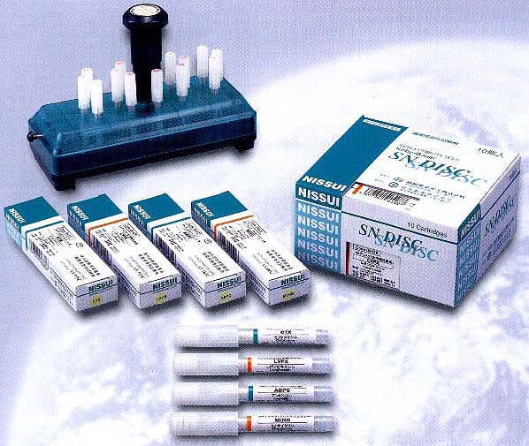  
Equipment used for Kirby-Bauer testing

 How to prepare the samples: -  
  
This is done collecting samples of infected tissue or body fluids and in the case of day old chicks the yolk sac within the sterile conditions to avoid contamination of samples with the bacterium is causing infection.  
Cultivated these samples on the maker of agar nutrient (nutrient agar) or or (Blood agar), depending on the type of bacteria to be isolated or potential infection and then incubating the samples for 24 hours at a temperature of 37 degrees.

**Method of planting: -**  
  
Initially is prepared the culture Media which is called (Mueller Hinton agar) and are ready commercially in the form of easy to prepare powder

**Preparation of the sterile conditions as possible to avoid contamination:**

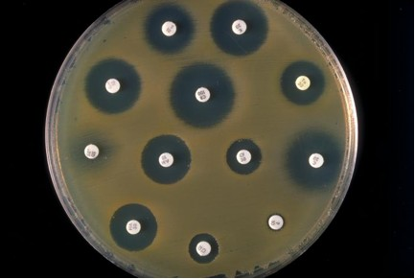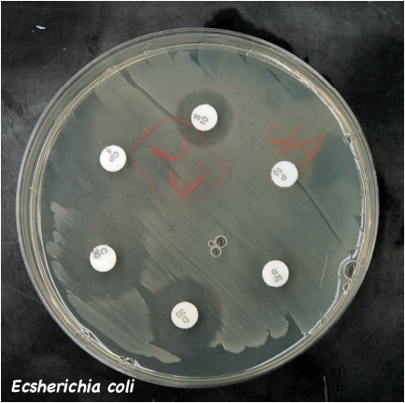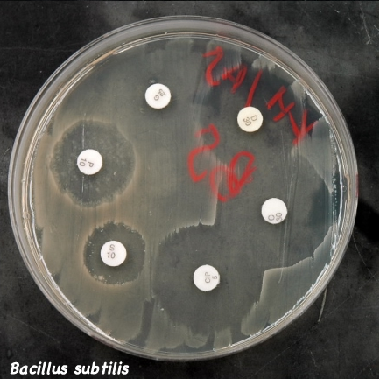  
Then take the ptridish of bacteria that resulted from the cultivation of the sample or nutrient broth Broth, which was planted by the sample in the first step and is grown on a plate (Mueller Hinton agar).  
Then placed tablets of antibiotics (microbial sensitivity discs), each disk of the disks containing the antibiotic is different from the others and distributed properly so that each disk away from the one next to it a bit where there is room to form a ring of lack of growth on each disk or present business organization and distributed evenly, as in the following images.  
 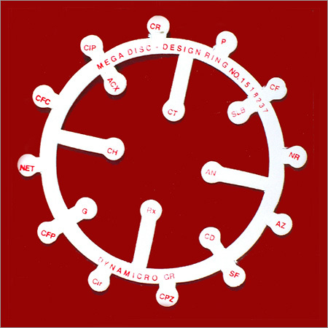  
  
When the growth of bacteria on cultured notes the existence of areas to prevent the growth of the colonies of the disk that contains the antibiotic most powerful and influential for these bacteria, called this region clear zone or inhibition zone.

**How do you determine the Result?**  
  
compare the diameters of reference specific antibiotic to determine the most powerful antibiotic and anti-this way is known for killing these microbes or stop their growth and given antibiotics symbols indicate the of their effect as follows:  
  
Sensitive (S) Sensitive  
Medium Sensitivity (I) Intermediate  
Resistance (R) Resistance