II.External Examination of the bird
Birds must be applied external examination before being killed and an autopsy will be in sequence starting from the head until ending with the legs.
1 – Combs and Wattles
Fowl pox - papules ----> ---- vesicles> pocks.
2 - Infection by beats Flavus- white material spread on combs and sometimes wattles are infected .
3 – Swelling and enlargement of wattles.
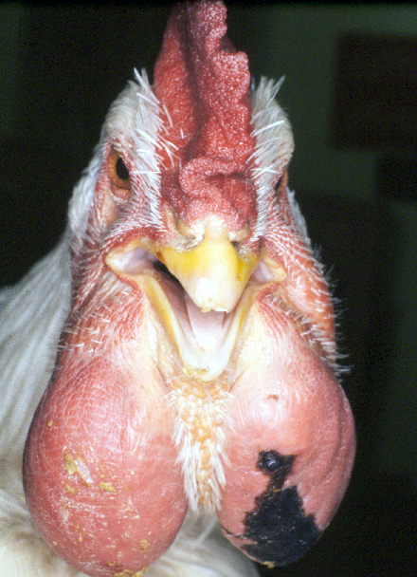
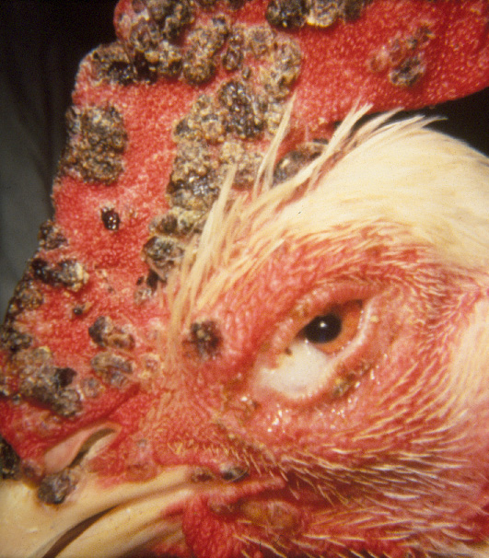
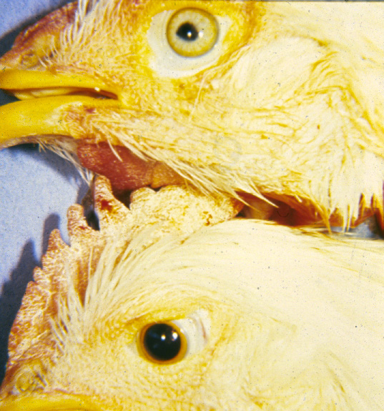
Chronic case of cholera disease – combs and wattles are containing material similar to cheese. Pocks
4 – paleness of combs and wattles:
this paleness appears in Anemia cases due to:
A - internal or external bleeding
B – infection in bone marrow
C – Infected anemia.
E – Infection by coccidia disease. Swollen of wattles
E - severe infection by red louse.
The face and eyes and eyelids:
swelling of face ---
subcutaneous inflammation of the skin sinusitis (swollen of the nose area)
collection of the gathered materials in the sinus.
Fowl Coryza
Deficiency of vitamin A. Eye lesions (Marks)
Newcastle disease (ND)
Infectious Bronchitis (IB).
Inflammation of the eyelids and the cornea and conjunctiva
Cannibalism case:
accumulation the air and water under the skin.
- Appear the green color on the skin
-Deficiency of vitamin E and selenium element and sulfur amino acids.
- Accumulation the air under the skin
- occurrence of injuries.
-Bitten by wild animals.
-Broken of leg bones or thigh bones.
- Dirty skin, feathers or blackness
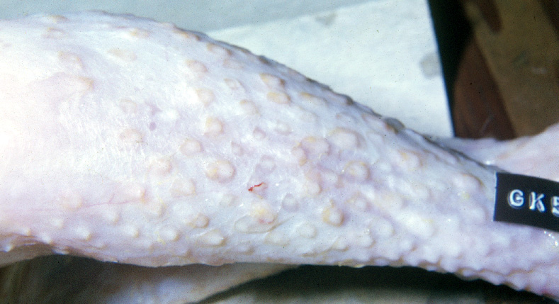
cutaneous form of Marek's disease - swelling around the follicles of the feathers.
Skin Lesions

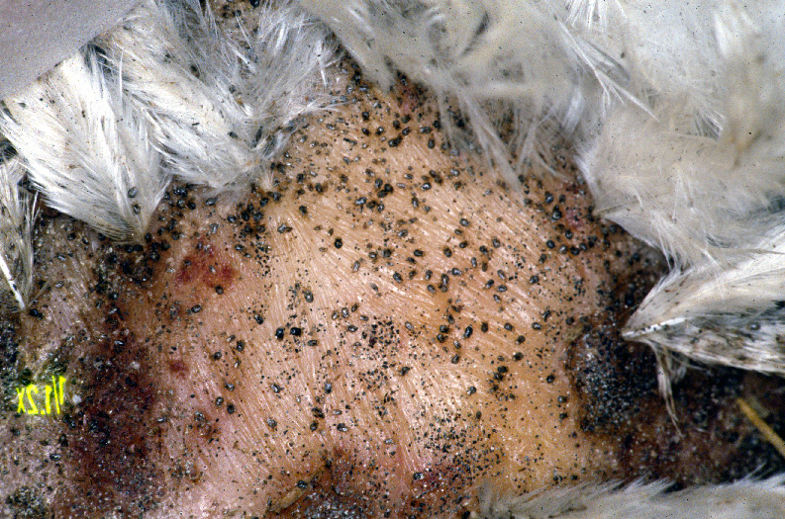
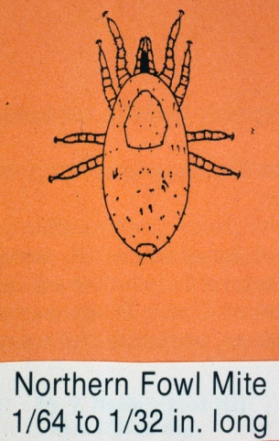
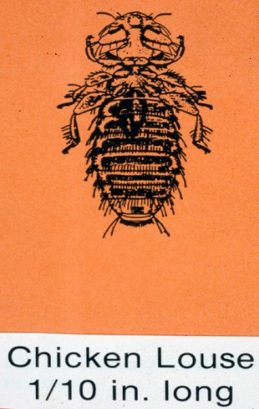
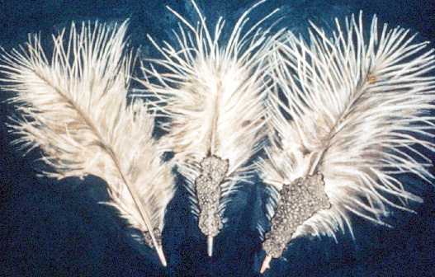
Examination of the skin and especially the director and under the wing to search for the presence of parasites, or louse or mites.
chicken Louse
Northern Fowl Mite
Legs and feet
- arthritis due to inflammation and swelling of the hock joint.
- viral arthritis.
-sliding tendon Perosis.
-rough scales of the legs Scaly leg because of the louse.
- twisting fingers to the inside – due to deficiency of vitamin B2.
-twisting fingers to the outside – due to a genetic disorder.

