Academic Curriculum Vitae
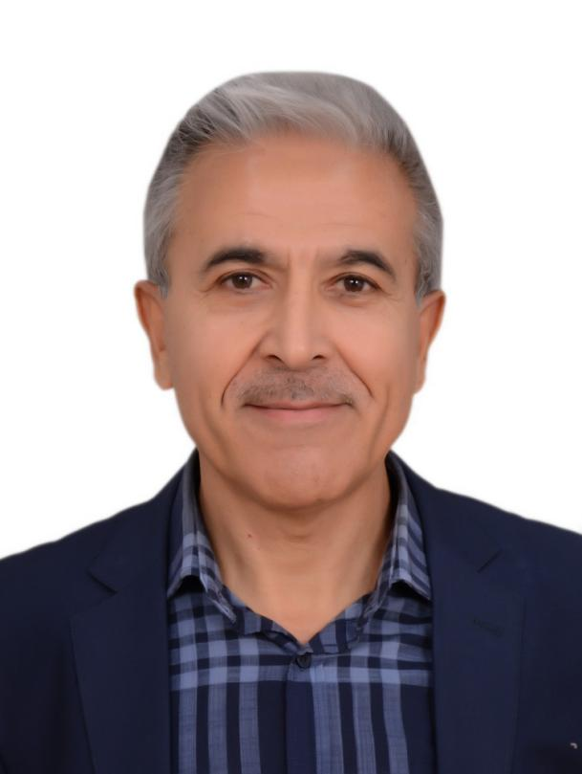
Personal Information:
Full Name:Nwzad Abduljabar Abdulla
Academic Title: Professor
Email: (university email) nawzad.abdulla@su.edu.krd
Mobile:0750 4680718

Education:
- State all educations accomplished

Employment:
- 1986 Bachelor of Engineering Sciences in Civil engineering.
- 1987 M.Sc in structural Engineering from University of strathclyde, Glasgow, United Kingdom.
- 1999 Ph.D. in structural Engineering from University of Technology, Baghdad, Iraq. State employment starting from first employment

Qualifications
- 1986-1987 Cowan and Linn consultancy
- 1987-1991 construction sector.
- 1991 Ministry of building and construction, Al Rasheed Company.
- Methods of Teaching
1994 Assistant Lecturer, Department of Civil Engineering, College of Engineering, University of Salahaddin, Erbil, Iraq.
1999 Doctor of Philosophy in Structural engineering.
1999-2008 Lecturer
2008 Assistant Professor
2020 Professor

Teaching experience:
- Engineering drawing-first year
- Descriptive Geometry-first year
- Geology- first year
- Technical english-first year
- Building materials-first year
- Technical english-first year
- Buliding construction-second year
- Concrete Technology-second
- Concrete tecnology lab-second year
- Concrete design-third year
- Structural analysis- third year
- Sustainability-third year
- Engineering masonry-third year
- Project-fourth year
- Economy and management- fourth year
- Concrete-diploma
- Structure-MSc
- Stability-PhD
- Concrete lab supervision

Research and publications
1- N. A. Abdulla, Strength of plain and blended concrete exposed to aggressive environment, Journal of Pure and applied Science, University of Salahaddin Erbil, Iraq Vol.15, No.2, 2003, pp. 77-87.
2- N. A. Abdulla, Flexural behavior of Portland cement Ground limestone concrete Beams, Journal of Pure and applied Science, University of Salahaddin Erbil, Iraq Vol.16, No.3, 2004, pp. 99-109.
3- N. A. Abdulla, Effects of elevated temperatures on bending strength of reinforced concrete beams, Journal of Pure and applied Science, University of Salahaddin Erbil, Iraq Vol.16, No.4, 2004, pp. 5-15.
4- N. A. Abdulla, blending concrete with local available, Journal of Pure and applied Science, University of Salahaddin Erbil, Iraq Vol.18, No.1, 2006, pp. 117-129.
5- N Abduljabar Abdulla, Effect of saline environment on the strength of reinforced concrete beams, AL-Rafdain Engineering Journal (AREJ) 16 (2), 1-23, 2008
6- J. I. Kakrasul and N. A. Abdulla, Size effect on shear strength of deep beams with opening in the web, Journal of Pure and applied Science, University of Salahaddin Erbil, Iraq Vol.20, No.3, 2008, pp. 135-150.
7-

Published papers in international Journals:

1- Abdulla NA. Effect of recycled coarse aggregate type on concrete
Journal of Materials in Civil Engineering 27 (10), 04014273
2- Abdulla NA. Concrete filled PVC tube: A review. Construction and Building Materials. 2017;156:321-329.
3- Abdulla NA. Influence of plastic pour-in form on mechanical behavior of concrete. Structures. 2019; 19: 193-202
4- Abdulla NA. The behavior of concrete-filled plastic tube specimens under axial load. Jordan Journal of Civil Engineering. 2020; 14(1):69–81.
5- Abdulla NA. Concrete encased with engineering plastics. Journal of Civil Engineering and Construction. 2020; 9(1):31–41.
6- Abdulla NA. Mechanical behavior of slender composite columns under axial compression load. KSCE Journal of Civil Engineering. 2020; 24(1):208–218
7- Abdulla NA. Concrete with an outer plastic protective shell. SN Applied Science. (https://doi.org/10.1007/s42452-020
8- Abdulla NA. Using the Artificial Neural Network to Predict the Axial Strength and Strain of Concrete-filled Plastic Tube. Journal of Soft Computing in Civil Engineering. 2020. DOI:10.22115/scce.2020.225161.1198
9- NA Abdulla, PVC Plastic Tube with Concrete Infill Strengthened with FRP: A State-of-the-art Review, Journal of Civil Engineering and Construction 9 (4), 196-204, https://doi , 2020
10- NA Abdulla, Axial strength of short concrete-filled plastic tube
NA Abdulla, structures https://authors.elsevier.com/a/1bYzN_rUeEUs4c 27 (https://authors …

Conferences and courses attended
1-Abdulla NA. Experimental stress-strain results using computers in concrete industry, 35th International conference on computers and industrial engineering 1, 617-623, 2005.
2-Abdulla NA. Concrete filled thermoplastic tube under compression. In: Proceedings of the 1st international Engineering Conference on Developments in Civil and Computer Engineering Applications. University of Ishik, Erbil, Iraq. 2014. p.60-70.

Professional Social Network Accounts:

- ReserchGate
- LinkedIn.
- Orchid
- Academia
- G. Scholar
- Semantic

