- What’s burnt clay bricks.
- Explain using sketches the function of ties in walls.
- Give three difference between confined and unconfined masonry systems.
- Explain three main elements of a confined building.
- What is the purpose of horizontal and vertical ties?
- Why there is no openings in masonry shear walls.
- Plot the positions of shear walls in a masonry building.
- Give size of wall openings.
- Draw the distributions of openings in a building.
- What is the net surface of concrete block.
- Difference between hollow and solid block.
- Explain a simple quality test for fresh concrete.
- Write a simple test for the quality of sand.
- explain a quick test of concrete consistency.
- Show three types of strip footing in a Sketch.
- In a simple building show the positions of horizontal and vertical ties.
- Plot a figure showing the stirrup spacing on vertical ties.
- Explain the recommenced minimum vertical tie dimensions with 45º stirrups.
- Show in a figure the spacing of stirrups near vertical ties.
- What is the minimum dimensions of plinth.
- Why anchoring rebar is important.
- Draw a figure showing rebar ends bent outward.
- What’s the function of spacers.
- Why masonry units must be staggered.
- illustrated the following bonds: English bond, staggered bond.
- demonstrate the details of dowels in : (a) blocks, (b) bricks.
- Illustrated graphically how mortar and bricks are placed.
- Write the maximum height of wall constructed in one day.
- How do you place conduits in a masonry wall.
- How do you integrate big pipes into walls.
- What’s meant by seismic bands.
- Whats the correct way of placing the vertical ties and columns.
- What are the two conditions for increasing the length of shear walls in the facade.
- How do you create shear walls for the building shown below.
- What is seismic bands.
- The difference between seismic bands and tie beams.
- Show the reinforcement details for a two-way stair case.
- How do you open up existing corner connections.
- Sketch the integration of connection bars into new plinth beams.
- Calculate the ceiling area for each floor for the building shown below, built with 20cm hollow block units. Given that the shear wall percentage for hollow concrete blocks: at ground floor 4%, at upper floor= 2%.

- Explain situations requiring the common form of loading and calculations checks.

- Tabulate the indicative design working life.
- Tabulate the types of action.
- write the load combinations for a shear wall.
- Illustrate the wind load check on load bearing wall.
- Illustrate the load check on internal load bearing wall.
- demonstrate wind load check on non-load bearing cladding panel.
- Explain how the characteristic strength of masonry ($f_{k}$) can be determined.
- Define masonry unit.
- List the types of masonry units.
- How masonry belongs to a group.
- Sketch a figure showing the extent of relative zones will be affected by macro climate.
- Draw the effective height of stiffened walls.
- Show the minimum requirement for assuming support to vertical ages of load bearing walls.
- How the load is distributed in walls subjected to concentrated loads.
- For the following wall determine the , given the following details: wall:1by 3m, load 2 ton. Determine the distance from the top of wall to effective length of bearing.

- Draw basic configurations of a structural reinforced masonry wall.
- List the fired masonry units.
- What is masonry accessory materials.
- Define connectors.
- Use of a sealant.
- Explain flashing.
- Use of coatings.
- What is the function of moisture barrier.
- draw the orientations of masonry units in an element.
- What is the difference between running bond and 1/3 running bond.
- What is Flemish bond.
- Describe the type of walls (according to water penetration resistance.
- Sketch four types of walls.
- What are the main compounds of cement powder.
- What is Retentivity.
- Describe the Manufacturing of Clay Masonry Units.
- Sketch three typical bed joint reinforcement.
- Draw typical use of post tensioning tendons in wall.
- Plot typical veneer ties.
- Show typical connectors.
- Describe the types of joints.
- Sketch the locations of control joints in: CMU, clay Wythe (loose and fixed lintels).
- Draw details of reinforcement in clay masonry lintel.
- Sketch a figure showing details of reinforcement in masonry wall made of hollow units.
- Check the design of (Single-Wythe Panel Wall using Solid Units: 8x8x16in) shown in Figure below, for a wind load w of 20 lb/ft2 , using PCL mortar, Type N, and units with a nominal thickness of 8 in. 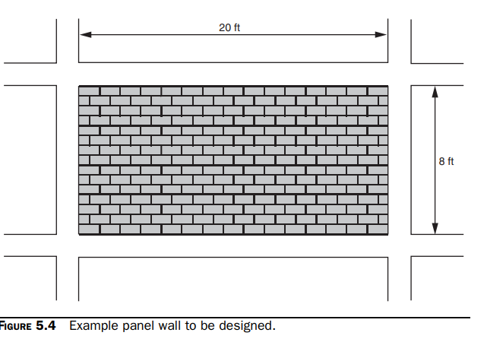
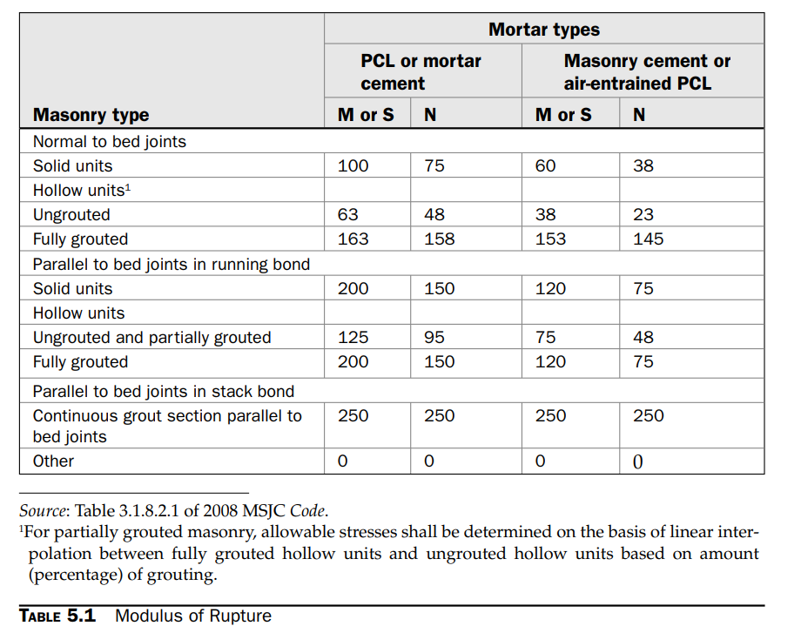
- Check the design of (Single-Wythe Panel Wall using hollow Units) shown in Figure below for a wind load w of 20 lb/ft2 , using PCL mortar, Type N, and units with a nominal thickness of 8 in.
- Unreinforced Bearing Wall with Concentric Axial Load The bearing wall shown in Fig. 5.12 has an unfactored, concentric axial load of 1050 lb/ft. Using hollow concrete masonry units with face-shell bedding, design the wall. the following loading combinations must be checked for strength design: 1. 1.2D +
1.6W + f 1 L + 0.5 (Lr or S or R) 2. 0.9D + 1.6W + 1.6H. 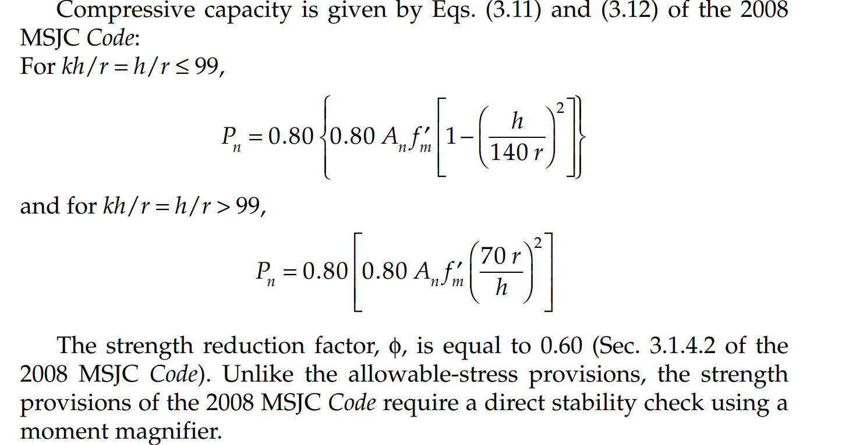
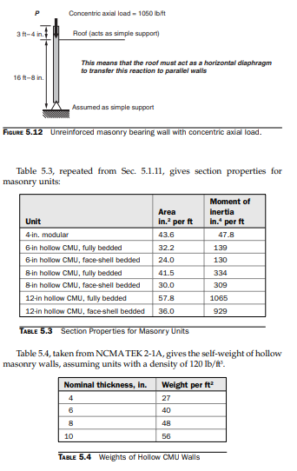
- What’s engineering brick.

