**Lipid Digestion**

Ruminants have a unique digestive system that allows them to efficiently break down plant material, including lipids, in their rumen.

The process starts with bacterial lipases breaking down triacylglycerols and phospholipids into their constituent fatty acids.

These fatty acids are then hydrogenated by rumen bacteria, converting unsaturated fatty acids like linoleic and linoleic acid into saturated fatty acids like stearic acid. Interestingly, during this process, some double bonds may be converted to the Trans configuration, leading to the presence of Trans fatty acids in the rumen.

The rumen microorganisms also produce their own lipids, which may contain unusual fatty acids such as those with branched chains.

These lipids ultimately contribute to the composition of milk and body fats in ruminants.

However, the capacity of rumen microorganisms to digest lipids is limited. High lipid content in the diet can reduce the activity of rumen microbes, leading to decreased fermentation of fiber and lower food intake.

Saturated fatty acids have less impact on rumen fermentation compared to unsaturated fatty acids.

Calcium salts of fatty acids, such as those found in fat supplements for ruminants, have minimal effect on rumen fermentation.

Long-chain fatty acids, unlike short-chain fatty acids, are not absorbed directly from the rumen. Instead, they reach the small intestine mainly as saturated and esterified fatty acids, with some being esterified in bacterial lipids. In the small intestine, lysophosphatidyl choline replaces monoacylglycerols, playing a role in the formation of mixed micelles.

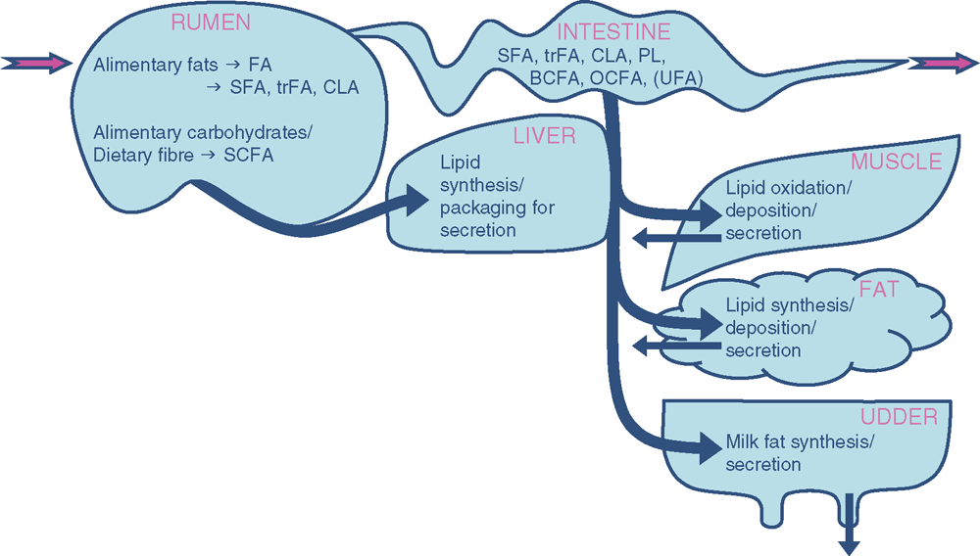

**Fat metabolism**

In ruminants is a complex process that involves multiple stages and interactions between the rumen, liver, and other organs.

1. **Rumen Hydrolysis**: Dietary fats, including triacylglycerols and phospholipids, are initially hydrolyzed in the rumen by bacterial lipases.

This process releases fatty acids, which are then further metabolized.

1. **Microbial Hydrogenation**: Fatty acids released in the rumen undergo hydrogenation by rumen bacteria. This converts unsaturated fatty acids, such as linoleic and linoleic acid, into saturated fatty acids, primarily stearic acid. Some double bonds may be converted to Trans configuration during this process.
2. **Limited Digestive Capacity**: The ability of rumen microbes to digest lipids is limited. High-fat diets can reduce microbial activity, affecting fermentation and food intake.
3. **Absorption in the Small Intestine**: Long-chain fatty acids, mainly saturated and esterified, reach the small intestine. Some may be esterified in bacterial lipids. Lysophosphatidyl choline replaces monoacylglycerols in the formation of mixed micelles.
4. **Liver Metabolism**: Fatty acids absorbed from the small intestine are transported to the liver via the portal vein. In the liver, fatty acids can undergo various metabolic pathways, including oxidation for energy production, synthesis of triglycerides for storage, or conversion to other lipid compounds.
5. **Formation of Body and Milk Fats**: Fatty acids processed in the liver contribute to the synthesis of body fats and milk fats. The predominant fatty acid in ruminant body fats is stearic acid, resulting from rumen hydrogenation.

In ruminants, liver metabolism plays a crucial role in processing fats absorbed from the small intestine and those synthesized in the body.

**1. Transport of Fatty Acids:** Fatty acids absorbed from the small intestine are transported to the liver via the portal vein.

Additionally, fatty acids synthesized from carbohydrates in the liver through de novo lipogenesis are also part of this process.

**2. β-Oxidation:** Fatty acyl-CoA molecules can enter the β-oxidation pathway within hepatocytes.

This process involves a series of enzymatic reactions that sequentially remove two-carbon units from the fatty acyl-CoA molecule, producing acetyl-CoA, which enters the citric acid cycle for energy production.

3**. Energy Production:** β-Oxidation of fatty acids in the liver generates energy in the form of ATP, which can be utilized by hepatocytes for various metabolic processes or released into the bloodstream for use by other tissues.

**4. Triglyceride Synthesis:** Excess acetyl-CoA generated from β-oxidation can be used for triglyceride synthesis within hepatocytes.

Triglycerides are then packaged into very low-density lipoproteins (VLDL) and released into the bloodstream for transport to adipose tissue for storage or to other tissues for energy utilization.

**5. Cholesterol Synthesis:** The liver also plays a significant role in cholesterol metabolism. Acetyl-CoA generated from fatty acid oxidation can be used for cholesterol synthesis within hepatocytes.

Cholesterol is essential for the formation of cell membranes and the synthesis of bile acids, which aid in fat digestion.

1. **Regulation of Lipid Metabolism:** Liver fat metabolism is tightly regulated by various hormones, enzymes, and transcription factors.

Insulin promotes lipid synthesis and storage, while glucagon and other hormones stimulate lipolysis and fatty acid oxidation during periods of energy demand.