**Animal Food components**

Food is material that, after ingestion by animals, is capable of being digested, absorbed and utilized. **herbivores**, the plant eaters (ruminants, horses and small animals such as rabbits and guinea pigs); **omnivores**, which eat all types of food (pigs and poultry), **carnivores**, which eat mainly meat (dogs and cats). The diet of farm animals in particular consists of plants and plant products, although some foods of animal origin such as fishmeal and milk are used. Plants are able to synthesise complex materials from simple substances such as carbon dioxide from the air, and water and inorganic elements from the soil.

The main components of foods, plants and animals are:

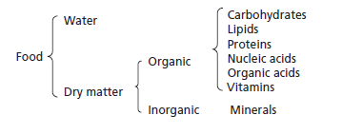

**WATER:**

The water content of the animal body varies with age. The newborn animal contains 750–800 g/kg water but this falls to about 500 g/kg in the mature fat animal. It is vital to the life of the organism that the water content of the body be maintained: an animal will die more rapidly if deprived of water than if deprived of food. Water functions in the body as a solvent in which nutrients are transported about the body and in which waste products are excreted.

The animal obtains its water from three sources: drinking water, water present in its food, and metabolic water, this last being formed during metabolism by the oxidation of hydrogen containing organic nutrients. The water content of foods is variable and can range from as little as 60 g/kg in concentrates to over 900 g/kg in some root crops. Because of this great variation in water content, the composition of foods is often expressed on a dry matter basis, which allows a more valid comparison of nutrient content.

**Composition of some plant and animal products on a fresh basis and a dry matter basis**

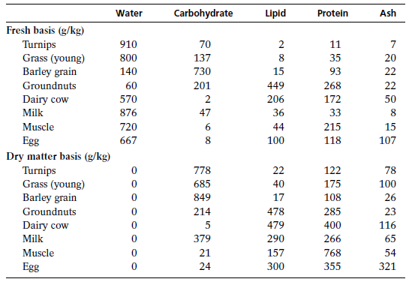

**DRY MATTER**

The dry matter (DM) of foods is divided into organic and inorganic material. the main component of the DM of pasture grass is carbohydrate. The oilseeds, such as groundnuts, are exceptional in containing large amounts of protein and lipid material. The carbohydrate content of the animal body is very low. One of the main reasons for the difference between plants and animals is that, the cell walls of plants consist of carbohydrate material, mainly cellulose, the walls of animal cells are composed of lipid and protein. Furthermore, plants store energy largely in the form of carbohydrates such as starch and fructans, whereas an animal’s main energy store is in the form of lipid.

The lipid content of the animal body is variable and is related to age, the older animal containing a much greater proportion than the young animal. The lipid content of living plants is relatively low, that of pasture grass, for example, being 40–50 g/kg DM.

In both plants and animals, proteins are the major nitrogen-containing compounds.

In plants, in which most of the protein is present as enzymes, the concentration is high in the young growing plant and falls as the plant matures. In animals, muscle, skin, hair, feathers, wool and nails consist mainly of protein.

Vitamins are present in plants and animals in small amounts, and many of them are important as components of enzyme systems. An important difference between plants and animals is that, plants can synthesise all the vitamins they require for metabolism, animals cannot, or have very limited powers of synthesis, and are dependent upon an external source.

The inorganic matter contains all those elements present in plants and animals other than carbon, hydrogen, oxygen and nitrogen. Calcium and phosphorus are the major inorganic components of animals, whereas potassium and silicon are the main inorganic elements in plants.

**DRY MATTER AND ITS COMPONENTS**

**T**he dry matter (DM) of foods is conveniently divided into organic and inorganic material, although in living organisms there is no such sharp distinction. Many organic compounds contain mineral elements as structural components. Proteins, for example, contain sulphur, and many lipids and carbohydrates contain phosphorus.

**It** can be seen from Table 1.1 that the main component of the DM of pasture grass is carbohydrate, and this is true of all plants and many seeds. The oilseeds, such as groundnuts, are exceptional in containing large amounts of protein and lipid material.

**In** contrast, the carbohydrate content of the animal body is very low. One of the main reasons for the difference between plants and animals is that, whereas the cell walls of plants consist of carbohydrate material, mainly cellulose, the walls of animal cells are composed almost entirely of lipid and protein. Furthermore, plants store energy largely in the form of carbohydrates such as starch and fructans, whereas an animal’s main energy store is in the form of lipid.

**The** lipid content of the animal body is variable and is related to age, the older animal containing a much greater proportion than the young animal.

**The** lipid content of living plants is relatively low, that of pasture grass, for example, being 40–50 g/kg DM.

**In** both plants and animals, proteins are the major nitrogen-containing compounds. In plants, in which most of the protein is present as enzymes, the concentration is high in the young growing plant and falls as the plant matures. In animals, muscle, skin, hair, feathers, wool and nails consist mainly of protein.

Like proteins, nucleic acids are also nitrogen-containing compounds and they play a basic role in the synthesis of proteins in all living organisms. They also carry the genetic information of the living cell.

**The** organic acids that occur in plants and animals include citric, malic, fumaric, succinic and pyruvic acids. Although these are normally present in small quantities, they nevertheless play an important role as intermediates in the general metabolism of the cell.

**Other** organic acids occur as fermentation products in the rumen, or in silage, and these include acetic, propionic, butyric and lactic acids.

**Vitamins** are present in plants and animals in minute amounts, and many of them are important as components of enzyme systems. An important difference between plants and animals is that, whereas the former can synthesise all the vitamins they require for metabolism, animals cannot, or have very limited powers of synthesis, and are dependent upon an external supply.

**The** inorganic matter contains all those elements present in plants and animals other than carbon, hydrogen, oxygen and nitrogen. Calcium and phosphorus are the major inorganic components of animals, whereas potassium and silicon are the main inorganic elements in plants.

**PROXIMATE ANALYSIS OF FOODS**

This system of analysis divides the food into six fractions: moisture, ash, crude protein, ether extract, crude fibre and nitrogen-free extractives.

**The** moisture content is determined as the loss in weight that results from drying a known weight of food to constant weight at 100 °C. This method is satisfactory for most foods.

**The** ash content is determined by ignition of a known weight of the food at 550 °C until all carbon has been removed.

**The** residue is the ash and is taken to represent the inorganic constituents of the food.

**The** major component of ash is silica but ash, however, contain material of organic origin such as sulphur and phosphorus from proteins, and some loss of volatile material in the form of sodium, chloride, potassium, phosphorus and Sulphur.

**The** crude protein (CP) content is calculated from the nitrogen content of the food, determined by a modification of a technique originally devised by Kjeldahl over 100 years ago.

**In** this method the food is digested with sulphuric acid, which converts to ammonia all nitrogen present except that in the form of nitrate and nitrite.

**It** is assumed that the nitrogen is derived from protein containing 16 per cent nitrogen, and by multiplying the nitrogen figure by 6.25 an approximate protein value is obtained.

**The** ether extract (EE) (lipid) fraction is determined by subjecting the food to a continuous extraction with petroleum ether for a defined period. The residue, after evaporation of the solvent, is the ether extract.

**The** carbohydrate of the food is contained in two fractions, the crude fibre (CF) and the nitrogen-free extractives (NFE).

When the sum of the amounts of moisture, ash, crude protein, ether extract and crude fibre (written as g/kg).

**DIGESTION IN RUMINANTS**

The foods of ruminants, forages and fibrous roughages, consist mainly of β-linked polysaccharides such as cellulose, which cannot be broken down by mammalian digestive enzymes. Ruminants have therefore evolved a special system of digestion that involves microbial fermentation of food before its exposure to their own digestive enzymes.

**ANATOMY AND PHYSIOLOGY OF RUMINANT DIGESTION**

The stomach of the ruminant is divided into four compartments. In the young suckling, the first two compartments, the rumen and its continuation the reticulum, are relatively undeveloped, and milk, on reaching the stomach, is channeled by a tube-like fold of tissue, known as the oesophageal or reticular groove. The consumption of fibrous foods, such as straw and hay, stimulates the enlargement of the reticulum. The fermentation of food by microbes in the rumen produces volatile fatty acids and these, particularly butyric acid from the fermentation of concentrates such as cereals, encourage the formation of papillae on the rumen wall. Papillae are small finger-like projections that increase the surface area for the absorption of nutrients.

Ruminant teeth and chewing actions are adapted for the efficient comminution of fibrous foods. The distance between the right and left teeth in the lower jaw is less than that in the upper jaw. Powerful muscles move the jaw in three phases – first the jaw is dropped, second it is moved laterally to one side on which chewing will occur, and finally it is strongly carried up and inside.

The food is diluted with copious amounts of saliva, first during eating and again during rumination: typical quantities of saliva produced per day are 150 l in cattle and 10 l in sheep. Rumen contents contain 850–930 g water/kg on average, but they often exist in two phases: a lower liquid phase, in which the finer food particles are suspended, and a drier upper layer of coarser solid material. The breakdown of food is accomplished partly by physical and partly by chemical means. The contents of the rumen are continually mixed by the rhythmic contractions of its walls, and during rumination material at the anterior end is drawn back into the oesophagus and returned by a wave of contraction to the mouth.

The major factor inducing the animal to ruminate is probably the tactile stimulation of the epithelium of the anterior rumen; some diets, notably those containing little or no coarse roughage, may fail to provide sufficient stimulation for rumination. The time spent by the animal in rumination depends on the fibre content of the food. In grazing cattle, it is commonly about 8 hours per day, or about equal to the time spent in grazing. Each bolus of food regurgitated is chewed 40–50 times and thus receives a much more thorough mastication than during eating.

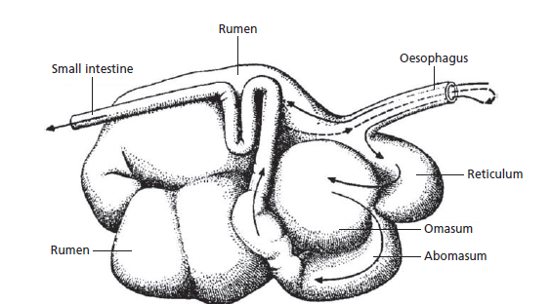Food and water enter the rumen and the food is partially fermented to yield principally volatile fatty acids, microbial cells and the gases methane and carbon dioxide. The gases are lost by ructation (belching) and the volatile fatty acids are mainly absorbed through the rumen wall. The microbial cells, together with undegraded food components, pass to the abomasum and small intestine; there they are digested by enzymes secreted by the host animal, and the products of digestion are absorbed. In the large intestine there is a second phase of microbial digestion. The volatile fatty acids produced in the large intestine are absorbed, but microbial cells are excreted with undigested food components in the faece.

**METABOLISM**

Metabolism is the name given to the sequence, or succession, of chemical reactions that take place in the living organism. Some of the reactions involve the degradation of complex compounds to simpler materials and are designated catabolic reactions, whereas other reactions involve the synthesis of more complex compounds from simpler substances and are designated anabolic reactions. Waste products arise as a result of metabolism and these have to be chemically transformed and ultimately excreted; the reactions necessary for such transformations form part of general metabolism. As a result of various catabolic reactions, energy is made available for mechanical work, transportation and anabolic activity such as the synthesis of carbohydrates, proteins and lipids. The starting points of metabolism are the substances absorbed after the digestion of food.

Sources and fates of major body metabolites. BHBA β-hydroxybutyric acid; NADPH (+H+) = reduced nicotinamide adenine dinucleotide phosphate