CV: Nawzad Abdullah Shukri

Email: nawzad.shukery1@su.edu.krd
Tel: Kurdistan: 07510512361

EDUCATION

• PhD (Doctoral) in the School Of Politics And International Relations At Leicester University -United Kingdom. (2012-2016).
• MA Political Science at Salahaddin University, Kurdistan region/Iraq 2006-2008.
• BA Political Science Salahaddin University, Kurdistan Region of Iraq- 2000-2004

RESEARCH AND TEACHING INTERESTS
• U.S. foreign policy towards Middle East contemporary Study
•U.S. foreign policy towards Iraq, Iran, Syria, Turkey , GCC , Russia and china
• U.S. foreign policy towards Kurdistan region of Iraq.
• Foreign Policy Theories
• International Relations theories

• Kurdish question and Regional states

• Kurdistan question in Iraq
• Strategic Studies

EMPLOYMENT

• teaching staff, College of Political Sciences: Department of International Relations & Diplomacy- Salahaddin University-Erbil

Awarded and honors

• PhD Scholarship- Kurdistan Regional Government- Iraq Scholarship, 2011

CONFERENCE ACTIVITY

• Paper title 'US foreign policy towards Iraqi Kurdistan 2003-2014', at Manchester Metropolitan University, APG Conference Programme 4-6 January 2015. see : uk.net/APG%202015%20Conference%20Programme.pdf)

• Participating Conference at Cambridge University ,Conference title, Iraq: A Decade of New Governance, 19 October 2013. http://www.crassh.cam.ac.uk/events/25019

SKILLS / LANGUAGES

Kurdish- native language
English- fluent
Persian – fluent
Arabic- – fluency in reading-writing- listening, Weak at speaking Arabic

RESEARCH AND ACADEMIC ACTIVITIES :

BOOKS:

• Kurdish Question In Iraq And Mechanism for Its Solution -After 2003(Erbil:Mokoryany Institute, 2009

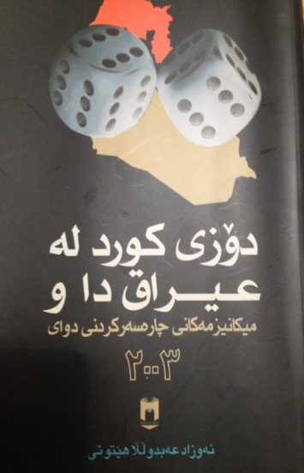

• Explaining U.S. Foreign Policy towards Iraqi Kurdistan 2003-2016: Why Does U.S. Foreign Policy towards Iraqi Kurdistan Change ? Published by LAMBERT Academic Publishing (October 5, 2017)

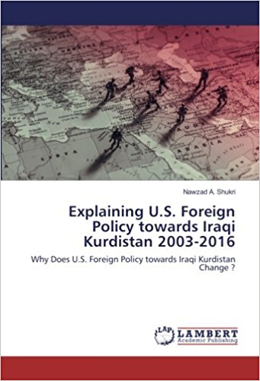

Article and News Papers:

I have published hundreds of newspapers article in Kurdish language in the Kurdish newspapers and website like Rudaw, Kurdistan 24, Xebat news papers, Hawlaty, Amene, Evro, Waar and Kurdistany New. Alos some of them even have been translated in to other language including Turkish language. here are some these recent newspapers article :

• What Are Differences Between Turkey And U.S. in Syria 19 November 2014
http://rudaw.net/sorani/opinion/191120141?keyword=&isArchive=True

• U.S. Foreign Policy Towards Kurdistan Region, Rudaw, 22 May 2015
http://rudaw.net/sorani/opinion/220520151?keyword=&isArchive=True

• U.S. And Territorial Integrity of Iraq, Rudaw , 14 April 2015
http://rudaw.net/sorani/opinion/10042015?keyword=&isArchive=True

• U.S. And Iraq : Two Different Strategies to Confront ISIL, Rudaw 4 July 2015, http://rudaw.net/sorani/opinion/04072015?keyword=&isArchive=True

• Is It Time For Referendum , Kurdistan 24, 15 May 2016 .

• West Kurdistan : Why The U.S. Policy is Inconsistence, Kurdistan 24 , 5 September 2016

• Trump and Middle East, Amene news paper , 25 August 2016, http://www.awene.com/2016/08/25/21524/

• Kurds in the new Turkey Game, Amene news paper, 10 July 2016
http://www.awene.com/2016/07/10/16022/

• Iraq Between Military Coup And Democratization, Kurdistany New , 16 January 2010
http://knwe.net/Direje.aspx?Jimare=997&Cor=2&Besh=Witar

•Irak ve ABD; IŞİD’e karşı iki zıt ülke, Rudaw 27 June 2015
http://www.rudaw.net/turkish/opinion/270620151

• Trump Would Choose Turkey or YPG ? Amene news paper, 14 February 2017

http://www.awene.com/2017/02/14/38355/

• Iraq After ISIL; Kurdistan Between Iran And U.S. Struggle. Rudaw 8 April 2017, http://www.rudaw.net/sorani/kurdistan/0804201714

WHY DOES IRAQI KURDISTAN WANT TO HOLD A REFERENDUM ON INDEPENDENCE? Jerusalem post, 16 July 2017http://www.jpost.com/Opinion/Why-does-Iraqi-Kurdistan-want-to-hold-a-referendum-on-independence-499880

• Why Move Away From Iraq Is The Solution? Rudaw 9 Augusts 2017
http://www.rudaw.net/sorani/opinion/09082017?keyword=&isArchive=True

• The Movement Of “No For Now” For Referendum And Unanswered Equation, Rudaw 16 Augusts 2017 http://www.rudaw.net/sorani/opinion/16082017?keyword=&isArchive=True

• Why U.S. Is Worry About Kurdish Referendum, Awene 11 September 2017

https://www.awene.com/2017/09/11/58294/

• Why Turkey Is Attacking Afrin , Awene 2 March 2018
https://www.awene.com/2018/03/02/79949/

Maida and radio Interview :

I have been interviewed by the many Maida in Kurdistan including following :

• Rudaw TV, Kurdistan 24, Kurdistan TV, Zagros TV, KNN , Gkurdistan, Dange America, Rdio Nawa, Radoi Dhouk. NRT WAAR tv

