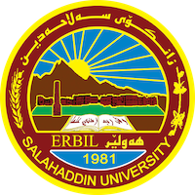
Academic Curriculum Vitae
Personal Information:
Full Name: Nazenin Shekh Muhemad Bapir
Academic Title: Assistant lecturer
Email: (university email) / nazenin.bapir@su.edu.krd
Mobile: 07503307275
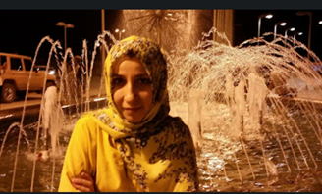
Education:
-State all educations accomplished
-Bachelor in English language 2011
-Master in applied linguistics 2017
-ph.D candidate in Applied Linguistics

Employment:
- State employment starting from first employment:
- First appointment: 2011 /4/11

Qualifications
- Teaching qualifications/ Department of English\ College of Education Salahaddin University-Erbil – teaching staff

- IT qualifications // computer hardware, software, some skills of programming, database management, and some of IT management
- Language qualifications such as TOEFL, IELTS or any equivalent
- Any professional qualification: Level B2, C1
- You could put any professional courses you have attended: Attended[ language Centre, IELTS, and online English writing]

Teaching experience:
- State all teaching courses you delivered, stating undergraduate or post graduate
- I have taught different topics such as: [Communication, Literature, Poetry, General English for University Students, Language & Culture, Research writing]

Research and publications
- State all researches, publication you made.
- 1. The Assessment of University Students Knowledge on Academic Writing
- 2. University Learners’ perspective towards factors affecting the Speaking Skill
- 3. Evaluating and Comparing Teacher-made Tests and Central Tests for “General English for University Student” Course for First Year Students at Salahaddin University-Erbil
- 4. An Analysis of Errors Made by Kurdish University Students in the English Consonant Cluster System
- 5.Teaching Strategies Used in Vocabulary in “Communication” Module for First Year Students at Salahaddin University
- 6. The Assessment of Writing- from Paragraph to Essay for Undergraduate students at Salahaddin University-Erbil
- 7. Investigating Teaching Literature Based-Communication in Enhancing University Students’ Intercultural Awareness: Students’ attitudes & Teachers’ Challenges
- 8. Literature Based-Communication in Enhancing EFL Students’ Intercultural Awareness through Implementing ICC Model

Conferences and courses attended
- Give details of any conferences you have attended, and those at which you have presented delivered poster presentations. Twice I attended VISAL Conference at with research

Funding and academic awards
- List any bursaries, scholarships, travel grants or other sources of funding that you were awarded for research projects or to attend meetings or conferences.

Professional memberships
- List any membership you hold of any professional body or learned society relevant to your research or other life activities.

Professional Social Network Accounts:

- List your profile links of ReserchGate, LinkedIn, etc.
- https://academics.su.edu.krd/nazenin.bapir
- https://www.linkedin.com/in/nazenin-shekh-muhamed-bapir-59963a278
- https://orcid.org/
- https://www.researchgate.net/profile/Nazenin-Bapir

It is also recommended to create an academic cover letter for your CV, for further information about the cover letter, please visit below link:
https://career-advice.jobs.ac.uk/cv-and-cover-letter-advice/academic-cover-letter/

